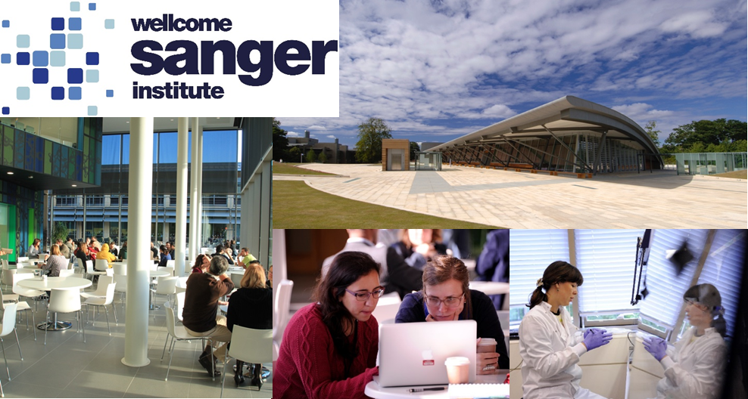

1-year research MPhil in Genomic Science studentships
Registered at the University of Cambridge
The MPhil in Genomic Science programme is based at the Wellcome Sanger Institute, Hinxton, UK.
The Wellcome Sanger Institute is a world leader in genomics research. Faculty members apply and explore genomic technologies at scale to advance understanding of biology and improve health. Making discoveries not easily made elsewhere, the Institute’s research delivers insights across health, disease, evolution and pathogen biology. For a full list of Faculty research interests, please see https://www.sanger.ac.uk/about/study/mphil-and-phd-student-supervisors/.
Genomics is assuming an increasingly prominent place in biological research. The MPhil in Genomic Science programme is being run in partnership with a number of partner institutions, and will equip students with a unique blend of experimental and informatics skills, maximising their competitiveness for future opportunities.
Participating partner institutions can nominate one local candidate, who must have the agreement of a proposed Sanger supervisor, by the 1 February 2026 nomination deadline. The candidate must then develop a suitable potential research project together with their proposed Sanger supervisor by the 8 March 2026 application deadline. The nominated candidates will then be interviewed on either the 26 or 27 March 2026 for one of four fully-funded (stipend and University fees) 1-year research MPhil studentships, based at the Wellcome Sanger Institute, starting 1 October 2026. Successful candidates will need to apply for admission to the University of Cambridge by the 14 May 2026 deadline. For further information about the programme, please see https://www.postgraduate.study.cam.ac.uk/courses/directory/blsimpbsc.
To apply to become the nominated candidate for ‘insert name of institution’ you will need to ‘insert details of local application procedure and relevant deadline’.

