

**Insights from the 18th EfD Annual Meeting, Nairobi, Kenya**

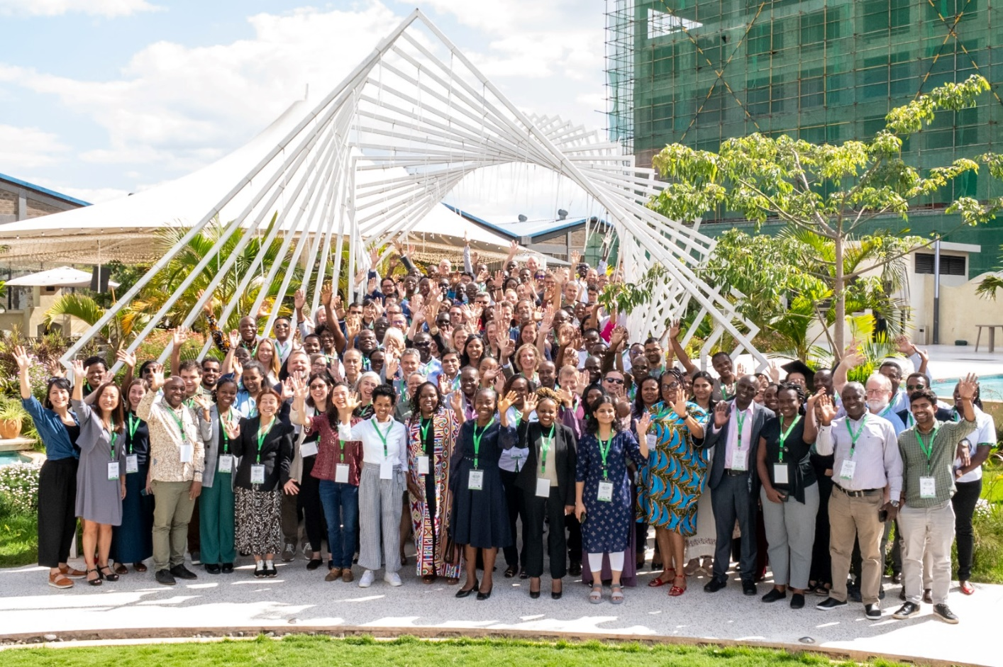

**Background**

The 18th Annual General Meeting of the Environment for Development (EfD) network took place from October 3rd to 6th, 2024, at the Argyle Grand Hotel in Nairobi, Kenya. Organized by the EfD Global Hub at the University of Gothenburg, this year’s meeting was hosted by the EfD-Kenya Centre at the University of Nairobi. The gathering brought together a diverse group of researchers and policy makers across the world. Invitation at AGM is through submission of a research paper or proposal. The research paper can be EfD funded or any other study provided it is in line with EfD themes. In addition to paper and proposal presentations and discussions, stakeholders engage in discussing pressing environmental challenges and sustainable development strategies. Alongside AGM, EfD administrators across all centres and global hub.

This brief therefore, provides a summary of the key insights gathered by the Ugandan delegation and the valuable lessons learned during the event in Nairobi.

**EfD Uganda Team**

EfD Uganda was represented at the meeting by Professor Edward Bbaale, the Centre Director and Mr. Gyaviira Ssewankambo, the Centre’s Office Manager. Each was individually invited by the EfD Global Hub for tailored meetings and training sessions. Additionally, several EfD-Mak researchers and collaborators who had submitted papers and proposals after a UGOT Call for proposals for the 18th Annual Meeting of the Environment for Development (EfD) Initiative ([www.editorialexpress.com/efd](http://www.editorialexpress.com/efd) by 1st July, 2024) were invited to present their work. These included Dr. Peter Babyenda, the IGE Program Coordinator; Dr. Susan Kavuma, Dr. John Sseruyange, Dr. Nicholas Kilimani, Dr. Florence Lwiza Nsereko, Mr. Jordan Ssemwanga, Mr. Nathan Mununuzi (Ministry of Water and Environment), and Eng. Domnic Mucunguzi (Ministry of Agriculture, Animal Industry, and Fisheries).

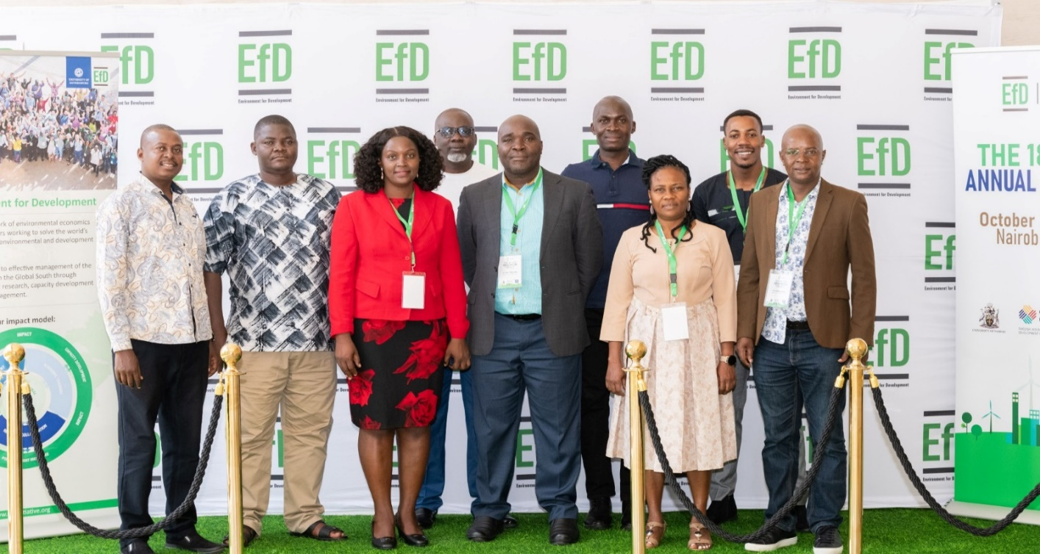 *Uganda Team (L-R):* Eng. Domnic Mucunguzi, Mr. Jordan Ssemwanga, Dr. Florence Lwiza Nsereko, Mr. Nathan Mununuzi, Dr. John Sseruyange, Dr. Nicholas Kilimani, Dr. Susan Kavuma, Mr. Gyaviira Ssewankambo and EfD Uganda Director-Professor Edward Bbaale.

**EfD Uganda Participants’ Presentations**

**Dr. Susan Kavuma:** Dr. Kavuma presented a proposal presentation Titled “A Quasi-Experimental Analysis on the Gender Costs of Biomass Dependency in Uganda”.

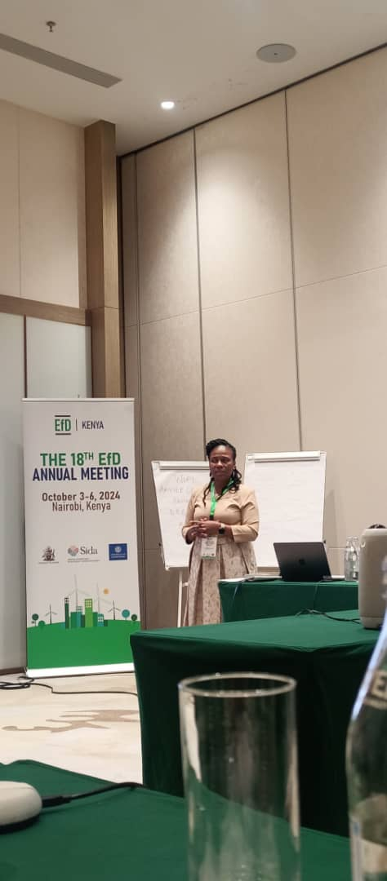

*Dr. Susan Kavuma presenting at the EfD Annual Meeting in Nairobi*

**Dr. Florence Lwiza Nsereko:** Dr. Lwiza presented a presentation for her proposal Titled “Climate Change and Agricultural Trade in Sub-saharan Africa: Implications for regional Market Integration”. Among other researchers on this project include Prof. Johnny Mugisa.

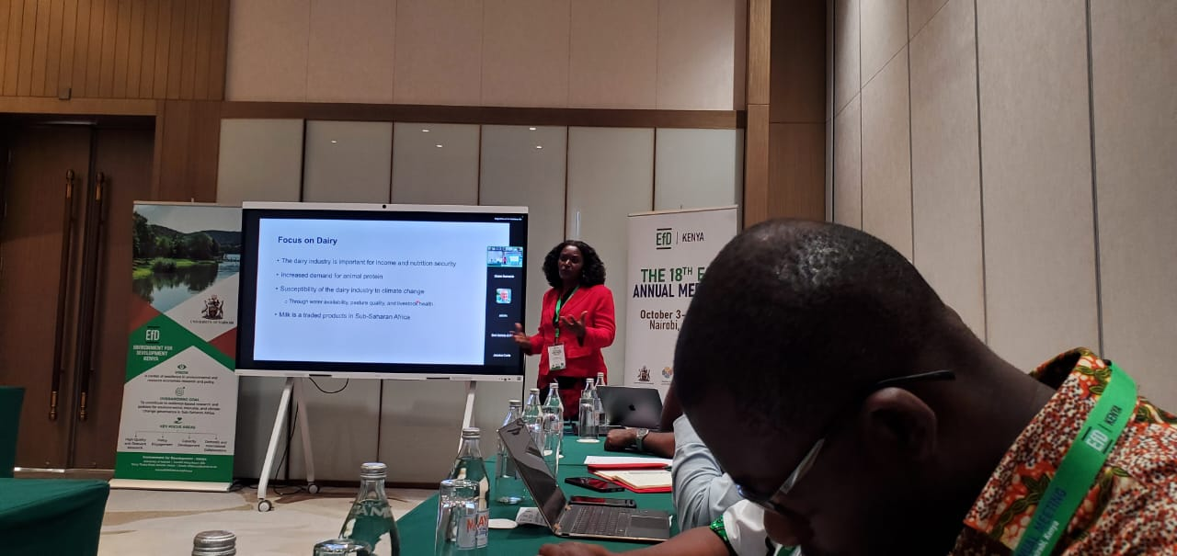

*Dr. Florence Lwiza presenting at the EfD Annual Meeting in Nairobi*

**Dr. John Sseruyange:** Dr. Sseruyange gave a presentation for his paper Titled “Public Acceptance of a Deposit Refund to Reduce Plastic Pollution in Uganda”. He was also the main discussant for Dr. Phu Le’s paper titled “Residential Electricity Efficiency and Implications for Vietnam’s Clean Energy Transition”.

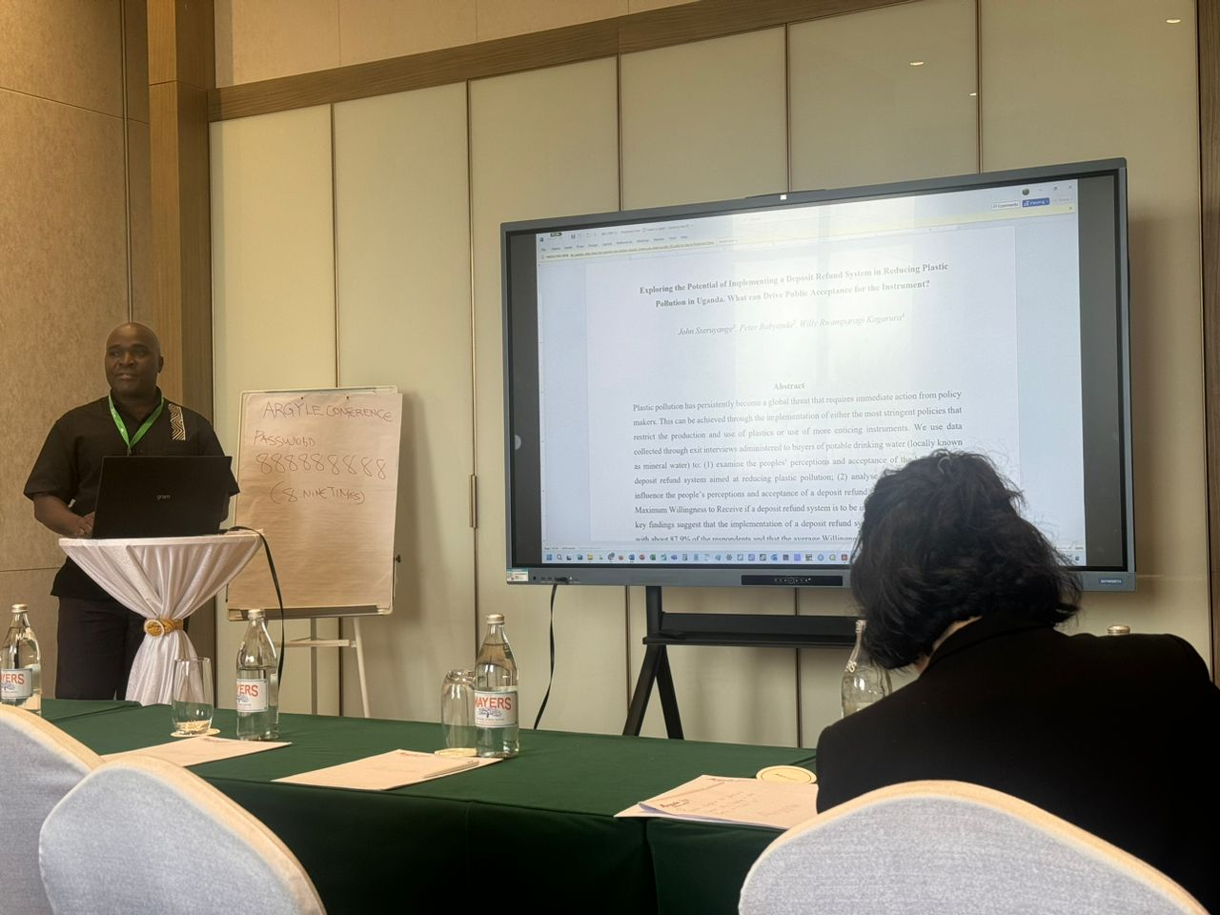

*Dr. John Sseruyange presenting at the EfD Annual Meeting in Nairobi*

**Early Career researchers graduate:** Dr. John Sseruyange and Dr. Florence Lwiza received prestigious EfD awards after graduating from the highly regarded EfD Young Professionals Program. Both were nominated by EfD-Mak Director to participate in this capacity building program. This achievement celebrates their remarkable progress through a transformative program that nurtures emerging leaders in environmental research and policy. Their success is a testament to their hard work, dedication, and the bright future they hold as they continue to contribute meaningfully to the field.

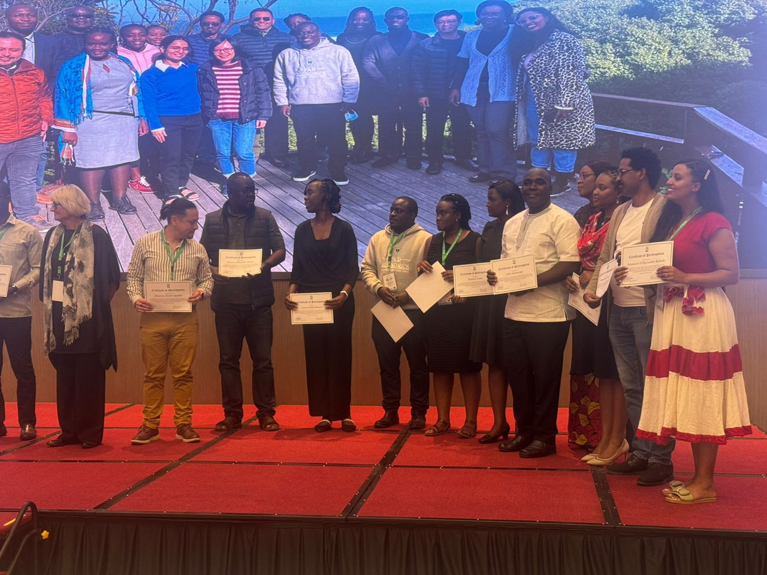

*Dr. Sseruyange (5th Right) and Dr. Lwiza (6th Right) alongside other EfD Young Professionals Program graduands with their awards in Nairobi*

**Dr. Peter Babyenda:** Dr. Babyenda presented a paper on the socio-economic impacts of reforestation initiatives on energy poverty in three Ugandan districts - Hoima, Dokolo, and Nakasongola.

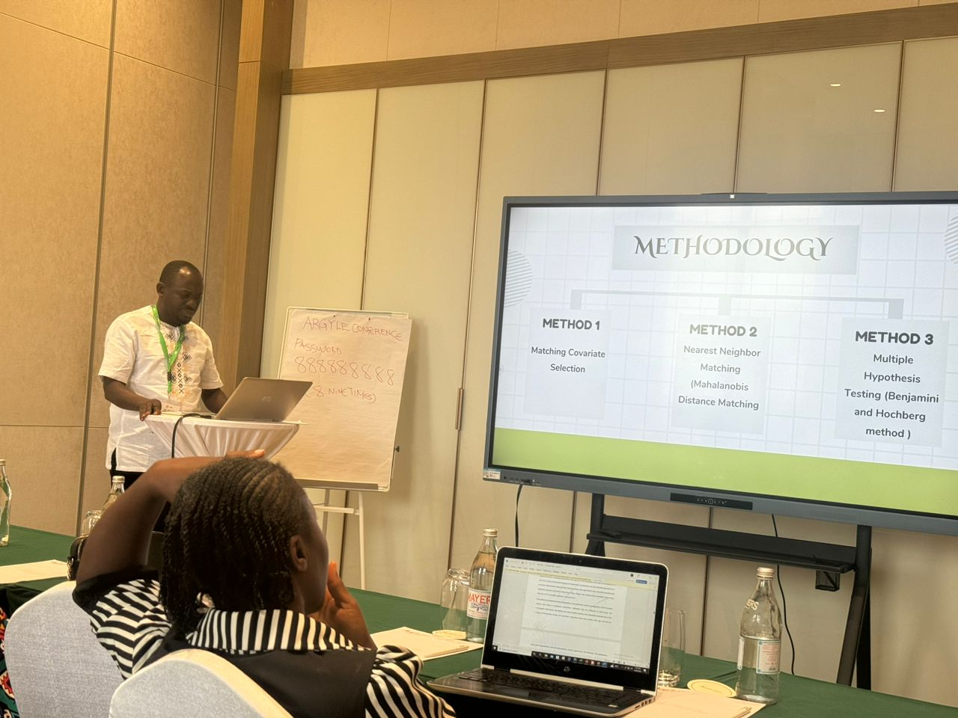

*Dr. Peter Babyenda presenting in Nairobi*

**Dr. Nicholas Kilimani:** Dr. Kilimani and his project team comprised of Eng. Domnic Mucunguzi, Mr. Nathan Mununuzi, and Mr. Jordan Ssemwanga participated in technical meetings for their project titled "Solar-Powered Irrigation Systems for Resilience to Climate Change: An Economic Viability Analysis." This multi-country research initiative aims to explore the feasibility of solar-powered irrigation systems in enhancing agricultural resilience to the impacts of climate change. His presentation showcased the potential of this innovative approach to address pressing environmental challenges while improving the sustainability and productivity of agricultural practices across diverse regions.

**Mr. Gyaviira Ssewankambo:** Support Staff from the entire EfD Network receivedcapacity building through interactive sessions by UGOT. The workshops mainly focused on quality assurance, timelines, budget and financial templates, as well as Centre audits.

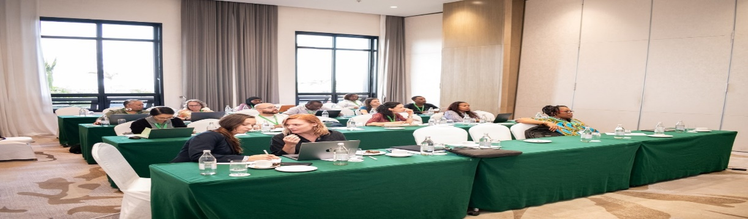

EfD Support Staff *during a session*

**Policy Impact Award**

In exciting news, the EfD Uganda team, led by Prof. Edward Bbaale, were Runners-Up for the prestigious EfD Policy Impact Award for their impactful paper on “Policy Options for Clean Cooking and Reduced Biomass Dependency."

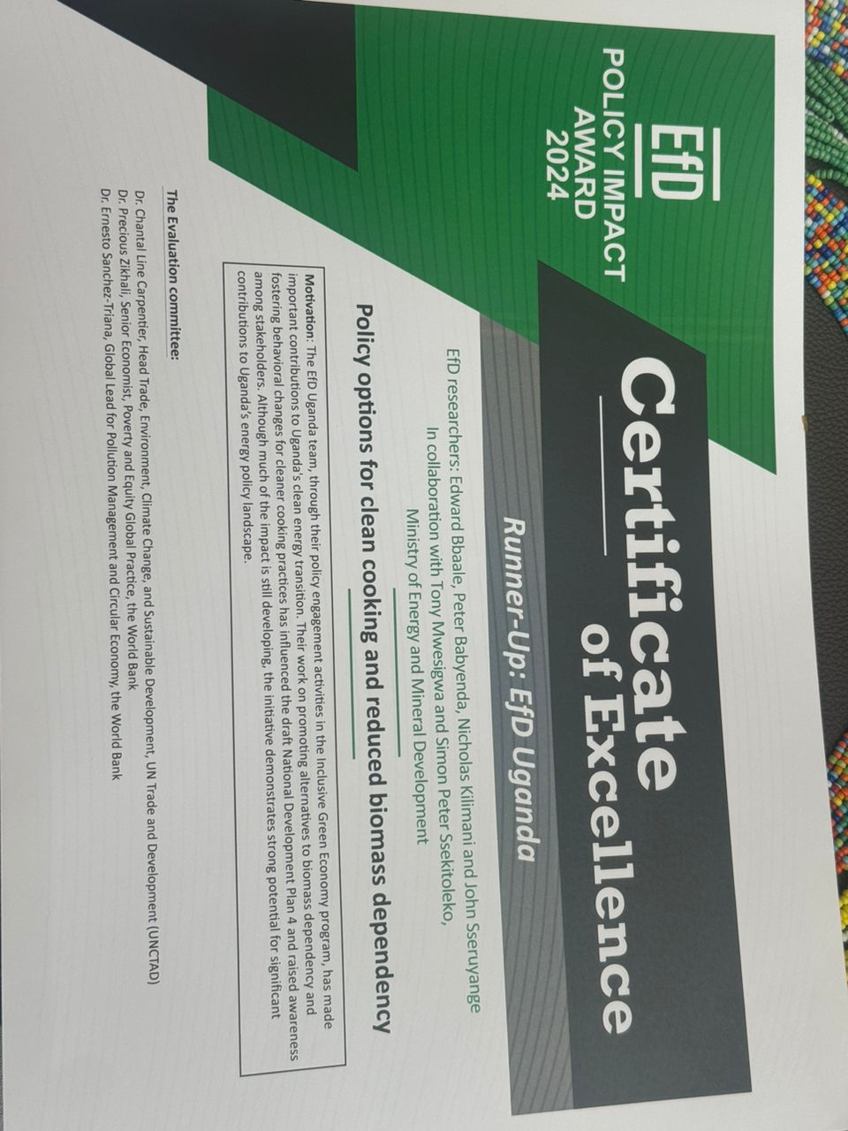

**Conclusion, Key Takeaways and Recommendations**

The 18th Annual Meeting of the Environment for Development (EfD) network, held in Nairobi, was a highly successful event filled with learning opportunities, valuable networking, and the potential for future collaborations. The EfD-Mak Centre appreciates the efforts of colleagues who submitted proposals and papers, and we congratulate Dr. Lwiza and Dr. Kavuma for presenting proposals. These proposals keep the Centre running. From our analysis, in comparison to other centres, we still have allot of work to do in mobilizing our research fellows to always submit as many papers as possible once the call is out. We thus, recommend that the two Centre put in place measures to ensure that the Centre directors are active and always submit papers for consideration even though they are not sponsored by EfD. We also recommend the appointment of collaborative leaders and co-leaders as a way of further helping in mobilizing researchers and thus make the Centre more vibrant.