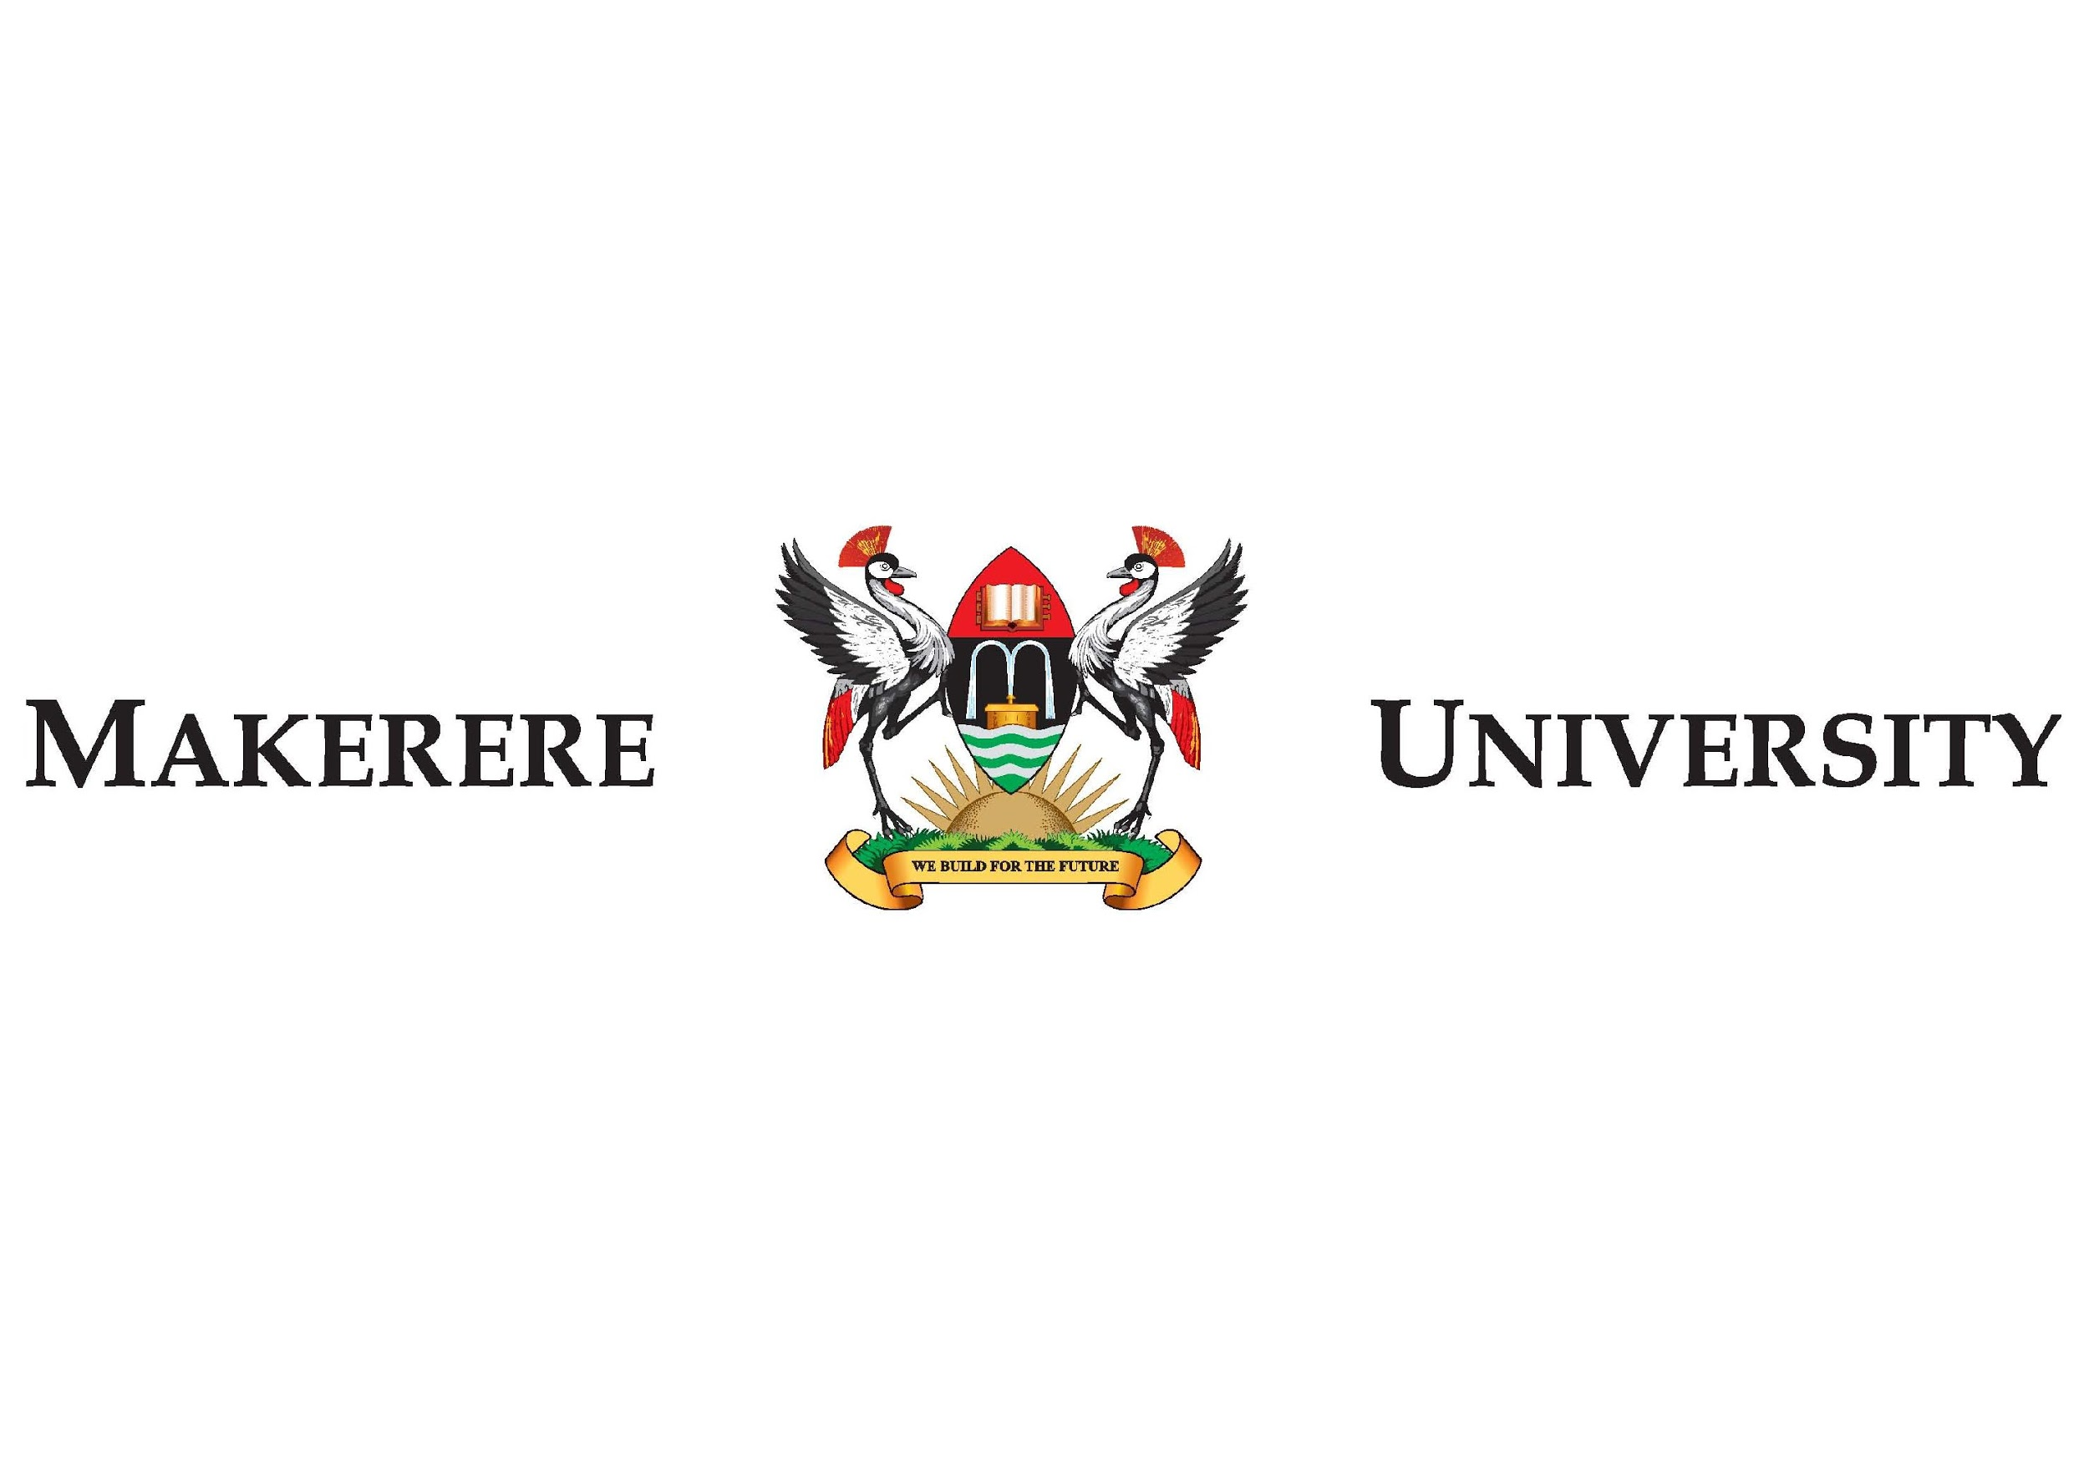

**SPEECH BY THE CHANCELLOR, PROFESSOR EZRA SURUMA**

**AT THE VICE CHANCELLOR’S INSTALLATION CEREMONY**

**THURSDAY, 14th SEPTEMBER, 2017, 2:00PM MAIN HALL, MAKERERE UNIVERSITY**

* **Your Excellency Yoweri K. Museveni, President Of The Republic Of Uganda**
* **The First Lady and Honourable Minister of Education and Sports Mama Janet Museveni**
* **Honorable Ministers**
* **Honorable Members of Parliament**
* **Members of the Diplomatic Corps**
* **Your Lordships the Judges of the Judicature**
* **Religious Leaders**
* **Representatives of Government Ministries, Departments and Agencies**
* **Chancellors and former Chancellors**
* **Chairperson and Members of Makerere University Council**
* **Vice-Chancellor and Members of University Management**
* **Former Vice Chancellors**
* **Vice Chancellors, Rectors and Principals of other Universities and Institutions**
* **Members of the University Senate**
* **Members of Staff of Makerere University**
* **The Media Fraternity**
* **Distinguished Visitors**
* **Students, Ladies and Gentlemen:**

**………………………………………………………………………..**

1. It is a great honor and privilege for me to add a warm welcome to you all to this historic occasion of the installation of Professor Barnabas Nawangwe as Vice Chancellor of Makerere University. In a very special way I wish to welcome Your Excellency the President of the Republic of Uganda and the First Lady and Honorable Minister of Education and Sports, Mrs. Janet Museveni. Thank you very much for sparing time from your demanding schedules to honour this ceremony with your presence. We are most appreciative of your support.
2. Your Excellency, allow me to thank the outgoing Vice-Chancellor Prof. Ddumba Ssentamu, for the successful completion of his term as Vice Chancellor of this great university. I thank him for his farewell remarks that have outlined the achievements of Makerere University over the last five years. I especially want to commend Prof. Ddumba-Ssentamu for continuing to supervise students and teach some Masters classes while serving as Vice Chancellor.
3. Your Excellency, both Prof. Ddumba-Sentamu and I were teachers in the Department of Economics here at Makerere almost 40 years ago. My career as a senior lecturer ended abruptly when late President Obote’s troops came to Mitchel Hall looking for late Joshua Mugenyi who was a lecturer in political science and myself. Our crime was that we had joined a young man called Yoweri Kaguta Museveni to form The Uganda Patriotic Movement. The rest is history.
4. I congratulate Ddumba for staying on and eventually rising to head this prestigious institution. I also thank His Excellency the President for remembering that I lost my position here because I followed him in politics and restoring me back to Makerere University as chancellor. Thank you Mr. President.
5. And now Your Excellency, it is time for a new beginning. I have the duty and honor to congratulate and welcome Prof. Barnabas Nawangwe upon his election and installation as Vice Chancellor of Makerere University. As we have all heard, Professor Nawangwe is a man of vast knowledge, vast experience and vast wisdom. He has distinguished himself in teaching, in college leadership and in administration. He has competed and won a free and fair race to become the chief executive officer of this great institution. Congratulations Professor Nawangwe.
6. As Chancellor, I will do everything I can to support your administration and to promote the good name of Makerere University. I assure you of my unwavering support and willingness to work with your office to ensure that Makerere continues to improve.
7. I wish to recognize the great contribution and support of the Government of Uganda to Makerere University. We thank you very much Honourable Minister and thank you very much Mr. President for your commitment to education.
8. Let me also recognize the enormous contribution of the development partners to Makerere University during the past 5 years. Please continue to invest in the knowledge industry and the future of Uganda.
9. Your Excellency, I thank all the great stakeholders of Makerere University: all members of the Makerere University Council, the Senate, the heads and faculties of all the colleges, the students and the various Staff Associations for the vital roles you have all played in helping Makerere University achieve its vision and mission.
10. Let us all unite to put past pitfalls aside and declare a new beginning in 2017. We look forward to your continued support and cooperation as Prof. Barnabas Nawangwe embarks on his new tenure as Vice Chancellor of Makerere University.

**FOR GOD AND MY COUNTRY.**

1. *It is now my distinct honour and privilege to invite our Chief Guest, His Excellency The President of the Republic of Uganda, Yoweri Kaguta Museveni, to address this congregation.*