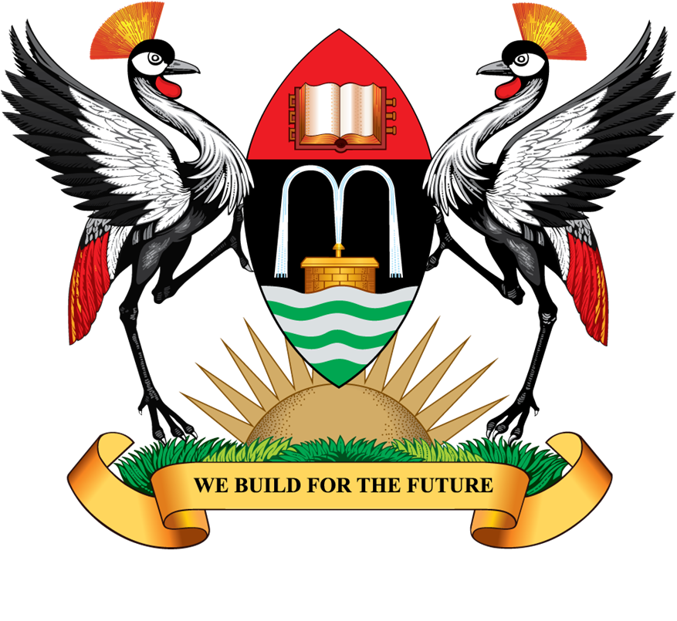

MAKERERE UNIVERSITY

66TH GRADUATION CEREMONY

(Please take note of the Dates when respective Colleges are presenting graduands)

DATE : TUESDAY, 19TH JANUARY, 2016
- College of Engineering, Design, Art and Technology
- College of Agricultural and Environmental Sciences
- College of Veterinary Medicine, Animal Resources and Bio-security
- College of Natural Sciences
- School of Law

DATE : WEDNESDAY, 20TH JANUARY, 2016
- College of Education and External Studies
- College of Humanities and Social Sciences

DATE : THURSDAY, 21ST JANUARY, 2016
- College of Health Sciences
- Makerere University Business School

DATE : FRIDAY, 22ND JANUARY, 2016
- College of Business and Management Sciences
- College of Computing and Information Sciences

Source: Mak, Department of the Academic Registrar, Room 501, Level 5, Senate Building

