**College of Engineering, Design, Art and Technology (CEDAT)**

CEDAT has continued to boost technological education and innovation for Uganda’s Industrialization. The benefits have been realised as many students have produced very interesting prototypes of machines and implements and a few have been commercialised. Graduate students and senior researchers have made innovations with the potential for transformation of our societies, especially the rural communities. The presidential initiative has improved the training of human resources by giving students relevant skills, improved research infrastructure, developed business incubation facilities to support commercialization of student and staff ideas and enhanced the understanding and appreciation of the role of science and technology in the development process, especially among the young generation.

The College has many innovative projects that continue to target human resource development, transfer of technologies to communities, and research to increase production. These projects have the potential to propel Uganda into a real knowledge economy and an industrial world.

The Presidential Initiative programme at CEDAT supports three components

* Modernization of Laboratory Infrastructure
* Support to Industrial training
* Innovative projects

The objectives of the initiative are to;

* Contributing towards increasing and retaining a pool of highly trained professionals with relevant skills in engineering, design art and technology to meet the country’s development needs
* Improve research infrastructure, that is, modern and well equipped physical and online laboratories
* Develop business incubation facilities to support commercialization of student and staff ideas.
* Increase the use of research outputs by the industrial firms and appropriate channels through which firms will become aware of the available skills to propel a technology-led, competitive development process.
* Enhance the understanding and appreciation of the role of science and technology in the development process, especially among the young generation.
* Increase industrialization and modernization through the use of energy efficient systems such as electric vehicles.

**Modernization of Laboratory Infrastructure**

The college has modernized and equipped many laboratories including the online laboratories.

The equipment purchased over the last four years has been used by students and senior researchers to conduct experiments, field work and enable access to information which has boosted the research capacity of the university. The computers purchased have been essential in increasing the ratio of computers to students, which is a key milestone.

The equipping of the laboratories has reduced experiment time for students from 2 hours to 40 minutes.

We can now teach computer numerically programed machining internally without out sourcing it from Kinyara sugar work as it was before.

Congestion in the laboratories has reduced.

The equipment has helped to meet the equipment demand and increase in enrolment of students in the college.

The college has been able to grow student numbers because of the improvement in laboratory infrastructure.

Acquisition of the equipment has helped students and staff to produce better quality work which has enabled our students to win some awards in the region. For example, last year the best architectural design among the schools of architecture in the East African region came from CEDAT. The Matibabu students have also been able to conduct research and win global awards.

**Online laboratories:**

Since 2010, 31 online laboratories have been developed to support several experimentation fields of Electrical and Computer Engineering. These include: basic analog and digital electronics (9), communication engineering (14), renewable energy (2), control systems Engineering (2), Applied digital electronics (2) and Digital Signal Processing (2). The labs are used at Makerere University to support the BSc. in Electrical, Telecommunications and Computer Engineering Programmes, by about 500 students every semester. The iLabs@MAK project has thus improved the laboratory experience of over 1,500 students since 2010. The results are evident in the quality of graduates produced by the college.

**Computer laboratories**

**The college has 6 computer laboratories equipped with over 300 computers and Wi-Fi at the college.**

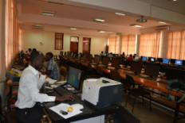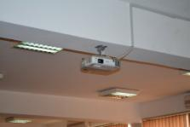

*One of the Computer laboratories Projectors have been mounted in all the classrooms*

**TelecommunicationsLaboratory**

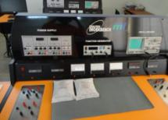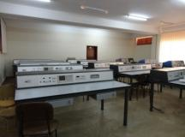

*The work benches have reduced the time of carrying out experiments*

**Surveying Laboratory / Equipment**

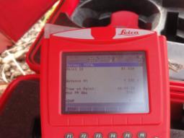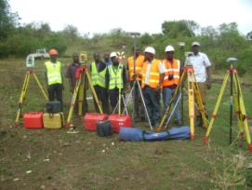

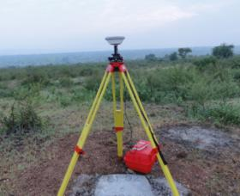

**Public Health laboratory**

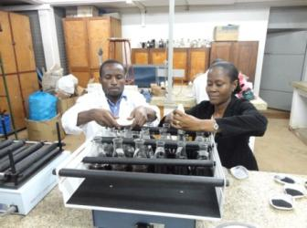

**Environmental Engineering Lab**

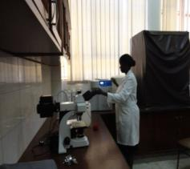

**Solar Laboratory**

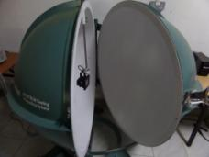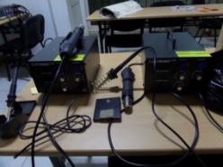

**Fluids Laboratory**

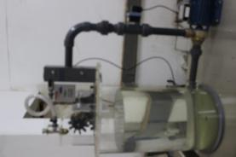

**Mechanical Engineering Training Workshop**

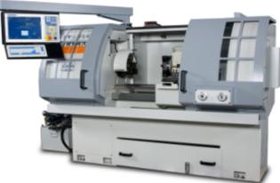 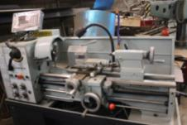

**Thermodynamics Lab.**

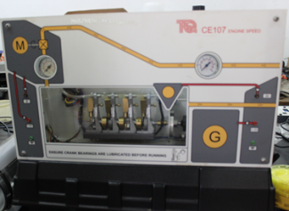

**Materials Lab.**

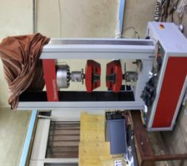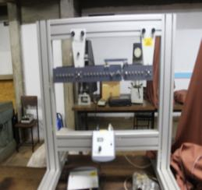

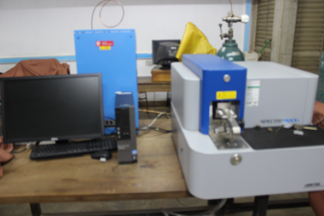

**Industrial Training**

The objective of this component is to support continuing students of the college during industrial training.

All continuing students who carried out field attachment since 2010 have benefited from the fund. About 600 students benefit from the fund annually.

**Innovative projects**

The college has 9 innovative projects under the presidential initiative that have the potential to propel Uganda into a real knowledge economy and the industrial world, these include;

**Irrigation Project,**

The project has been able to design and manufacture affordable pumps which are being used by farmers for irrigation so as to mitigate the effects of unreliable rainfall. This is helping in boosting small holder farmers’ production and improving food security in Uganda. The project is working with tea growers in Kyenjojo to test the pumps. Others farmers that have benefitted from the research include those in Wakiso and the Eastern districts of the country. The researchers are continuing to do research in solar driven pumps so as to reduce the cost of irrigating fields.

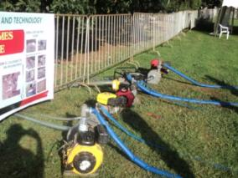 

**MakaPads**

For many girls in the rural areas, menstruation means no school. MakaPads are used to meet this need by providing an effective low cost protection to the girls. The pads are made out of papyrus and paper waste. For many schools, in the rural areas, these pads are given out for free or at 50% less than the cost of the imported sanitary towels. This has helped keep the girl- child in school.

The project is implemented alongside UNHCR. This has economically empowered the women living in the camps especially those living with HIV. These women are employed in the various production factories within the refugee camps.

Some of the schools that benefited this year include Nakanyonyi Girls School, Wairaka College, Wanyange Girls Jinja and Jinja Secondary School. The project distributed MakaPads in 30 UPE schools per district benefiting 100 pupils per school and each received a pack of 12 packets and a pair of panties. In Soroti district, Eastern Uganda the schools that benefited included, Awoja, Owalei, Moruapesur, Soroti Islamic, Pioneer, Nakatunya, Oderai & Bamba Primary schools. In Oyam district, Northern Uganda the schools were Kamdini, Obang, Omwa Dem, Aleny, Aminormir, Barmwony, Ayomapwano & Oyoe Primary schools.

Over 200 schools have benefitted since 2010.

The research for MakaPads has progressed into designing of the Maternity Bed Pads. These have been tested in selected hospitals and maternity clinics namely; Mulago Medical Centre Kitebi, Lions Medical and Laboratory Services in Kitebi, Kagoma Maternity clinic, Makindye Medical Centre, Cure Medical centre Salaama and in Wakiso district. The distribution of Maternity Bed Pads will be continuous for more months to evaluate the performance of Bed Pads.

**Community Wireless Resource Centre**

The Community Wireless Resource Centre (CWRC) arose out of the need to provide or enhance sustainable Internet connectivity infrastructure, particularly in rural or under-served areas in Uganda, by means of wireless technology. The CWRC has focused on the potential of cognitive “smart” radio in promoting affordable connectivity and effective radio resource utilization. The research is focusing on wireless communication networks and techniques with the selected modules/topics.

**Centre for Technology Design and Development (CTDD)**

The Centre for Technology Design and Development is a Technology Development and Transfer Centre. Its role is to develop capacity in technical, socio-economic, cultural and political aspects of technology transfer from other countries to Uganda, and also within different parts of Uganda. CTDD plays the roles of coordinating technology development and transfer activities in the college.

CTDD is also the college’s student incubation centre.The centre has nurtured students’ innovations into profitable and fruitful business enterprises. The center provides funds to students in the final year of their study to do research and or construction of projects. Some prototypes have been tested in the communities of Nakasongola. Projects like solar fruit driers, maize shredders, peddle washing, wind turbine have been deployed to help the rural communities. The idea behind students’ projects is to provide community based solutions. The next level of the project is commercialisation of the student prototypes.

**Innovation Systems and Clusters Programme**

Innovation Systems and Clusters Programme- Uganda (ISCP-U) is part of the East African regional Pan African Competitiveness Forum, (PACF-EA), which in turn forms part of the continental Pan African Competitiveness Forum (PACF) that comprises of all cluster programmes in Africa. The Competitiveness Institute (TCI) is the International umbrella organization that brings together all continental fora (including the PACF), that nurture competitiveness through clustering processes.

This programme is one of the various initiatives that focus on competitiveness for SMEs through innovation and cluster approach. It aims at making Uganda’s businesses more competitive locally and globally, through innovations and cluster initiatives. Under the cluster system, ISCP-U brings together groups of independent firms, collaborating and competing; geographically concentrated in one area, and are specialised in a particular field, linked by similar technologies or skills. The operations of the cluster system are centred on the triple helix as a major driver, which consists of three key players, namely; the Government, the academia/universities and the private sector, including businesses especially Small and Medium Enterprises (SMEs). Innovative cluster initiatives are championed by trained facilitators, normally representing each component of the triple helix.

**Academic Records Management System (ARMS) Project**

The ARMS Project is a premier computer systems engineering research and development entity, actively promoting systematic, disciplined and quantifiable approaches toward successful development of high-quality and ubiquitous computer systems. Since its inception in December 2007, the ARMS Project has nurtured patrons for eloquent and rational application of contemporary methodologies, tools, techniques, and guidelines to meet the unique requirements of computer systems in Education, e-Governance, e-Health and e-Commerce.

In its continued effort to meet the information support needs of Higher Education Institutions, the ARMS Project has been incubating home grown computer systems e-Governance, e-Health and e-Commerce by focusing on development of a comprehensive user-centric Academic Records Management System to support the university’s logical and physical academic infrastructure using state-of-the-art technologies and current generation industrial aesthetics. It has also supported the provision of relevant learning experiences for students in the School of Engineering at the University through Project-Based Learning.

**Centre for Research in Energy and Energy Conservation (CREEC)**

The Centre for Research in Energy and Energy Conservation (CREEC) is a research and training centre with a goal of creating capacity in all fields related to renewable energy and energy management especially focusing on the thematic areas of rural electrification, energy for productive use, energy efficiency, household energy and testing services for technologies including bioenergy (cook stoves, fuels, biogas, gasification) solar PV and pico hydro. The aim is to improve the livelihoods of the rural poor through providing alternative cheap energies. The project has extended solar kiosks to rural areas e,g Ntenjeru. The kiosk has rechargable lights which residents hire for just Shs500 per night. The lights are charged using solar panels which are mounted on the kiosk.

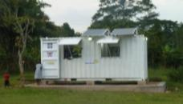

*The solar kiosk at Kabanda, Mukono District*

**Ilabs@Mak Project**

The research project was established to undertake research in the development and deployment of internet laboratories to support curricula in the Department of Electrical and Computer Engineering. This would ultimately address the dearth of conventional laboratories facilities experienced in universities in Africa. The project is implemented in collaboration with Massachusetts Institute of Technology (MIT), University of Dar es Salaam and Carinthia University of Applied Sciences in Austria. Since 2010, 31 online laboratories have been developed; with over 500 students at CEDAT utilizing the iLabs every semester.

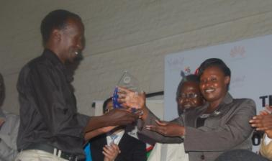

*The patron of Dr Obote College Boroboro receives the winners award during the STIC 2013*.

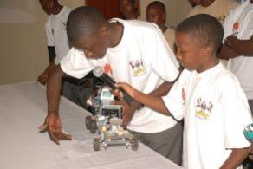

*During the challenge 2013*

CEDAT continues to contribute to technology development, community development and innovative teaching through the above projects and many others. We call upon Government and members of the private sector to support the college in its effort to fulfill its mandate.