**The Food Technology and Business Incubation Center (FTBIC)**

The Food Technology and Business Incubation Center (FTBIC) is a new state-of-the-art center where innovations, knowledge and skills are transformed into viable enterprises. The center is housed at the School of Food Technology, Nutrition and Bioengineering, Makerere University. It targets youths, particularly women and young graduates with innovative science and technology ideas that have commercial potential. 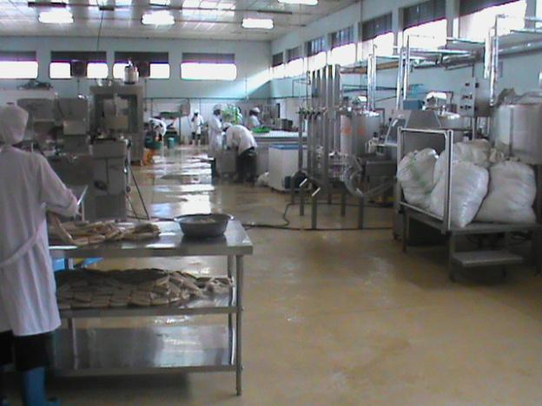

FTBIC state-of-the-art plant at Makerere University Main Campus

**Vision**

Where innovative world class agribusiness enterprises and products are born

**Mission statement**

To nurture and sustain food and allied businesses especially among women and young graduates by providing innovative research, practical solutions, linkages, entrepreneurship development and outreach leading to wealth creation and nutrition enhancement.

The Food Technology and Business Incubation Center (FTBIC) is the first University-based technology and business incubator in the East and Central Africa region.The center, which started as a technology business incubation program, was commissioned in 2009 by the H.E. Y.K. Museveni - the president of Uganda, who is also the Center patron.

FTBIC offers the following services:Processing infrastructure and space, Research and product Development support, Technology transfer, Enterprise Development,Outreach and Skills Development.

**Infrastructure**

The incubation activities have reached an exciting time since the center was officially opened, with tremendous progress on all fronts. The processing units have been equipped to a level that most food processing operations can be carried out. The following process lines are equipped with state-of-the-art technology: meat processing, dairy processing, fruit and vegetable processing, extrusion processing, confectionary and baking. More space and equipment are planned to cover thermal processing and fermentations.

**Research and Development**

The FTBIC as a center for technology development carries out Technology and Food Product Development and value-addition, taking advantage of the research conducted at Makerere University. With this wide array of modern food processing equipment, the FTBIC will continue to focus on developing world class products from locally abundant raw materials.

**Enterprise Development and Outreach**

Young graduates who were admitted to the incubation program with mere ideas have translated and transformed them into businesses that are delivering products which have reached most upscale market outlets and 3 of them have graduated from the Incubator to go and set up their own businesses outside. The project has led to creation of 100 direct jobs in production and marketing of value added foods and has created jobs for over 500 raw material suppliers. The center has also acquired a mobile fruit and vegetable processing plant which is capable of processing the produce from near the farm.

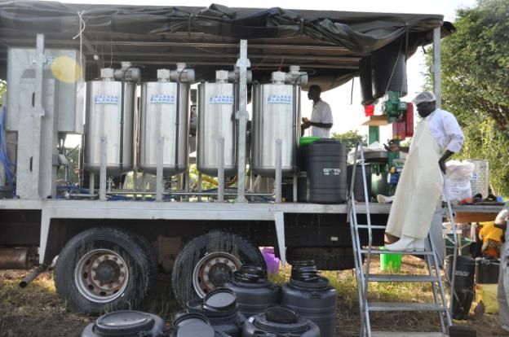

The mobile fruit processing factory in operation in YumbeDistrict

**Hands-on skills Development and Training**

The Food Technology and Business Incubation Center (FTBIC) conducts hands-on training in different technologies and provides mentoring for food processing entrepreneurs through the Skills Training Program for SMEs (STRAP 4 SMEs). FTBIC has engaged a number of virtual incubatees under its Virtual Incubation Program (VIP). This is intended to provide emerging entrepreneurs with on-site and off-site services as they take steps forward and mature in their businesses. Many of the trainees from this program have gone ahead to start microenterprises in food processing and thus virtual incubation forms part of the post-training technical support services.

**Conclusion**

FTBIC is looking at advancing its operations to capture a wider segment of the population in thecountry. Coming up with new strategies will have a bigger impact on the youths by providing leadership and guidance in the area of science, technology and innovation for job creation.

It is also envisaged that the government and the private sector will take advantage of the demonstration provided by the FTBIC to support the innovative enterprise and job creation initiatives taken by the FTBIC and fully integrate technology into thecountry’s industrialization drive.