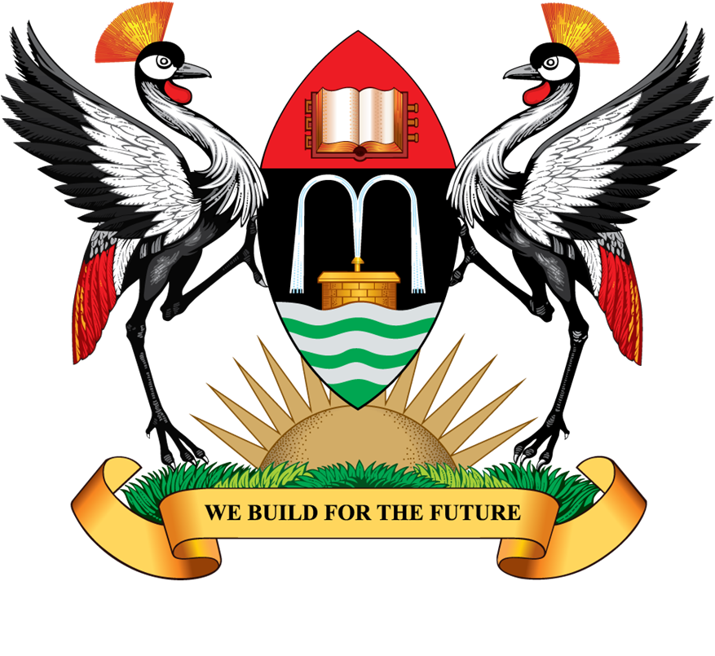

MAKERERE UNIVERSITY

P.O. Box 7062 Tel: (Gen) +256-414-543251

Kampala Uganda

Website: www.cees.mak.ac.ug E-mail: pr@cees.mak.ac.ug

COLLEGE OF EDUCATION AND EXTERNAL STUDIES

ARABIC LANGUGE SCHOLARSHIPS FOR STUDENTS AT MAKERERE UNIVERSITY

The College of Education and External Studies is pleased to announce the availability of 10 scholarships funded by the Kingdom of Saudi Arabia for students wishing to undertake a Postgraduate Diploma in Education (PGDE) with Arabic Language.

The scholarships are for the academic year 2014/2015.

Applicants should hold at least a second class lower Bachelors degree with Arabic Language and at least two teaching subjects.

Closing date for applications: Saturday 30th August 2014.

For further information regarding the application process, please contact
The Chair Department of Humanities and Language Education
Room 1.10
School of Education

