Makerere University Students Scoop Top Prize for the First ever Inter-University Medical Quiz Challenge
What started as a simple idea of uniting the different medical schools in Uganda under one umbrella has turned out a wheel of fortune or rather glory for Makerere University medical students. The idea was brought up by Federation of Uganda Medical Student’s Association and was put into action by Makerere University Medical Students’ Association.
The first ever Inter-University Medical Quiz was held from 31st August – 2nd September 2012 at Makerere University College of Health Sciences. There were four participating universities; Makerere University, Mbarara University of Science and Technology, Gulu University and Kampala International University. Three medical students per university were chosen to participate by their respective Medical Students’ Associations.
The questions asked to the participants were generated by medical students of the various participating universities. They were collected and stored in computers under password. They were reviewed by a team that comprised lecturers from all the different universities and were headed by Dr. Sabrina Kitaka-Bakeera (Senior Lecturer in Pediatrics at Makerere University).
Living up to its name, stature and age, Makerere University College of Health Sciences emerged winners of the quiz.
The theme for the maiden event was based on Non-Communicable Diseases (NCDs), the incidence of which is on a steady rise in Uganda. The motive behind the quiz was to inform the community at large about the incidence of NCDs, the risk factors, complications and preventive measures, while testing and strengthening the students’ knowledge. However, to nurture all-round doctors the quiz also had question rounds on general knowledge, basic physical sciences, logic and current affairs in Uganda.
On day one, all the teams played the first leg of qualifiers which was based on NCDs. On day two, the teams played the second and final leg of qualifiers which was based on general knowledge, current affairs in Uganda, basic sciences and logic. At the end of qualifiers, Makerere University was highest at 480 points, Mbarara University of Science and Technology and Kampala International University had tied at 380 points and Gulu University dropped out at 330 points.
On day three, the semi-finals were played among Makerere University, Mbarara University of Science and Technology and Kampala International University. At the end of semi-finals, Makerere still stood highest at 500 points, Mbarara University of Science and Technology stood at 410 points and Kampala International University dropped out at 400 points.
The finals were then played on the same day between Makerere University and Mbarara University of Science and Technology. At the end of the finals, Mbarara University of Science and Technology stood at 290 points and the winners of the Inter-University Medical Quiz Challenge were the gallant medics of Makerere University after scooping a total of 620 points.
All the participants were awarded certificates as were the mentors of the respective teams. A plaque was awarded to the winning universities. Plaques were also awarded to the team members of the winning team, first runner-up team and second runner-up team. Gifts were given to all the participants.

The quiz was sponsored by Makerere University College of Health Sciences, Medical Education for Equitable Services to All Ugandans (MESAU) Consortium, Nile Broadcasting Services (NBS) Television, Makerere University School of Public Health, Uganda Society for Health Scientists, Widespectrum Enterprises (U) Ltd, Shree Kutch Swaminarayan Temple, Annapurna Sweetmart, Economic Exchange and all the Medical Students’ Associations of the participating Universities.
The quiz show was recorded by NBS Television and will be broadcast in three episodes playing every Thursday starting 13th September 2012.
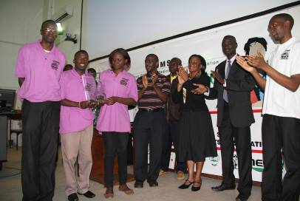
The gallant Makerere University Team receiving the Award for the Winning University.

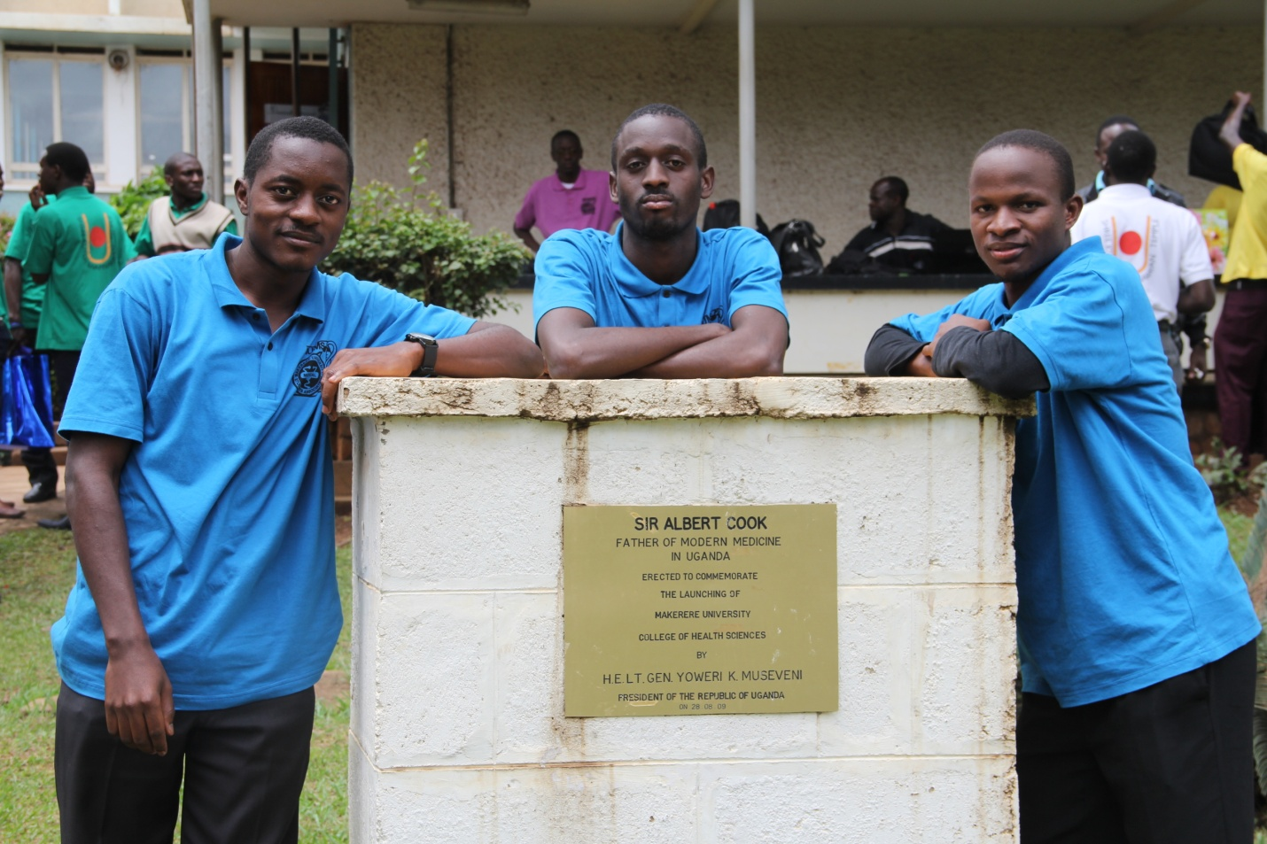

Team Gulu University

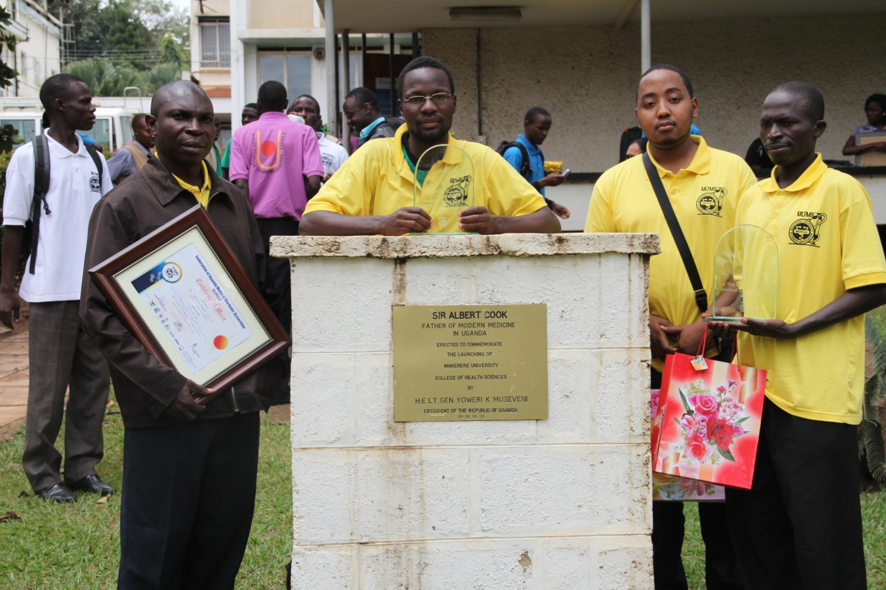

Team Kampala International University

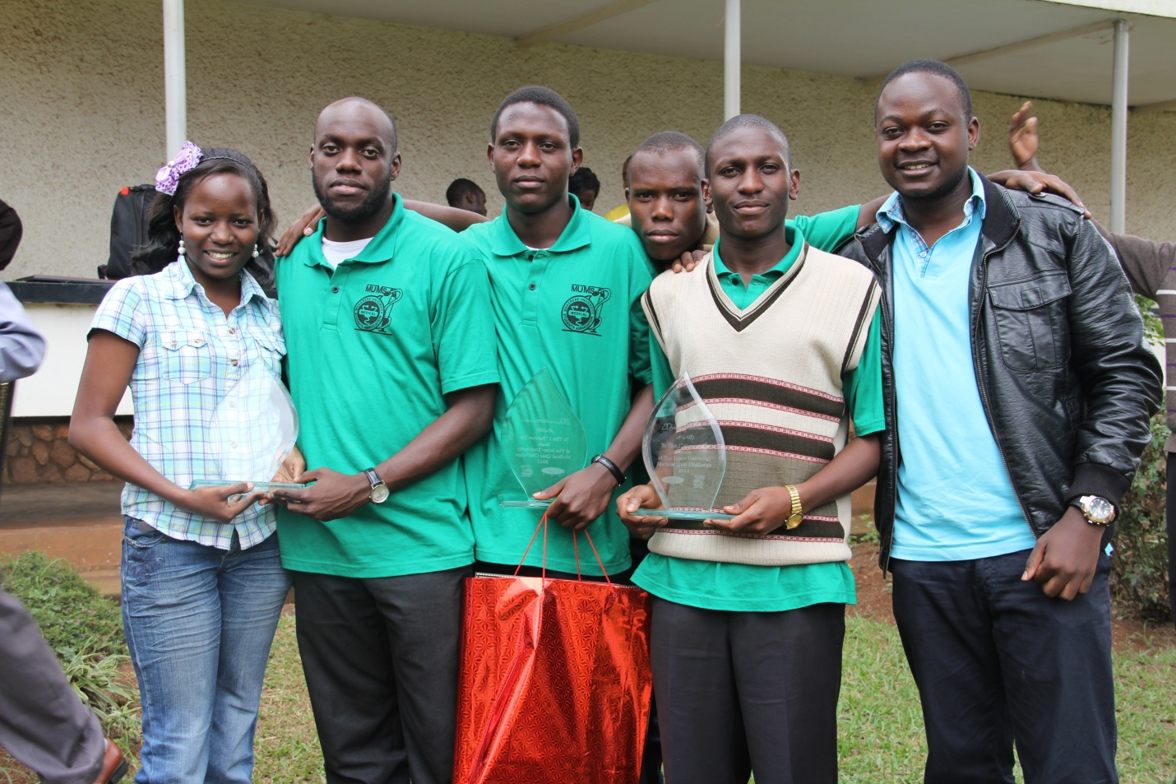

Team Mbarara University of Science and Technology

