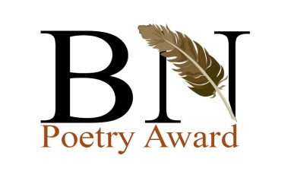

Submit your poetry to the 4th BN Poetry Award. This year’s theme is
MUSIC
Guidelines:
- Ugandan women resident in Uganda and above 18 years can participate. Send up to a maximum of 3 previously unpublished poems to bnpoetryaward@mail.com under the theme of Music.
- Poems should not be more than 40 lines long, typed in Times New Roman, single spaced and sent as one attachment. The second attachment should have the poet’s name, email address and phone number, along with the titles of poems. Do Not submit poems with your names on them.
PRIZES:
- The first three will win an all-expenses paid trip to the Storymoja Hay Festival in Nairobi from 14 to 16 September 2012 and meet some of the movers and shakers of the literary world
- First cash prize, 500 US Dollars
- Second cash prize 300 US Dollars and
- Third cash prize 200 US Dollars
- Poetry journals for the first ten
- The deadline for submissions is May 18 2012.
- For more information, call +256 704355466.

