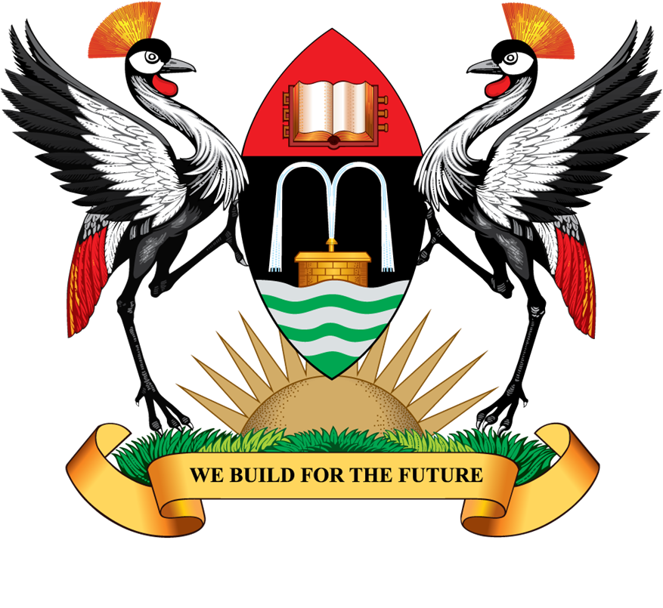

MAKERERE UNIVERSITY

P.O. Box 7062 Tel: (Gen) +256-414-532631/4

Kampala Uganda Fax: +256-414-541068

Website: http://mak.ac.ug E-mail: pro@admin.mak.ac.ug

OFFICE OF THE VICE-CHANCELLOR
PUBLIC RELATIONS OFFICE

Tuesday, November 08, 2011

To: Members of Staff

THE 23RD VICE-CHANCELLOR’S MONTHLY PRESS BRIEFING, HELD ON MONDAY 7TH NOVEMBER, 2011

Introduction
The Acting Vice-Chancellor, Professor Venansius Baryamureeba welcomed all present and thanked members of the media for consistently reporting about Makerere’s research and innovations. The College of Agricultural and Environmental Sciences (CAES) and the Makerere University Printery participated in the media briefing.

In attendance were:
- Professor Venansius Baryamureeba – Ag. Vice Chancellor
- Professor Samuel Kyamanywa – Principal, CAES
- Mr. John W. Wabwire – Director, PDD & Secretary, Board of Commercial Units
- Mr. Joseph Kirabo – Manager, Makerere University Printery
- Professor John Stephen Tabuti – Department of Environmental Management, CAES
- Dr. Lukman N. Mulumba, Department of Agricultural Production, CAES
- Ms. Ritah Namisango – Ag. Senior PRO, Public Relations Office
- Ms. Betty Kyakuwa – Communication Officer, CEDAT
- Ms. Jane Anyango – Communication Officer, CAES
- Ms. Hasifa Kabejja – Communication Officer, CHUSS
- Ms. Harriet Musinguzi – Communication Officer, School of Law
- Ms. Marion Alina – Assistant Communication Officer, Public Relations Office
- Mr. Elias Tuhereze – Web Administrator, Public Relations Office
- Mr. Mark Wamai – Web Manager, Public Relations Office
- Mr. Issa Agaba Mugabo – Brand and Marketing Manager, Public Relations Office

PRESENTATIONS
- Presentation from the Vice Chancellor

  - Makerere University is Preferred Institution outside South Africa
As a result of being consistently ranked among the top 10 best Universities in Africa for a period of over one year and half (1.5 years), Makerere University has become the preferred institution in Africa with exception of Universities in South Africa for partnerships/collaborations. This has led to increased research funding to the University. For example the School of Public Health in the College of Health Sciences now has 47 funded projects and the same school has submitted more proposals.

Currently Makerere University has an approved policy of 15% overhead on all funded projects but most of our funders have rejected provision of any overhead. Our strategy as a University to begin discussions with the funders to ensure that we introduce a negotiated overhead ranging from 1% to 50% on all projects, to go towards funding the University budget. The average overhead charged by the Universities in the USA is 50% and this contributes more than 80% of the University budget.

This is one of the possible ways of how Makerere University can raise its budget from approximately US$ 50 Million to over US$ 200 Million in order to be in the same range with other leading Universities in the region like University of Nairobi and Dar es Salaam University in terms of funding. We all know that quality has a cost—and quality higher education is not cheap.

  - Makerere University to Specialize within Disciplines
Makerere University was established in 1922 as a humble technical college. By 1935, it had expanded to become a centre of excellence in Higher Education in East Africa and later transformed into the University of East Africa on 29th June 1963 with three campuses at Makerere, Nairobi and Dar es Salaam. On July 1, 1970, Makerere became an independent national university of the Republic of Uganda and so did Nairobi for Kenya and Dar es Salaam for Tanzania.
The Islamic University in Uganda, IUIU was the 2nd University to be established in Uganda. IUIU is a subsidiary organ of the Organisation of the Islamic Conference (OIC), a body that represents fifty-seven member countries from Asia, Africa, Europe and South America. The university is located on the out skirts of Mbale town eastern Uganda with 3 branches in Kampala, capital of Uganda (Kampala campus-Kibuli and Females’ campus-Kabojja) and Arua district in northern Uganda (Arua campus). The Mbale campus is the main and the first campus established in 1988 following the 1974 OIC decision to start an Islamic University in Uganda for the English speaking member countries of the OIC.
It was not until 1989 that Uganda established the 2nd public University, Mbarara University of Science and Technology and the 3rd University in Uganda. Mbarara University of Science and Technology (MUST) was established in 1989 following a statute of the National Resistance Council, the then legislative body in Uganda. This was in response to government’s realization that higher education was a critical asset for nation building, at a time when Uganda’s economy and social infrastructure had collapsed, due to civil wars in the 1970’s and 1980’s.
Thereafter several Universities have been established. Today we have over 26 Universities. As result Makerere University cannot continue to operate as if it’s the only University in Uganda, i.e. we cannot teach everything. We have begun a process that is going to see us specialize within disciplines by the beginning of the next academic year.
An academic programme in a discipline shall not cover all the sub-disciplines. This will in a way allow for example all public Universities to have B.Sc. in Computer Science but each University’s programme will have a different focus.
Again in some areas, such as languages Makerere University will no longer teach all languages under the BA (Arts). BA (Arts) programme currently comprises of more than 20 subjects.
Within the region, our fees are low compared to Universities in countries such as Kenya and Tanzania. In addition to charging lower fees, we spread our meager resources thin by offering so many courses/subjects/options within one academic programme, and yet with each course come a teaching cost, teaching materials cost and other costs.
  - Media Week/ Open days
As a University in order to showcase the innovations, the research and the projects being undertaken at Makerere University we are planning a media week in December 2011. During the media week we shall have our 9 colleges and the School of Law showcase their achievements. On each Monday through Friday, we shall have one college show case in the morning and another college showcase in the afternoon.
Some colleges have been having an annual open day. For the College of Engineering, Design, Art and Technology it will have its open day this month as highlighted below:

  - Open Day for Innovations In Science, Engineering And Technology
Makerere University is now operating under the collegiate system aimed at improving service delivery, promoting efficiency and creating centres of excellence, research and innovations in the respective academic disciplines.
The College of Engineering, Design, Art and Technology (CEDAT) is a renowned centre of excellence in the area of technology. The students and lecturers of the College have been involved in research which has greatly contributed to the promotion of the University’s mission-To provide world class innovative teaching, learning, research and services responsive to national and global needs.
On November 18-19, the College will hold a Student Open Day to showcase this research and innovations to potential investors, the private sector, industrialists, and the general public with an aim of attracting the business community to partner with us to turn these brilliant ideas into commercially viable enterprises.

The Government of Uganda earmarked Shs25billion to support research and innovation in the University over a period of five (5) years. The college will therefore also exhibit about ten (10) research projects that have been supported by the Government of Uganda under the Presidential Initiative.

Some of these projects include the Vehicle Design Project, and on Tuesday 1st November 2011, we witnessed the first official test drive of the Kiira EV. In addition, ground breaking innovations like the MakaPads are ensuring that students in rural Uganda have access to free sanitary towels.

Other projects include: the Low Cost Irrigation Project; The Community wireless Resource Centre Project with centres in Kabale and Nabweru; The Academic Records Management Systems (ARIS) Project, which is working with the Academic Registrar; and soon, the University will no longer incur costs on software maintenance.

CEDAT will be joined by the College of Agricultural and Environmental Sciences (CAES) and the College of Veterinary Medicine, Animal Resources and Bio Security (CoVAB) in this exhibition. All these units are beneficiaries of the Presidential Initiative.

- Presentation from Secretary Board of Commercial Units

Makerere University Printery unveils Xerox Security Printing Digital Colour 700 Series
In 2008, the Makerere University Council approved and rolled out a ten (10) year strategic plan. In the strategic plan, the University re-defined her core business as providing teaching and learning, research and services responsive to national and global needs. The University envisioned herself as being the leading institution of academic excellence and innovations in Africa.

Printing is one of the services provided by the University. On Friday 28th October 2011, the University launched state-of-the-art digital facility in the name of Xerox security printing digital colour 700 series. With the acquisition and launch of this facility, the University has unlocked the security printing market in Uganda. This is in line with the change in consumer behavior; preferring fewer print quantities given the revolution of electronic media.

What makes this development remarkable is that unlike in the past when such developments were underwritten by donors or development partners such as NORAD, EEC-EU, Japan Cultural Grant through the Japanese Embassy, and the Federal Republic of Germany, this time round this was made possible by the use of the Printery’s internal resources. The value of the investment was US$200,000.

This facility has unique capabilities and therefore the University Printery is now in position to print tamper proof documents such as Degree certificates, land titles and trading licenses. With this facility, the Makerere University Printery will live up to its billing as “The Home of Secure Quality Printing.”
The Makerere University Printery is also making arrangements to forge partnerships with international publishing houses to enable Makerere University academic staff to publish in good journals.

The advent of the Internet in the 1980s and its successive growth over the last three (3) decades has revolutionized the computer and communications world. This has created virtual marketing and communication frontier. This frontier has led to newer innovations like social networking, a completely distinct world of its own with millions of citizens. These developments led to a new brand of consumers whose digital world gave rise to inventions like E-stationery, E-books, E-magazines, and a whole new host of electronic material. These digital revolutions thus made Digital Printing the number one choice for any printing facility so as to remain competitive.

This change in consumer behavior has given rise to the preference for smaller, rather than bigger quantities of print as was the case last 5 - 10 years ago. As a result, many machines have been left idle, and of late so many firms have cut their printing budgets by half. The move has reduced the cost of doing business for customers but increased the cost of doing business for the managers of conventional sheet fed printing technology. The future therefore belongs to Digital Printing, and as published by the East African Printing & Packaging magazine 2011 on a survey done in the United States, the Digital Printing industry is growing at 25-30% per year compared to the conventional sheet-fed printing technology that is growing at less than 15%.

- Presentation from the College of Agricultural and Environmental Sciences (CAES)

3.1 Makerere seeks new anti-HIV therapies, medicinal plants’ conservation
Makerere University under the umbrella organization of the Inter-University Council for East Africa (IUCEA) has embarked on a new project aimed at producing drugs to alleviate HIV/AIDS in East Africa.

The three year project titled “Value chain analysis and development of plant-derived medicinal products for management of HIV/AIDS in the face of climate change in the Lake Victoria basin” is supported by the Swedish International Development Cooperation Agency (SIDA) and is implemented by the Inter-University Council for East Africa (IUCEA), through the Lake Victoria Research Initiative (VicRes). The project has a budget of USD$600,000.

This project is going to determine and evaluate plants to produce new anti-HIV therapies. And because plants, the sources of traditional medicines, are threatened, this project will also research, demonstrate and promote plant conservation.

This is a regional project with partnering universities in Uganda, Kenya, Rwanda and Burundi. The project is headed by Prof. Philip Aduma of Maseno, Kenya. Professor John Tabuti, an ethnobotanist, of Makerere University College of Agricultural and Environmental Sciences is leading the Ugandan team.

3.2 Soil Health Research key to unlocking African Green Revolution
Makerere University College of Agricultural and Environmental Sciences with funding from the Alliance for a Green Revolution in Africa (AGRA) has embarked on training soil scientists for Uganda and Rwanda who can help in steering the African Green Revolution and other emerging issues related to land degradation.

This follows the decline in the intake of students into soil science courses that have left a deficit of human resource in soil science. Evidence reveals that jobs that require skills in soil science and management are allotted to people in other disciplines due to the scarcity of soil scientists.
The three year project titled, “Building Capacity for Soil Health Research and Development in Uganda”, commenced in June 2010 and will cost US$781,994. The project is being implemented in collaboration with other AGRA funded institutions including NARO, Africa 2000 Network, Millennium Villages Initiative and the Regional Universities Forum for capacity building in Agriculture (RUFORUM).

-----------------------------------We build for the future------------------------------------------

Sincerely: Ritah Namisango, Ag. Senior Public Relations Officer, Makerere University

