[Call for applications]
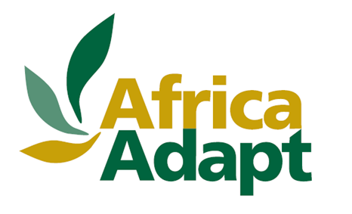
Launch of the 3rd Edition of the AfricaAdapt Knowledge Sharing Innovation Fund

Theme: ‘What knowledge could help strengthen the adaptive capacities of small family farms in Africa?’
The AfricaAdapt network is launching the 3rd Edition of its AfricaAdapt Knowledge Sharing Innovation Fund that promotes local/indigenous knowledge and local knowledge sharing initiatives.
What is the Knowledge Sharing Innovation Fund?
The AfricaAdapt Innovation Fund will offer grants of up to US$9,000 for adaptation activities and original knowledge sharing initiatives, for sharing knowledge about adaptation on a local scale.
During the last 2 years, the Innovation Fund has already funded 15 projects in 14 African countries.
These projects are carried out by researchers, cooperatives and community organisations and the target beneficiaries are those communities directly affected by climate change.
This 3rd call for applications is specifically dedicated to small family farms of the continent in view of their importance in the livelihoods of the continent’s population. This call for applications will provide funding for concrete adaptation activities on the ground to generate new knowledge and to document innovative and promising agricultural practices for Africa.

Why communities first?
Marginalised communities are the first to suffer the effects of climate change. They have valuable knowledge that results from local adaptation strategies and from observing the environment, with which they have a close relationship.
The communities’ contribution to knowledge sharing is essential to strengthen their capacity for adaptation to climate change. Projects supported by the AfricaAdapt Innovation Fund will test adaptation options and ways of sharing knowledge that could be replicated in another context or on a wider scale.

Who can participate?
Civil society organisations, community-based organisations and cooperatives from the African continent are encouraged to submit their project ideas.
Key dates:
The first Call for Applications will be open until 22nd August 2011.

What is the AfricaAdapt network?
The AfricaAdapt network facilitates the sharing and use of knowledge and forges links between various adaptation stakeholders. The network has built a community of interest around the issue of adaptation and a website which now hosts more than 1000 members.
AfricaAdapt encourages innovation in Africa through its various activities, both online and on the ground, with stakeholders, in particular through the Innovation Fund. For more information on the projects that were selected in 2010 for the Innovation Fund, visit our website: http://www.africa-adapt.net/AA/

