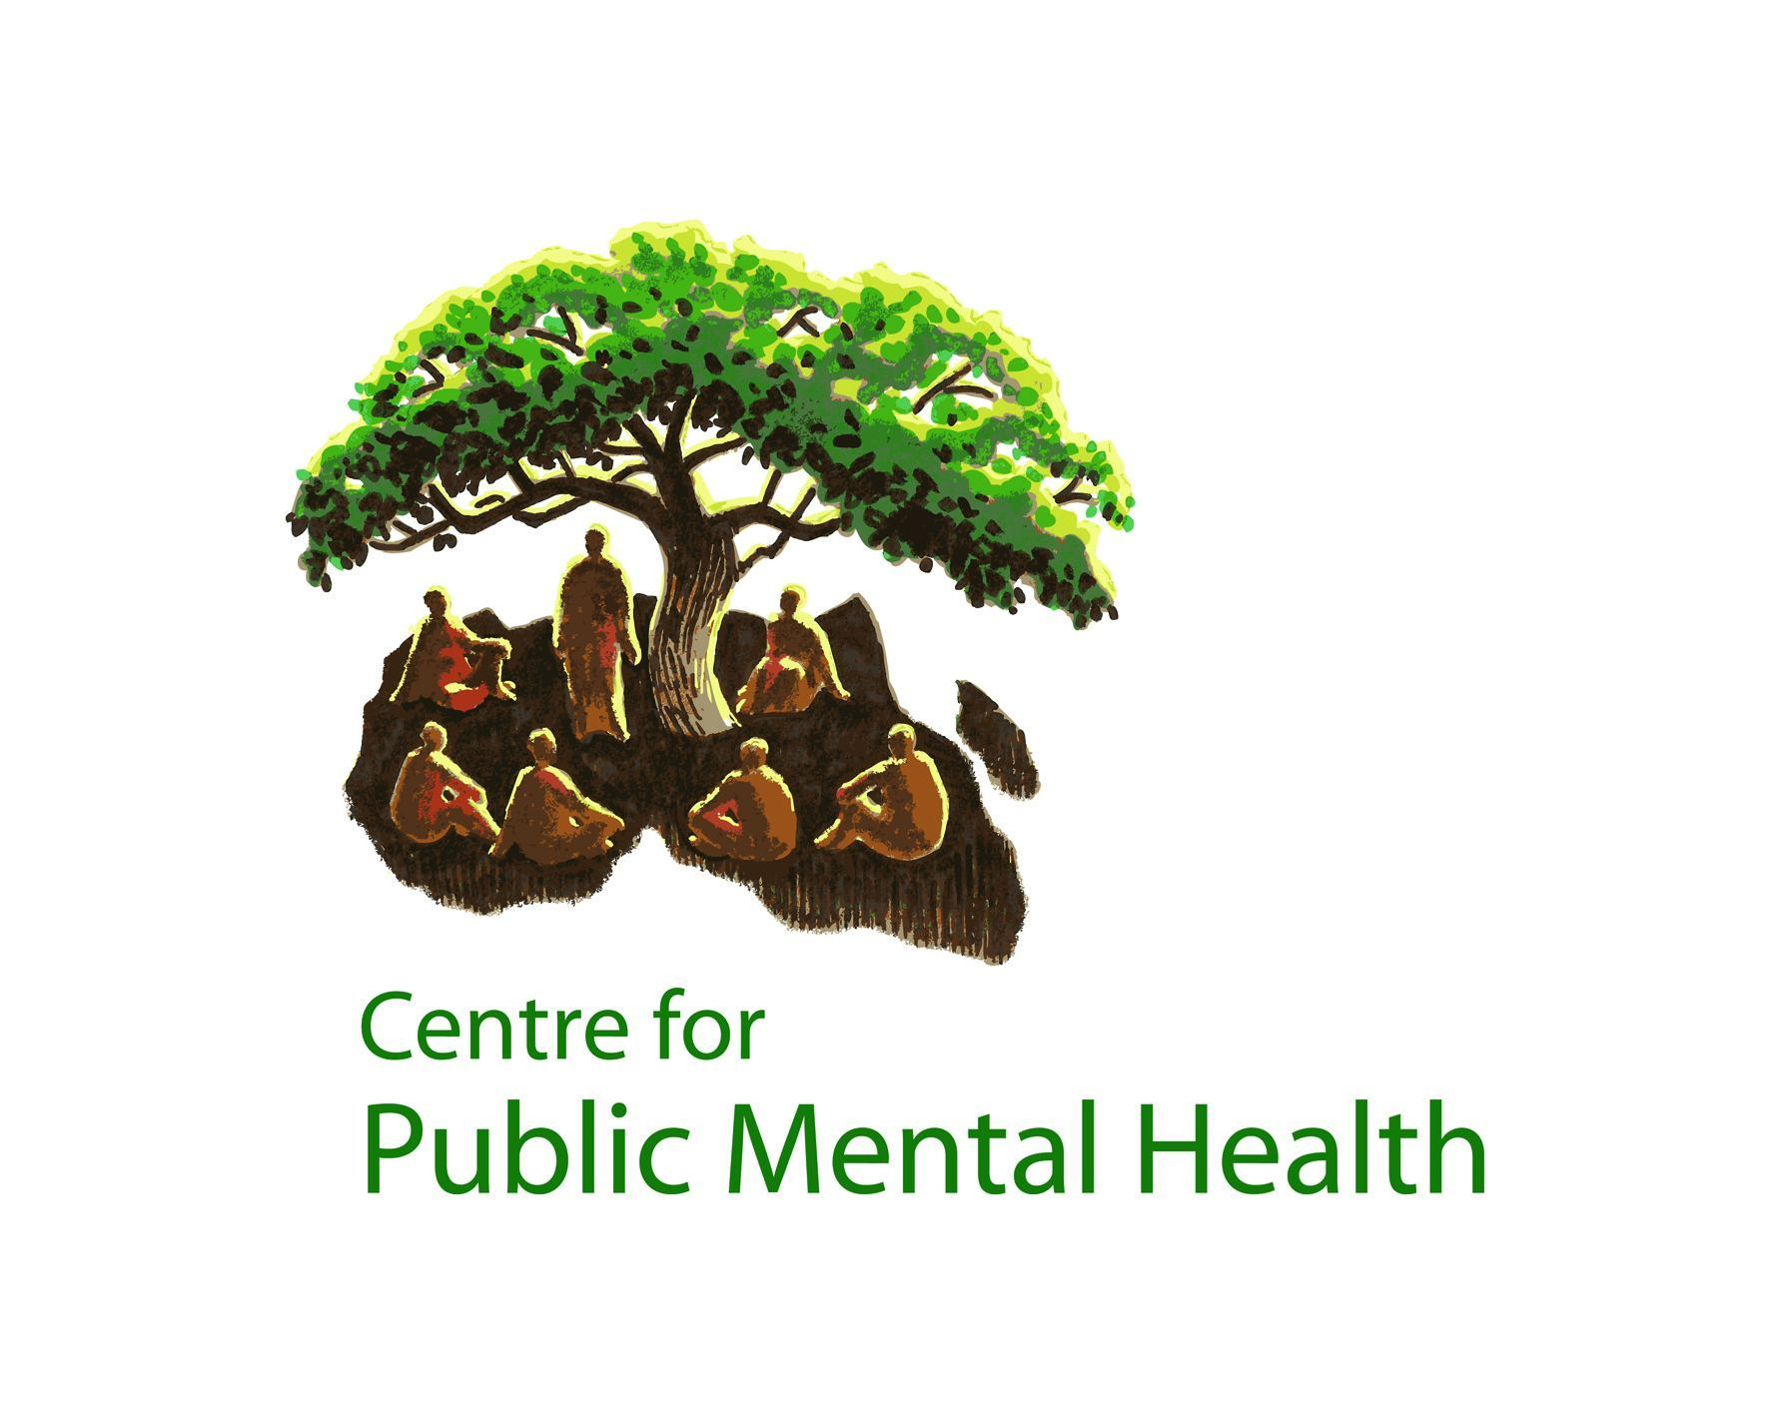

STELLENBOSCH UNIVERSITY

Department of Psychology



UNIVERSITY OF CAPE TOWN

Department of Psychiatry and Mental Health

Strengthening public mental health in Africa

I would be potentially interested in studying towards the PG Diploma or MPhil in Public Mental Health, through the Centre for Public Mental Health in Cape Town, South Africa.*

NAME
EMAIL
ORGANISATION
COUNTRY
WHICH COURSE WOULD YOU BE INTERESTED IN? |  |  |  |  | MPHIL PG DIP
WOULD YOU REQUIRE FINANCIAL ASSISTANCE? |  |  |  |  | YES NO
IF NO, HOW WOULD YOU FUND YOUR STUDIES?

* Please note that this does not constitute an application to the course – it is merely an indication of potential interest in the course, to allow the CPMH to plan course requirements. If you are interested in studying with the CPMH, we will send you an application form in due course.

Thank you. Please return to ereshia@sun.ac.za by 3 June 2011.

