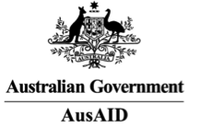
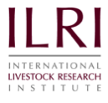
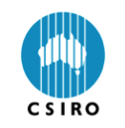
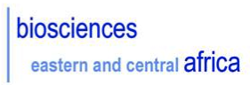
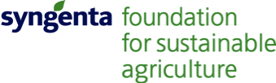

Africa Biosciences Challenge Fund

2011 Research Fellowships
Call for Applications

The Africa Biosciences Challenge Fund is a competitive fund which facilitates access to the Biosciences eastern and central Africa(BecA) Hub at the International Livestock Research Institute (ILRI) for scientists and students from African national research institutes and universities. Fellowships awarded through the Africa Biosciences Challenge Fund support short-term placements for scientists and students from the BecA region to access the world-class facilities and expertise at the BecA Hub at ILRI, located in Nairobi, Kenya.

With financial support from AusAID, the Australian Government's overseas aid program, the BecA Hub is working with Australia's Commonwealth Scientific and Industrial Research Organisation (CSIRO) to build capacity in the African agricultural sciences community. The BecA-CSIRO partnership is offering fifteen fellowships through the Africa Biosciences Challenge Fund in 2011.

The BecA-CSIRO partnership supplements the continuing support of the Syngenta Foundation for Sustainable Agriculture (SFSA), which provides financial support to the BecA Hub to ensure that our facilities are accessible to the African scientific community. We gratefully acknowledge SFSA’s commitment to Africa’s agricultural development through its partnerships with the scientific community and projects with smallholders.

Funding will cover travel, accommodation, stipend and research costs.

We are seeking applicants from the 17 BecA countries (listed below)who have developed ideas for short-term projects (2-4 months) related to food and nutritional security or animal health, to use the advanced molecular biology and bioinformatics capacity available at the BecA Hub. While at the Hub, Fellows will have access to our facilities and receive support from our scientists and capacity building technicians.

Women are encouraged to apply. The projects will be selected on a competitive basis.
BecA Hub at ILRI

BecA is an initiative developed within the framework of the New Partnership for Africa’s Development (NEPAD)/African Union African Biosciences Initiative. Located at and managed by ILRI in Nairobi, Kenya, the BecA Hub provides a common biosciences research platform, research-related services and capacity building opportunities to the region and beyond. The Hub aims to increase access to affordable, world-class research facilities and to create and strengthen human resources in biosciences and related disciplines in Africa. The facility has approximately 10,000 square meters of laboratory and support spaces, including a biosafety level (BSL) 3 laboratory and non-containment and containment (BSL2) plant growth facilities. The BecA Hub has facilities for genotyping, genetic sequencing and analysis, including ABI Genetic Analyzers, a Roche 454 next generation sequencer, and a bioinformatics computing platform. Training is provided in each of these areas as appropriate by dedicated staff (BecA Hub scientists capacity building technicians, SegoliP research-related services unit and ILRI Bioinformatics team).The Hub works with African scientists and their partners from around the globe to address key constraints to African agriculture.

Applicant requirements:
- Working knowledge of English
- PhD or MSc in any agricultural bioscience area
- Currently affiliated with an African national agricultural research program or university
- From one of the BecA countries: Burundi, Cameroon, Central Africa Republic, Congo Brazzaville, Democratic Republic of the Congo, Equatorial Guinea, Eritrea, Ethiopia, Gabon, Kenya, Madagascar, Rwanda, Sao Tome and Principe, Somalia, Sudan, Tanzania, Uganda.
- Completed application form, concept note and curriculum vitae submitted by 10 June 2011 to r.njunge@cgiar.org

Thank you in advance for considering this opportunity. We look forward to hearing from you.



Segenet Kelemu, PhD
Director, BecA Hub at ILRI

