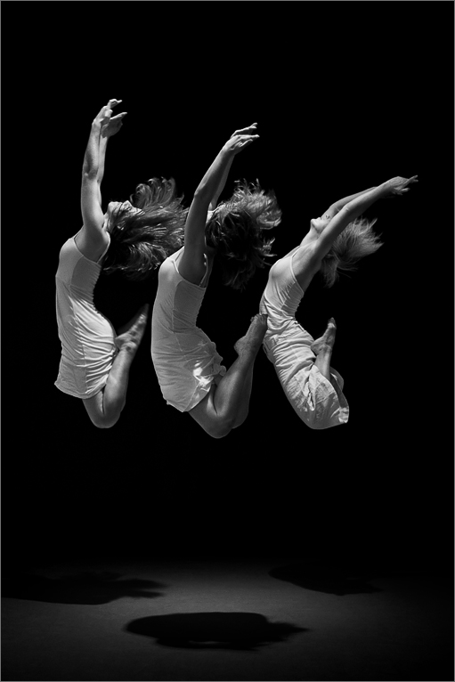
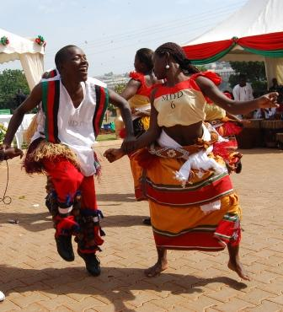

“Together in the art of dance”
March 12th to April 10th, 2011

Together in the Arts of Dance is a collaborative project between the Norwegian College of Dance (Norway) and the Makerere University Department of Performing Arts and Film, which was established in November 2010. From March 12 – April 10, 2010 the Norwegian dance teachers and students are at Makerere University in the pilot program where they will have three activities: 1) Dance Education at Makerere where the Norwegian dance teachers are teaching jazz and modern dances to Ugandan dance students and the Ugandan dance teachers are teaching Norwegian students Ugandan cultural dances. And yet the teachers are teaching each other dance didactic as a way of developing the academic standards in dance performance and education at both institutions; 2) Dance in the Community, where students from both institutions collaborate in a school and community project with Lwagula Aremo Memorial Primary School in Makindye. At the closing of this school and community outreach, the dance students from both institutions will perform with the pupils; 3) Let them Dance, a joint performance where Norwegian and Uganda dance students will perform Ugandan dances, jazz, and modern dance together at Makerere University Freedom Square to crown this year’s Together in the Art of Dance Project.

This project is the beginning of a long time dance education collaboration were we are planning a joint Masters degree in dance, student and teacher exchange, joint research and archiving.

