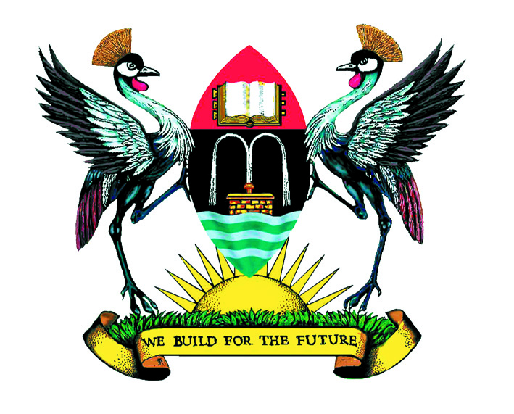

Speech

By

Professor George mondo kagonyera

Chancellor, makerere university, Kampala

At

University Farewell/welcome Dinner

Venue: Serena Hotel, Kampala

Date: Tuesday, 11th January 2011

Rt Hon Prime Minister—Guest of Honor
Honorable Ministers
Outgoing Chairperson and Incoming Chairperson of Council
Vice Chancellor
Deputy Vice Chancellors
University Staff
Ladies and Gentlemen:

Introduction
I am happy to be here at this farewell/welcome dinner for the outgoing and incoming University Council.

My appointment as Chancellor came during the tenure of the outgoing Council. I am therefore specially privileged to commend my brother Mathew Rukikaire and my sister Christine Kiganda for their able leadership of the outgoing Council.

Similarly, I warmly welcome the new council under the leadership of my brother Eng Dr Wana Etyem, Chairperson, and my sister, Dr Katherine Namuddu, Vice Chairperson, and all the Council members.

Some Challenges for the new Council
Hon Rukikaire mentioned a number of achievements of Makerere University during the tenure of the outgoing Council. He highlighted a couple unique achievements, namely:

- the “Kiira –EV” electric car project by the students of the Faculty of Technology;
- Launch of the Makerere University Female Scholarship Foundation and Makerere’s special appeal to Government for UGX 1.5 billion for affirmative opportunity scholarships for girls of Greater Northern Uganda to access university education at Makerere University;
- Launch of the Professor Ali A. Mazrui Endowment Chair and the East African Ali A. Mazrui Center for Global Studies at Makerere University, Kampala.

Our Guest of Honor, Prime Minister Sir, permit me to remark briefly on these special challenges for the new Council. Why? Because I believe these will also open great opportunities for Makerere University.

“The Kiira-EV” Electric Car Project of the Faculty of Technology
I have special attachment to this project as one of its earliest promoters. Not only did I make a personal contribution to the project; but I personally also informed H.E President Museveni, the Visitor, about this project. I am very glad that H.E the President has spearheaded significant Government support to this project and other science and technology innovations at Makerere. May I call upon the new Council to oversee the roll out of the Kiira-EV—the first car ever to be designed and built in Uganda by Engineering students of Makerere University!

Makerere University Female Scholarship Foundation
I was here, in this same place, for the launch of the Makerere University Female Scholarship Foundation on November 20, 2010. I am a keen supporter of the special appeal to Government made by the Gender Mainstreaming Directorate, for UGX 1.5 billion towards affirmative opportunity scholarships for girls from Greater Northern Uganda, to access university education at Makerere University.

In my speech, I challenged Gender Mainstreaming Directorate of Makerere University to raise the bar of women’s scholarship in Africa. I said:
“Makerere can start planning to develop and promote African Women Scholars’ cutting edge leadership in Science and Technology beginning with women from Uganda/East Africa, and then the whole of Africa. This could start by targeted financial development for specialized doctoral and post-doctoral studies, research and fellowships, especially in the Sciences and Technology. The aim should be to grow this into an African Center of Excellence!
Makerere would then publish and disseminate the research, findings and innovations from the African Center of Excellence globally.
In this, Makerere could partner with other world class universities and help engender “knowledge based” economic growth and sustainable development of Africa.”
As Chancellor, I am committed to continuing as “cheerleader” for this possibility at Makerere. I am also willing to ask my alma mater, University of California at Davies, to partner with the Gender Mainstreaming Directorate towards developing this African Women Scholarship Center of Excellence at Makerere--East Africa’s oldest and premier University!

I pledge to work with the new Council for this to become a reality.

Celebrating great Makerere “Ancestors”!
As Chancellor, I presided over the launch of the Professor Ali A. Mazrui Chair Endowment and the East African Ali A. Mazrui Center for Global Studies at Makerere. I performed the ceremony of Mzrui’s “academic enthronement” on the symbolic Professor Ali A. Mazrui Chair.

I wish to re-echo what my brother Rukikaire said and call upon the new Council to finalize the restructuring of the Makerere University Private Sector Forum so as to complete the Mazrui Project as soon as possible.

I would also like to challenge the new Council to pick the cue from honoring Professor Ali Mazrui to continue and celebrate other great Makerere “Ancestors”.

In this regard, I wish to congratulate the School of Education for recently unveiling a bust of Uganda’s veteran educator and two-time Makerere University Vice Chancellor: none other than Professor Senteza Kajubi!

On this note, could I challenge the new Council to plan to honor all past Vice Chancellors, renowned Deans and distinguished Professors of Makerere University?

Why is this important? Because celebrating our glorious past is in order for “great and mighty” Makerere! Celebration of our glorious yesterday will strengthen our resolve for today’s challenges. This will in turn sketch a bright tomorrow at Makerere.

In particular, it will help many of the young members of Makerere Community who might be tempted to be complacent. For it is easy to be complacent if we forget our great Makerere Ancestors whose sacrifices and excellence have gone to make our University the “great and mighty” Makerere!

Celebrating Makerere’s glorious history and “great Ancestors” will help the young members of our Community to remember where and from whom they have come.

Celebrating our past achievements and challenges will help us appreciate that probably the worst is behind us; and that the best is yet to come. It will help us know Makerere’s special and unique legacy in Africa: that our Makerere is the mother of all Universities in East Africa and Central Africa!

And that no other University in Africa has produced so many Presidents, Vice Presidents, Prime Ministers, Chief Justices, Governors of Central Banks, Cardinals and Archbishops, Diplomats, Authors and Scientists, etc., as Makerere University, Kampala!

For “once great: always great” because Makerere’s seed of greatness will never die!

With these few remarks, I wish to congratulate the outgoing Council and welcome the new Council as together WE BUILD FOR THE FUTURE!

