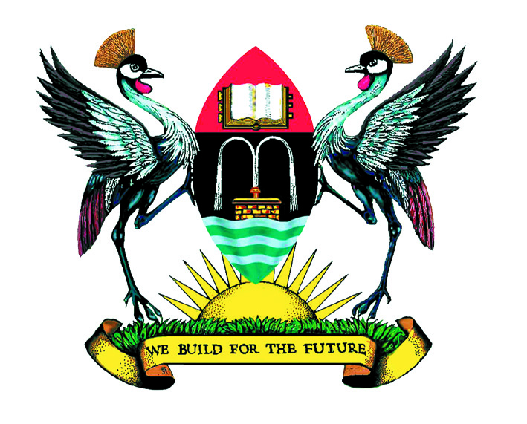

Speech

By

Hon Mathew Rukikaire

Chairperson of Council 2006-2010
Makerere University, Kampala

At

The Dinner to bid farewell to the outgoing council and welcome the incoming council

Venue: Serena Hotel, Kampala

Date: Tuesday, 11th January 2011

Rt. Hon Prime Minister—the Guest of Honour
Honorable Minister of Education & Sports
Chancellor of Makerere University
Outgoing Chairperson of Council and your team
Incoming Chairperson and Vice Chairperson of Council
Vice Chancellor and the entire University Management
University Staff
Ladies and Gentlemen:

Introduction:

First and foremost, I want to thank God for enabling us to enter the New Year. I wish everyone here a Happy and Prosperous 2011!

Second, I want to thank my Vice Chairperson and the entire outgoing University Council Members with whom we have worked tirelessly as a team. All of us deserve the successes we have won because we confronted all the challenges and storms together. Thank you, fellow Council members, and thank you all once again!

Third, I wish to express my profound gratitude to the Government of Uganda for the increased support to Makerere University during our Council tenure. I have no doubt this will continue and expand as my successor, Eng. Dr. Charles Wana-Etyem takes over the leadership of the new University Council 2010-2014.

In this regard, I wish to pay special tribute to our Guest of Honor tonight, Rt Hon Professor Apolo Nsibambi, the Prime Minister, for his friendship and support to me personally and everlasting commitment to Makerere University—our alma mater! Thank you, Prime Minister.

Fourth, I have paid tribute in the past to the staff and student community of Makerere University for their patience and support in maintaining an environment free of strife in the last 4 years that I have been Chairperson of Council. Thank you all once again.

Achievements

We were inaugurated as a Council in 2006 at a very difficult time in Makerere’s history. As many of you may recall:

- This was when MUASA had gone on strike for salary increment;
- Students had joined the MUASA Staff Strike and the University was brought to a stand-still;
- The once “great and mighty” Makerere had a poor image nationally and internationally and had very low rankings of Universities in Africa;
- We received report of management of internally generated funds following allegations of mismanagement
- Makerere Academic Transcripts were a nightmare: it was easier for students to “milk an elephant”—so to say--than receive their transcripts on time!
- And the woes continued.

However, we have made some remarkable achievements together as a Council, management, staff and students of Makerere with active support of Government! For example:-

- The Editorial of the Daily Monitor this past week singled out the very good news about transcripts. That this year’s graduating students will receive their transcripts before graduation! This is a remarkable achievement for Makerere University!
- Makerere’s rankings have greatly improved both continentally and globally
- We approved and have been implementing the Ten-Year Strategic Plan 2008/09-2018/19.
- Approved transformation of Makerere into a Collegiate University
- We have had successful capital and infrastructure developments, e.g., extension to the Main Library; construction of Faculty of Computing and Information Technology; Construction of Faculty of Technology; Construction of Pharmacy Building; etc.
- We have had great successes in ICT including a number of online innovations

Unique Achievements

There are three unique and outstanding achievements of Makerere University I would like to comment on briefly. Two stand out in my mind because I presided over them on behalf Council. The other is the outstanding achievement of innovation in which Makerere University students competed and came top among students from some of the world class universities from all over the world.

- On August 11th 2009 in our famous Main Hall, Makerere University Private Sector Forum launched the Professor Ali A. Mazrui Chair Endowment; and the East African Ali A. Mazrui Center for Global Studies at Makerere University, Kampala.

The Great Professor Ali A. Mazrui himself was in attendance. And the Rt Hon Professor Apolo Nsibambi represented H.E the President.

This was quite memorable for me. It brought back fond memories of my student days in Makerere in the early 1960s. In particular, it was reminiscent of the 1963 installation of late Mwalimu Julius K. Nyerere as the Chancellor of the University of East Africa at Makerere.

I was there that day in the Main Hall as in my capacity as the Guild President of an East and Central African student body at Makerere University at the time!

- The second unique achievement has been this past November 20, 2010 high profile dinner gala for the launch of the Makerere University Female Scholarship Foundation. It was also a “Thank You” Dinner to the Carnegie Corporation of New York for their 10-year support to the Female Scholarship Initiative at Makerere that ended last year. This event was hosted by the University Council. And soon after, we approved the Gender Mainstreaming Directorate.

The special aspect of this second achievement was Makerere’s appeal to Government for UGX 1.5billion for affirmative scholarships for girls from Greater Northern Uganda beginning this academic year 2011/2012.

- The other unique achievement has been Uganda’s first electric car designed and built by the students of the Faculty of Technology! That this came out of an international students’ research competition in which Makerere was the only African University that qualified is quite remarkable!

Not only that, but the original research project was led by none other than the Massachusetts Institute of Technology (MIT), Boston, USA!

This is the “great and mighty Makerere” we know and love!

Words of Wisdom and Experience

Let me pass on some thoughts to the incoming Council, especially to succeed where we failed.

I request the incoming Council to:

- Lobby Government to implement the student unit cost;
- Address the persistent problems of low staff salary scales, low sitting allowances; and the low remuneration of Council
- Enable Council Committees to get out of the “Council Room” and visit some of the resource centers and units to acquaint themselves with the operations of units so Council can make informed decisions
- Provide access to People with Disabilities in all University buildings
- Finalize the restructuring of the Makerere University Private Sector Forum so as to proceed and implement the Professor Mazrui project
- Follow through with the Special Appeal for UGX 1.5billion for Affirmative Opportunity Scholarships at Makerere University for Girls from Greater Northern Uganda.

We build for the future.

Sincerely: Hon. Matthew Rukikaire, Chairperson of Council (Dec 2006-Dec 2010).

