
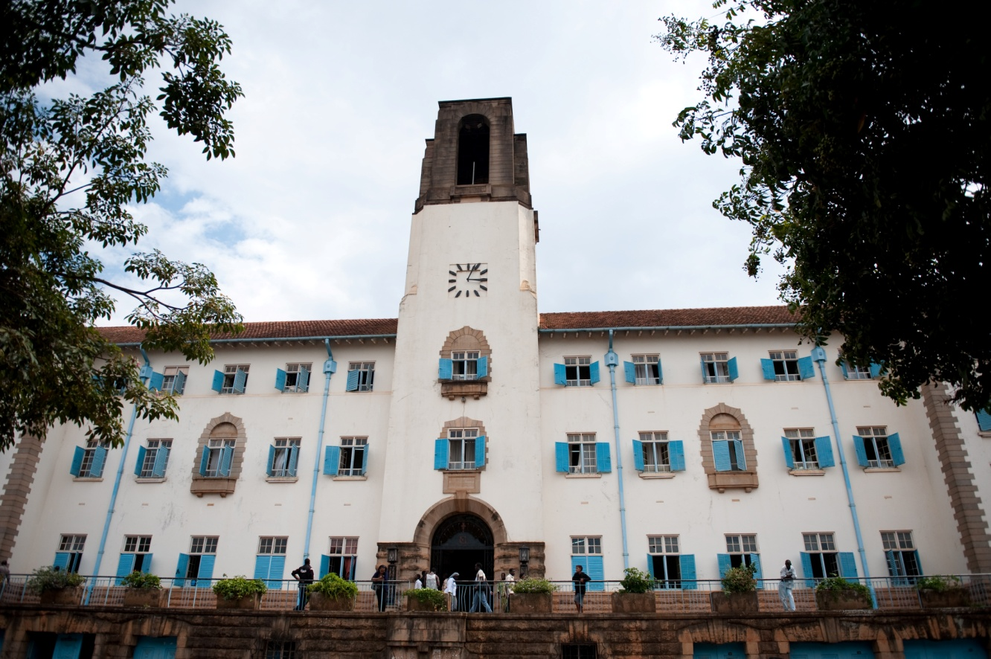

makerere university
We build for the future

Table of Contents

List of Acronyms iv

The Executive Summary v

1.0 Introduction 1
1.1 Rationale 1
1.2 Criteria Used for College Formation 2

2.0 The College Structure 2
2.1 The Colleges 3
2.2 Schools in Transition: 3
2.3 The College of Natural Sciences (CONAS) 3
2.4 The College Of Business and Management Sciences (COBAMS) 5
2.5 The College Of Computing And Information Sciences (COCIS) 8
2.6 The College of Engineering Design Art and Technology (CEDAT) 9
2.7 The College Of Humanities and Social Sciences (CHUSS) 12
2.8 The College of Agricultural and Environmental Sciences (CAES) 19
2.9 The College of Education and External Studies (COEES) 22
2.10 The College of Health Sciences (CHAS) 23

3.0 Cost Benefit Analysis 26
3.1 Qualitative Benefits 26
3.1.1 Administration 26
3.1.2 Financial 26
3.1.3 Professionalism 26
3.1.4 Customer Responsiveness 27
3.1.5 An Efficient and Effective Makerere University 27
3.2 Quantitative Benefits 27
3.3 Cost/Benefit – Net Effect 28

4.0 The Road Map to College Formation 28
Appendix 1 Teaching Learning & Colleges Sub-committee -Terms of Reference 28
Appendix 2: University Models 30
Appendix 3.1 Financial Implications of Administrative Staff 34
Appendix 3.2 Administrative Structure Cost at College fitting within existing Payroll (initial) 36
Appendix 3.3 Financial Implications of Administrative Staff at Colleges 38
Appendix 3.4 Financial Implications of Academic Staff 41
Appendix 4: Implementation Plan 46

List of Tables and Figures

Fig.2.2.0 Structutre of Natural Sciences (CONAS) 4
Table 2.2.1 In Post Staff at CONAS 4
Table 2.2.2 Required Academic Staff Establishment at CONAS 5
Fig.2.4.0 Structure of the College of Business and Management Sciences (COBAMS) 6
Table 2.3.2 Staff in Post COBAMS 7
Table 2.3.3 Required Staff Establishment 7
Fig 2.5.0 Structure of the College of Computing And Information Sciences (COCIS) 8
Table 2.4.1 In Post Academic Staff Establishment at COCIS 9
Table 2.4.2 Required Academic Establishment at COCIS 9
Table 2.5.1 In Post Academic Staff Establishment at CEDAT 12
Table 2.5.2 Required Academic Staff Establishment at CEDAT 12
Table 2.7 Structure of The College Of Humanities and Social Sciences (CHUSS) 13
Table 2.7.1 In Post Academic Staff Establishment under CHUSS 17
Table 2.7.2 Required Academic Staff Establishment in CHUSS 18
Fig 2.8 The College of Agricultural and Environmental Sciences (CAES) 19
Table 2.8.1 In Post Academic Staff Establishment in CAES 21
Table 2.7.2 Required Academic Staff Establishment in CAES 21
Table 2.9.1 In Post Academic staff for COEES 23
Table 2.9.2 Required Academic Staff Establishment for COEES 23

List of Acronyms

FEMA – Faculty of Economics and Management
FTSE – Full Time Student Equivalent
ISAE – Institute of Statistics and Applied Economics (ISAE).
IT – Information Technology
KTP - Knowledge Transfer Partnerships
MTSIFA - Margaret Trowell School of Industrial and Fine Art (MTSIFA).
MUCS - Makerere University College Statute
NCHE - National Council for Higher Education
TLC - Teaching, Learning & Colleges Sub-committee of UFRARC
UDSM - University of Dar es Salaam
UFRARC - University Finance, Administrative, Research Reforms Committee
UOTIA - Universities and Other Tertiary Institutions Act

The Executive Summary
This paper presents the setting for College formation in Makerere University as part of the requirement for submission to the National Council for Higher Education (NCHE) for validation and approval. The present document should be understood under the overarching guiding principle that the College Formation process synthesizes a way of creating an efficient and effective model that structurally, administratively and pedagogically will enhance the management of Makerere University so as to fulfil its revised Vision and Mission as stipulated in its Strategic Plan 2008/2018. Colleges are being proposed under the following assumptions:

- The formation of college is meaningful and this transformation shall provide synergic academic and functional relations;
- The Faculties, Schools or Institutes transforming into Colleges will be more effective and efficient since they will have some degree of autonomy within their institutional frames and will be able to constitute and regulate issues which are peculiar and unique to them in a more timely manner;
- That individuals will have more influence in decision making in administration, finance and in developing programs within their Colleges than it had been before thereby ensuring motivation towards up to date team work approaches in teaching and learning;
- That the synergies created shall provide Colleges with a better scope and environment in sourcing for funds, re-organising themselves, re-branding their academic image and undertaking other activities within their mandate.

Using the Full Time Student Equivalent (FTSE) and Workload analytical model, as well as qualitative cost benefit analysis by comparing re-organised central processes(academic registrar, finance, human resource and library), the initial cost of implementation will mean an additional 27 Uganda Million Shillings to the current budget wage component in the seven colleges. This represents an increment of 0.02% of the total recurrent budget of the University

In essence, therefore, the initial stages of college formation will be budget neutral with regard to administrative processes. Therefore, the structures being presented to NCHE shall enhance motivation of both students and staff through decentralised efficient service delivery and decision making. These structures will also encourage team approach to teaching and learning as well as re-focus the university Vision towards research and knowledge transfer partnerships within the newly established interdisciplinary college units. It should be noted however, the university has undertaken a comprehensive review of academic staff establishment with a view of filling the established position to a 50% level as recommended by the Ministry of Education and Sports Budget Committee. Filling these positions will however be subject to the availability of funds. A summary of the financial implications of academic and administrative positions under the college system is given in table 1.

Table 1: Summary Cost Implications in Uganda shillings
Staff Category | Existing | Restructured | 50% Establishment | 100% Establishment
Academic Staff | 27,294,283,998 |  | 38,660,809,821 | 69,321,044,442
Technicians | 1,052,961,361 |  | 1,614,635,256 | 3,229,270,511
Admin Staff (M-10) Centre | 4,021,513,672 | 2,391,321,514 |  | 3,727,132,463
Admin Staff (M-10) Colleges | 778,385,084 | 2,381,737,630 |  | 3,505,030,578
Totals | 33,147,144,115 | 4,773,059,143 | 40,275,445,076 | 79,782,477,994

Note that restructuring of support and group staff will be in the next phase of the college formation process scheduled for January 2011

1.0 Introduction
"There is no passion to be found playing small - in settling for a life that is less than the one you are capable of living." Nelson Mandela
Makerere University, over the years has been growing both in student numbers, programs, research and outreach. From a humble technical school in 1922, Makerere is now an internationally well known University with a population of about 35,000 students (45% of whom are female). Many of these enrolled following the Government’s liberal reforms in the education sector which lead to a rapid expansion in numbers of private students. The growth in the number of programmes, enrolment and activities dictated that the structure of the university needed to realign its self to be more efficient and effective.
Although the concept of Makerere University’s shifting to the College Model of academic organisation has been in the offing for more than 15 years, the initial impetus for it to take shape was based on the dictates of the University Strategic Plan of 2000/01 - 2006 /07. This was structurally against the backdrop of the phenomenal expansion in the student numbers experienced by the University over the preceding years. The initial breakthrough was the establishment of the College of Health Sciences (CHAS) on a pilot basis in 2007. Implementation of the CHAS has generated experiences and lessons that have informed the new collegiate structure being proposed under the new system of governance.
In the Strategic Plan 2008/09 -2018/19, it is envisaged that the University moves towards becoming a research-led institution. This inevitably calls for major reforms in the University’s governance, financial and administrative structures, with the purpose of making them leaner and more efficient. The Strategic line of action has focused on transforming and re-organising the existing Faculties & Institutes into larger Colleges with a view to improving their efficiency and effectiveness. The latter has continued to be the baseline principles upon which the College formation process has been anchored.
In 2006, Makerere University Council approved the “Makerere University Statute for Constituent Colleges” (MUCS).This, together with the Universities and Other Tertiary Institutions Act 2006 as amended (UOTIA), has provided the guidelines for college formation. The Committee has indicated where there were gaps needing amendments to incorporate new positions and nomenclature.

1.1 Rationale
Having looked at the various models operating in the different parts of the World including those in the region such as collegial, bureaucratic, political and cybernetic among others (See Tianey, 2004 in appendix2); the Committee was convinced that the Collegiate is the most appropriate for Makerere University for the following reasons:
  - It enhances decision making around the notions of efficiency and consensus.
  - Decisions made are honoured in deference to the professional and intellectual competence and authority of the makers, and not through politics, rules and other persuasions (Hamilton, 1997).
  - The benefits of implementing College Formation are greater than the cost of continuing operating under a highly constrained, centralised model.

1.2 Criteria Used for College Formation
The new structure of colleges will utilize a coordinated devolution of powers, utilizing the re-engineered process maps for effective and efficient functionality. The reconfiguration into colleges has utilized the criteria elaborated below for efficacy. The criteria are cognizant of:
- Synergy in mission and objectives of the combining units to promote optimal utilization of the ambient capacities;
- Potential for resource sharing (human, infrastructural) and mobilization;
- Potential for modularization of Academic Programmes, rationalization and elimination of duplications;
- Capacity to form viable college substructures like Academic Boards, Administrative Boards, Procurement committees and Senate as elaborated in the College Statute;
- Baseline Resources:
  - Numbers of students;
  - Number of Programmes;
  - Number and Distribution of Academic Staff;
  - Teaching and office Space;
  - Number of Computer access points;
  - Library facilities;
  - Laboratory space;
  - Other capacity indicators considered by the National Council for Higher Education.

2.0 The College Structure
The proposed college structure will comprise of the College, Schools, Institutes, and Departments. For purposes of this structure, the following definitions have been used.
A COLLEGE A constituent unit of the University consistent with the UOTIA and offers Degrees, Diplomas and Certificates and enjoys Administrative, Academic and Financial semi autonomous status.
A SCHOOL This is an Academic Unit of a College engaged in Teaching, Learning, Research and Knowledge Transfer Partnerships (KTP) based on a focused body of Knowledge.
INSTITUTE This is a unit of a college which is exclusively research based.
CENTRE This is a unit of a college, which is largely focused on service and Knowledge Transfer Partnerships.
DEPARTMENT This is a unit of a school that deals with core functions of teaching, learning and research functions of a particular focused discipline, with at least one programme leading to the award of a degree.

2.1 The Colleges
- College of Natural Sciences (CONAS) ;
- College of Business and Management Sciences (COBAMS);
- College of Computing and Information Sciences (COCIS);
- College of Engineering, Design, Art and Technology (CEDAT)
- College of Humanities and Social Sciences (CHUSS);
- College of Agricultural and Environmental Sciences (CAES);
- College of Education and External Studies (COEES);
- College of Health Sciences (CHAS) is already operational.

2.2 Schools in Transition:
- School of Veterinary Medicine (to access services through the College of Health Sciences);
- School of Law (to access services through the College of Business and Management Sciences).

College of Health Sciences: to align its current structure to the new Colleges’ format.

2.3 The College of Natural Sciences (CONAS)
The College of Natural Sciences is formed out of a merger of eight departments that form the Faculty of Sciences and the Division of Engineering Mathematics originally housed in the Faculty of Technology. Due to scientific uniqueness in the nine departments and the very specific scientific set up, the departments in the CONAS merged to form two schools. The Departments of Botany and Zoology merged to form Department of Biology due to their long standing scientific commonalities.

The departments of Biochemistry and Sports Science merged to form Department of Biochemistry and Sports Science. It is also noted that (1) the rest of the subjects have unique scientific backgrounds and discipline-specific applications with no commonalities (2) The facilities (equipment, chemicals, apparatus) for each of these subjects are different (3) The laboratories for each of these are different:

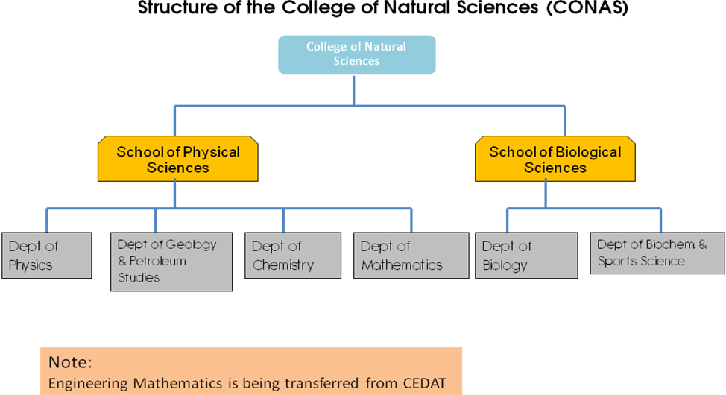

Fig.2.2.0 Structutre of Natural Sciences (CONAS)
Due to reasons stated above and administrative effectiveness and convenience the College of Natural Sciences is composed of two Schools:

- The School of Physical Sciences is composed of:
- Department of Physics.
- Department of Chemistry.
- Department of Geology and Petroleum Studies.
- Department of Mathematics.

- The School of Biological Sciences is composed of:
- Department of Biology.
- Department of Biochemistry and Sports Science.
Table 2.2.1 In Post Staff at CONAS
 | Biochem | Botany | Chem | Geology | Maths | Physics | Sports Science | Zoology | Total
Professor | 0 | 2 | 2 | 0 | 2 | 3 |  | 1 | 10
Associate Professor | 2 | 4 | 2 | 1 | 1 | 0 |  | 3 | 13
Senior Lecturer | 1 | 2 | 1 | 2 | 3 | 1 |  | 3 | 13
Lecturer | 8 | 4 | 8 | 6 | 7 | 4 |  | 7 | 44
Assistant Lecturer | 5 | 0 | 6 | 4 | 6 | 7 | 2 | 3 | 33
Teaching Assistant | 4 | 4 | 4 | 1 | 11 | 5 | 7 | 2 | 38
Curator |  | 2 |  |  |  |  |  | 1 | 3
Total | 20 | 16 | 23 | 14 | 30 | 20 | 9 | 20 | 152

2.2.2 Required Academic Staff Establishment
The option to implements staff increment, in general, has to take into account thresholds already set by the Council under the university Human Resource Policy and it is also subject to the availability of funds.

Table 2.2.2 Required Academic Staff Establishment at CONAS
 | Physics | Geology | Chemistry | Maths | Biology | Biochem & Sports Science | Totals
Professors | 2 | 1 | 3 | 6 | 6 | 2 | 20
Ass. Professors | 2 | 2 | 3 | 7 | 7 | 3 | 24
Sen. Lecturer | 4 | 5 | 10 | 17 | 11 | 5 | 52
Lecturer | 6 | 5 | 10 | 28 | 15 | 10 | 74
Assist Lecturer | 6 | 5 | 9 | 28 | 15 | 8 | 71
Teaching Assistant | 3 | 2 | 9 | 16 | 9 | 5 | 44
Total | 23 | 20 | 44 | 102 | 63 | 33 | 285

2.4 The College Of Business and Management Sciences (COBAMS)
The proposed college is a merger between the current Faculty of Economics and Management (FEMA) and the Institute of Statistics and Applied Economics (ISAE). The rationale for the merger between FEMA and ISAE is mainly demonstrated in the commonalities and inter-linkages shared across their study disciplines and academic offerings.
For a long time FEMA has been facilitating a good number of course units in the ISAE programmes of Bachelor of Statistics, BSC Quantitative Economics and Bachelor of Science in Business Statistics. Likewise, FEMA has a number of Quantitative and Statistical based courses in her programmes, where ISAE has good competence. FEMA and ISAE share critical elements in their vision and mission focus. The individual disciplinary areas of Economics, Statistics and Population Studies, for example, essentially serve the development policy arena, and greatly support the efficient and effective functionality of Business and Management of organizations, across the spectrum of public, private and non-governmental/civil society sectors.
The College of Business and Management Sciences (COBAMS) will comprise of three schools:
- School of Economics with 2 departments;
- School of Business, with 2 departments;
- School of Statistics and Applied Economics, with 3 departments

Fig.2.4.0 Structure of the College of Business and Management Sciences (COBAMS)

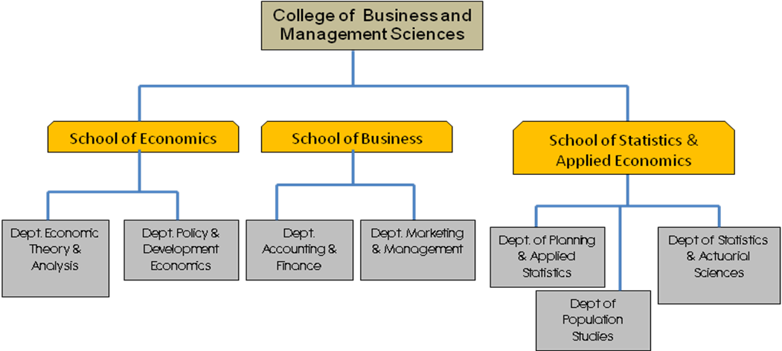

- The School of Economics will be composed of 2 Departments namely;
- The Department of Economic Theory and Analysis and
- The Department of Policy and Development Economics

The original two departments of Economic Policy and Planning and that of Development Economics have been merged to form the department of Policy and Development Economics.
- The School of Business is composed of two departments namely:
  - The Department of Marketing & Management and
  - The Department of Accounting and Finance.
The two departments under the School of Business will promote 8 main disciplinary areas of the broader business and management studies’ realm, including: Accounting, Finance & Banking, Marketing, Entrepreneurship, Procurement, Human Resources Management, International Business and Insurance.

3) The School of Statistics and Applied Economics
The ISAE Board of Studies stressed the fact that ISAE is a Regional Institute and has regional mandates. ISAE will therefore move into the College Structure as one unit. This is for identity purposes because for the last forty years the Institute has built its name worldwide and the stakeholders will be confused by the change of the name.

The School of Statistics and Applied Economics structure will comprise of three Departments:

  - Department of Planning and Applied Statistics;
  - Department of Population Studies;
  - Department of Statistics and Actuarial Science

Table 2.3.2 Staff in Post COBAMS
Staff Rank | Finance & Accounting | Marketing & Management | Economic Policy &Development | Economic Theory &Analysis | Planning &Applied Statistics | Population Studies | Statistics &Actuarial Sciences
Professor | 0 | 0 | 1 | 0 | 0 | 1 | 0
Asoc Prof | 0 | 0 | 0 | 0 | 0 | 0 | 0
Sen. Lect | 0 | 1 | 2 | 0 | 2 | 4 | 0
Lecturer | 1 | 0 | 8 | 3 | 5 | 2 | 5
Asst. Lect | 13 | 7 | 8 | 5 | 4 | 7 | 5
T .Asst | 0 | 0 | 2 | 1 | 1 | 5 | 2
T O T A L | 14 | 8 | 21 | 9 | 12 | 19 | 12

Table 2.3.3 Required Staff Establishment
Department | Prof | Assoc. Prof | Senior Lect | Lect | Asst. Lect | Teach Asst | Total Staff Requirement
Finance And Accounting | 7 | 7 | 14 | 29 | 29 | 14 | 100
Marketing And Mgt. | 8 | 8 | 16 | 33 | 33 | 16 | 114
Development Economics | 5 | 5 | 10 | 21 | 21 | 10 | 73
Economic Policy and Planning | 3 | 3 | 6 | 12 | 12 | 6 | 42
Economic Theory and Analysis | 6 | 6 | 12 | 24 | 24 | 12 | 86
Planning, Applied Statistics | 2 | 2 | 4 | 7 | 7 | 4 | 25
Population Studies | 3 | 3 | 5 | 10 | 10 | 5 | 35
Statistical Methods | 3 | 3 | 5 | 11 | 11 | 5 | 37
Sub total in post | 37 | 37 | 73 | 146 | 146 | 73 | 513

2.5 The College of Computing and Information Sciences (COCIS)
The College will comprise of two schools, namely the School of Computing and Informatics Technology (CIT) and the East African School of Library and Information Science (EASLIS). The School of Computing and Informatics Technology (CIT) will have four academic departments while that of the East African School of Library and Information Science (EASLIS) will have two.
The School of Computing and Informatics Technology (CIT) will be formed from the present Faculty of Computing & Informatics Technology (CIT). It will have four academic departments namely:
- The Department of Computer Science
- The Department of Information Technology
- The Department of Information Systems, and
- The Department of Networks.

Fig 2.5.0 Structure of the College of Computing And Information Sciences (COCIS)

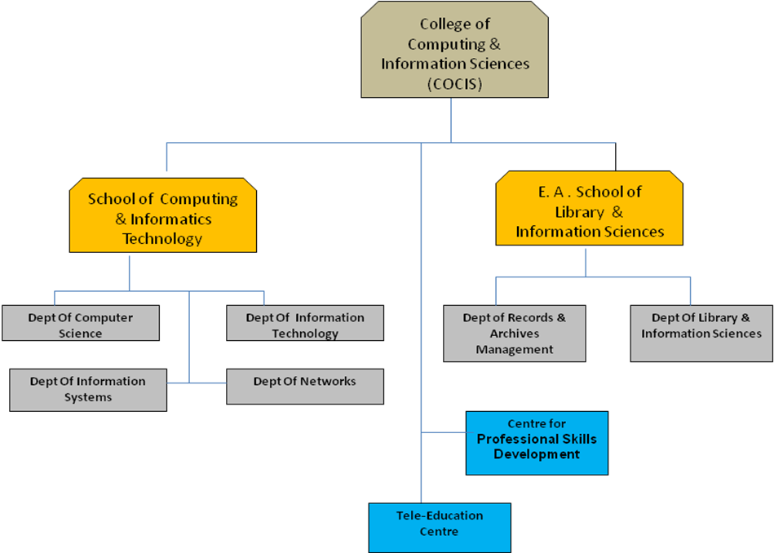

The East African School of Library and Information Science (EASLIS) will be an academic unit of the College of Computing and Information Sciences. The School will be formed from the present EASLIS and will have two departments namely;
  - The Department of Library and Information Sciences and
  - The Department of Records and Archives Management.
Table 2.4.1 In Post Academic Staff Establishment at COCIS
 | Computer Science | Information Technology | Information Systems | Networks | Library Information Science | Records & Archives Management | TOTAL
Professor | 1 | 0 | 0 | 0 | 2 | 0 | 3
Ass. Professor | 0 | 0 | 1 | 1 | 1 | 1 | 4
Senior Lecturer | 2 | 2 | 1 | 0 | 1 | 0 | 6
Lecturer | 0 | 2 | 3 | 4 | 2 | 0 | 11
Assistant Lecturer | 10 | 7 | 8 | 5 | 4 | 2 | 36
Teaching Assistant | 3 | 4 | 4 | 4 | 1 | 2 | 18
Total | 16 | 15 | 17 | 14 | 11 | 5 | 78
Table 2.4.2 Required Academic Establishment at COCIS
 | Computer Science | Information Technology | Information Systems | Networks | Library Information Systems | Records & Archive Management | Total
Professor | 10 | 3 | 2 | 2 | 2 | 1 | 20
Ass. Professor | 12 | 5 | 2 | 4 | 3 | 1 | 27
Senior Lecturer | 19 | 8 | 4 | 6 | 4 | 2 | 43
Lecturer | 27 | 28 | 7 | 12 | 8 | 3 | 85
Assistant Lecturer | 28 | 28 | 8 | 12 | 9 | 4 | 89
Teaching Assistant | 24 | 12 | 4 | 5 | 7 | 2 | 54
Total | 120 | 84 | 27 | 41 | 33 | 13 | 318

2.6 The College of Engineering Design Art and Technology (CEDAT)
The idea to establish a College of Engineering Design Art and Technology (CEDAT) has been discussed since the beginning of the millennium, after realizing the co-relation between the Faculty of Technology (FOT) and the Margaret Trowell School of Industrial and Fine Art (MTSIFA). In 2004, the first formal meetings were held between the two faculties and a Committee on the Formation of CEDAT was set up to work out the modalities. It was however not until 2009 that the idea of CEDAT was concretized having realized the longstanding mutual relationship that MTSIFA and FOT have enjoyed since the 1980s. FOT students would come to MTSIFA for Art history and Drawing classes, while MTSIFA students sought the technological input of FOT while executing their major projects in the various art and design disciplines. FOT students and staff have from time to time collaborated with MTSIFA academic staff and students on various research projects aimed at improving materials, products and systems for sustainable industrial development.

This academic cooperation springs from the practical-based teaching and learning methods in FOT and MTSIFA which emphasize creativity and innovation aimed at solving societal problems. The technological advancement in the twenty-first century has further reduced the gap between art, design and technology, which more than ever before, calls for interdisciplinary pedagogical approaches between the artists, designers, architects, surveyors, construction managers and engineers. Therefore, the merger of FOT and MTSIFA to form a College of Engineering Design Art and Technology is a step in the right direction which has long been overdue.

CEDAT shall be composed of three Schools with nine departments offering both undergraduate and graduate programmes in the fields of engineering, design, art and technology.

- The School of Engineering shall be comprised of three departments namely:
  - The Department of Civil and Environmental Engineering;
  - The Department of Electrical and Computer Engineering;and
  - The Department of Mechanical Engineering.

2.5.0 Structure of the College of Engineering Design Art and Technology (CEDAT)
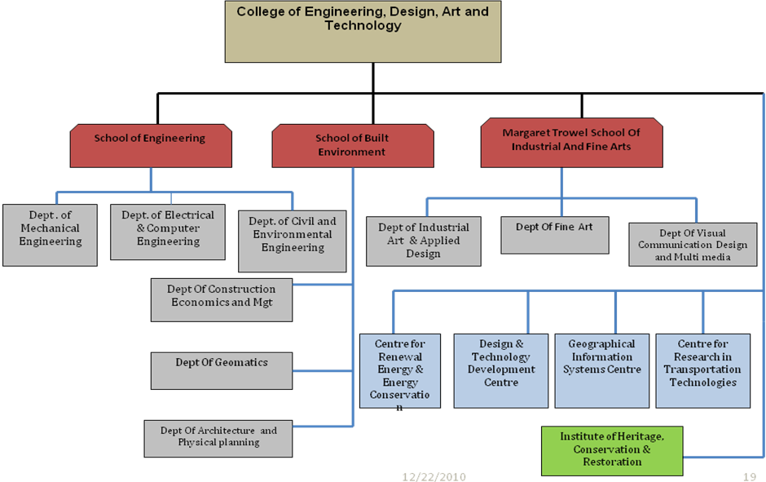

- The School of the Built Environment shall have three departments:
  - The Department of Architecture and Physical Planning;
  - The Department of Construction Economics and Management;
  - The Department of Geomatics and Land Management.
- The Margaret Trowell School of Industrial and Fine Art shall also initially have three departments. Because of the need to streamline teaching, learning and research activities at MTSIFA, the original departments (Painting and Art History; Sculpture and Drawing; and Industrial Arts and Design) shall be disbanded and a new nomenclature has been proposed as follows:
  - The Department of Fine Art;
  - The Department of Visual Communication Design and Multi-media; and
  - The Department of Industrial Art and Applied Design.
Table 2.5.1 In Post Academic Staff Establishment at CEDAT
 | Civil | Mech | ECE | Arch | Construction | GEOMaps | Fine Art | Indus Art | Vis Comm | Total
Professors | 2 | 0 | 1 | 0 | 0 | 0 | 1 | 0 | 0 | 4
Associate Professors | 0 | 2 | 0 | 1 | 0 | 0 | 0 | 1 | 1 | 5
Senior Lecturer | 2 | 4 | 4 | 0 | 1 | 1 | 2 | 2 | 2 | 18
Lecturer | 7 | 4 | 4 | 1 | 4 | 4 | 6 | 4 | 6 | 40
Assistant Lecturer | 6 | 7 | 8 | 27 | 27 | 5 | 2 | 4 | 2 | 88
Teaching Assistant | 2 | 4 | 9 | 0 | 0 | 4 | 2 | 2 | 2 | 25
Total | 19 | 21 | 26 | 16 | 29 | 14 | 13 | 13 | 13 | 164

Table 2.5.2 Required Academic Staff Establishment at CEDAT
 | Civil | Mech | ECE | Arch | Construction | GEOMaps | Fine Art | Indus Art | Vis Comm | Total
Professors | 4 | 2 | 6 | 3 | 2 | 2 | 1 | 1 | 1 | 18
Ass. Professors | 4 | 3 | 4 | 5 | 3 | 2 | 1 | 2 | 2 | 26
Senior Lecturer | 9 | 8 | 9 | 6 | 3 | 6 | 3 | 3 | 3 | 50
Lecturer | 12 | 9 | 9 | 8 | 6 | 7 | 6 | 5 | 6 | 68
Ass. Lecturer | 15 | 12 | 16 | 10 | 12 | 8 | 3 | 3 | 3 | 82
Teaching Assistant | 10 | 10 | 14 | 15 | 8 | 12 | 3 | 3 | 3 | 82
Total | 54 | 44 | 58 | 47 | 34 | 37 | 17 | 17 | 18 | 326

2.7 The College Of Humanities and Social Sciences (CHUSS)
The Faculties of Arts and Social Sciences, the Institutes of Psychology and Economics, and the Makerere University Institute of Social Research started the process of college formation in 2002. Through the Pentaplan Project, the units formed the College of Humanities and Behavioural Sciences; however the structure was not implemented due to uncertainties at the time.

The proposed College of Humanities and Social Sciences has brought together some of the largest and the oldest units in the University: Faculty of Arts, Faculty of Social Sciences, the Institute of Psychology and the Makerere University Institute of Social Research. Given the uniqueness of Humanities and Social Sciences and the niche each unit occupies in the university, five schools and one institute were formed:
- The School of Languages, Literature and Communication,
- The School of Women and Gender Studies,
- The School of Liberal and Performing Arts,
- The School of Psychology,
- The School of Social Sciences, and the
- Makerere University Institute of Social Research
2.7 Structure of The College Of Humanities and Social Sciences (CHUSS)
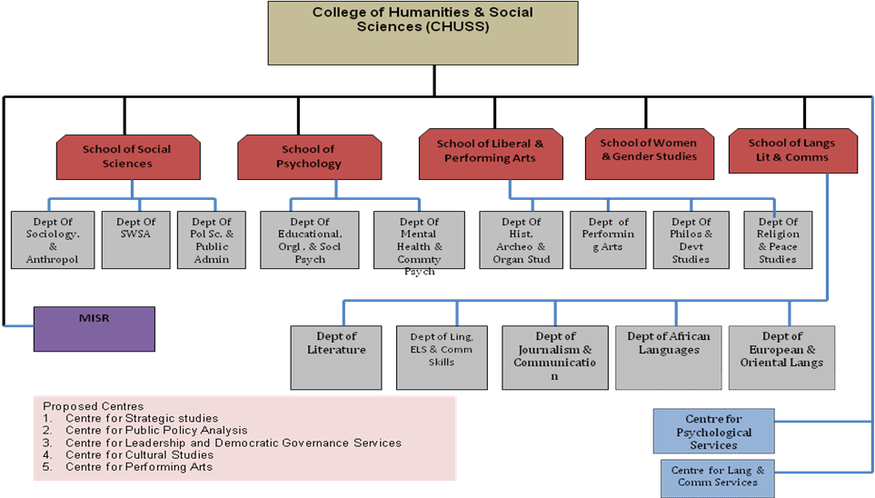

The formation of the College of Humanities and Social Sciences is informed by the Universities and other Tertiary Institutions Act, 2001; the Makerere University Statute for Constituent Colleges (2006); the Guidelines for College Formation and Makerere University Strategic Plan 2008/09-2018/2019. In addition the College structure is based on the composition and number of units forming the College; the nature (classic and core) of the programmes in the College; the relatedness of the disciplines; and the large student body. Specifically:
- The College has a student body of over 9,560 and is bringing together 47 undergraduate and graduate programmes.
- The College has four cross-cutting courses, Introduction to Gender, Communication Skills, Ethics and Development Studies. These courses serve 17,000 students each.
- Women and Gender Studies is transformed into a school because of its uniqueness and core role of promoting gender within the entire university and at national and regional levels through teaching, research and knowledge transfer partnerships.
- It was observed that the disciplines (Political Science, Sociology, Social Work and Social Administration, Religious Studies, History, Philosophy and Literature) in the proposed College cannot be collapsed because they are unique and core disciplines. Consultations with the Faculty of Social Sciences and Faculty of Arts revealed the desire to keep these disciplines separate departments.
- The above disciplines are characteristic of disciplines that should be available in a national university like Makerere. In addition, these are subjects being taught in secondary schools; as such these subjects have to be visible in the university.
1) The School of Liberal and Performing Arts
The School Of Liberal And Performing Arts is the oldest and hosts the most fundamental disciplines of any university. It will have the following departments
- The Department of Philosophy & Development Studies.
- The Department of Religion and Peace Studies.
- The Department of Performing Arts
- The Department of History, Archaeology & Organizational Studies

2) The School of Women and Gender Studies
The School of Women and Gender Studies discussions of a separate structure of WGS started in 2000/2001. Makerere University Senate approved the School of Women and Gender Studies on September 28, 2010. The Department has grown into a large structure and its mandate has been broadened to teach gender studies across the University. The proposed School has the required programmes and students for the School structure. The subject of gender is a unique and a multidisciplinary discipline core to university teaching and research, and Gender Mainstreaming in national development.

3) The School of Languages, Literature and Communication
The School of Languages, Literature and Communication has six departments. The School will offer Communication Skills across the university. The department of Journalism and Communication has the potential to grow into a school. The Departments include:
- Literature
- Linguistics, English Language Studies & Communication Skills
- European and Oriental Languages
- Oriental Languages
- Depart of African Languages
- Journalism and Communication

4) The School of Psychology
The School of Psychology services education and Social Sciences, Sciences and Medicine. It will have the following Departments;
- Mental Health and Community Psychology
- Educational, Organizational and Social Psychology

5) The School of Social Sciences
The School of Social Sciences will comprise of the following Departments:
- The Department of Sociology & Anthropology.
- The Department of Social Work and Social Administration and
- The Department of Political Science and Public Administration

6) Makerere Institute of Social Research (MISR)
MISR is mandated to operate as one of the main research arms of Makerere University, operating as a conduit for enhancing the research capacity of staff, students and international scholars. In so doing, the Institute expects to continue raising its academic credibility and institutional visibility through research, publications, training and outreach activities. Currently, the Institute is organised into three research groups. These are:
- Land: access, conflict and governance;
- Oil: The politics and political economy of the emerging oil economy;
- State: sovereignty, the state and the communities.
Table 2.7.1 In Post Academic Staff Establishment under CHUSS
Department | Prof | Assoc. Prof | Senior Lecturer | Lecturer | Asst. Lecturer | Teaching Assistant | Total Staff in post
Political Science, Public Admin | 0 | 4 | 8 | 6 | 1 | 0 | 19
Social Work, Social Admin | 0 | 0 | 3 | 10 | 6 | 1 | 20
Sociology | 2 | 1 | 5 | 6 | 5 | 2 | 21
Women and Gender Studies | 1 | 1 | 5 | 4 | 6 | 2 | 19
Educational Psychology | 0 | 0 | 1 | 2 | 2 | 2 | 7
Mental Health, Community Psy | 0 | 0 | 2 | 1 | 4 | 4 | 11
Organizational, Social Psy | 1 | 1 | 0 | 3 | 3 | 1 | 9
Outreach Department | 0 | 0 | 0 | 0 | 0 | 1 | 1
History | 0 | 1 | 0 | 12 | 1 | 0 | 14
Languages | 2 | 1 | 3 | 10 | 23 | 6 | 45
Literature | 0 | 2 | 5 | 3 | 4 | 2 | 16
Mass Communication | 0 | 1 | 2 | 1 | 5 | 1 | 10
Music, Dance and Drama | 1 | 2 | 3 | 3 | 3 | 13 | 25
Philosophy | 0 | 4 | 1 | 3 | 1 | 1 | 10
Religious Studies | 0 | 0 | 2 | 11 | 2 | 0 | 15
Sub total in post | 7 | 18 | 40 | 75 | 66 | 36 | 242

Table 2.7.2 Required Academic Staff Establishment in CHUSS

Department | Prof | Assoc. Prof | Senior Lecturer | Lecturer | Asst. Lecturer | Teaching Asst | Total Staff Requirement
Political Science, Public Admin | 2 | 2 | 5 | 10 | 10 | 5 | 33
Social Work, Social Admin | 2 | 2 | 5 | 10 | 10 | 5 | 34
Sociology | 3 | 3 | 6 | 13 | 13 | 6 | 45
Women and Gender Studies | 2 | 2 | 4 | 8 | 8 | 4 | 27
Educational Psychology | 1 | 1 | 1 | 2 | 2 | 1 | 7
Mental Health, Community Psy | 3 | 3 | 6 | 12 | 12 | 6 | 42
Organizational, Social Psy | 2 | 2 | 4 | 8 | 8 | 4 | 27
Outreach Department | 0 | 0 | 0 | 0 | 0 | 0 | 1
History | 4 | 4 | 8 | 15 | 15 | 8 | 53
Languages | 9 | 9 | 19 | 38 | 38 | 19 | 131
Literature | 1 | 1 | 2 | 5 | 5 | 2 | 16
Mass Communication | 2 | 2 | 3 | 7 | 7 | 3 | 24
Music, Dance and Drama | 3 | 3 | 6 | 11 | 11 | 6 | 40
Philosophy | 1 | 1 | 1 | 3 | 3 | 1 | 10
Religious Studies | 2 | 2 | 3 | 7 | 7 | 3 | 23
Total staff required | 37 | 37 | 73 | 147 | 147 | 73 | 513

2.8 The College of Agricultural and Environmental Sciences (CAES)
The College of Agricultural and Environmental Sciences comprises of the current Faculties of Agriculture and Forestry and Nature Conservation, Makerere University Institute of Environment and Natural Resources and Department of Geography.
This proposal seeks to reform the administrative structures of the merged units, so as to improve the quality of teaching, learning and research, and harmonizing programmes with synergies, as well as elimination of duplication.

The College will comprise of three schools, i.e. School of Agricultural Sciences, School of Food Technology, Nutrition and Bioengineering and School of Forestry, Environmental and Geographical Sciences.
Fig 2.8 The College of Agricultural and Environmental Sciences (CAES)

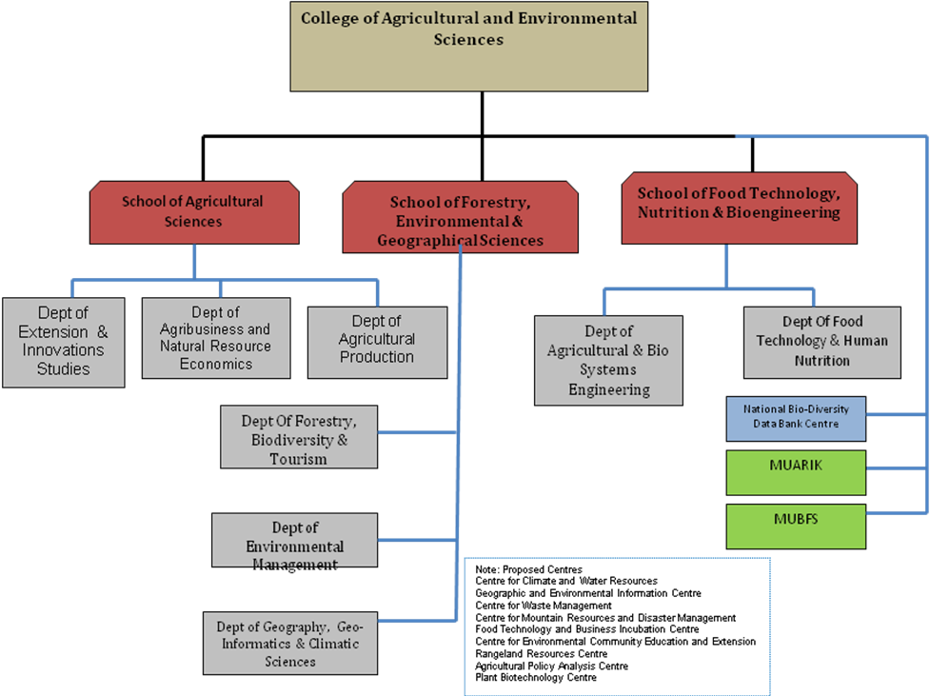
It was noted that some programmes cut across Units and this formed the basis for merging departments within the existing faculties. All the degree programmes were assigned a unit where they will be anchored. It was therefore agreed that 8 Departments/Units down from the (original 12 and One Centre) be constituted.
A relationship analysis of the proposed departments/units was also undertaken and it was agreed that three clusters from the 8 departments/units based discipline relatedness as follows:
Cluster 1 comprising of three Departments of Forestry Science & Biodiversity Management, Rural and Urban Environment Management and Geography, Geo-Informatics and Climate Sciences (8);
Cluster 2 comprising Departments of Environmental Community Education and Extension, Agribusiness and Natural Resource Economics and Plant and Animal Sciences; and
Cluster 3 Comprising Department of Forestry and Agricultural Engineering and Food Technology and Human Nutrition.
An evaluation of the 3 groups was then undertaken to gauge the potential for sustainability as stand-alone units within the college. This analysis considered the degree programs, student enrolment, strategic importance and available physical resources (lecture space, laboratories, office space, library and ICT facilities). From this analysis, it was clear that three major clusters emerged which constitute the proposed three schools in the College of Agricultural and Environmental Sciences The Schools will be, The School of Agricultural Sciences, The School of Forestry, Environmental and Geographical Sciences and the School of School of Food Technology, Nutrition and Bio-engineering.

- The School of Agricultural Sciences
This School will have the following Departments
- Agricultural Production (AP)
- Agribusiness and Natural Resource Economics (Ag & NRE)
- Extension & Innovations (EI)

2) The School of Forestry, Environmental and Geographical Sciences
The School will have the Departments as follows:
- The Department of Forestry, Bio-Diversity and Tourism (F, B &T)
- The Department of Environmental Management (EM)
- The Department of Geography, Geo Informatics and Climatic Sciences (GGCS)

3) The School of School of Food Technology, Nutrition and Bio-engineering will have the following Departments
- The Department of Agricultural & Bio systems Engineering (ABE)
- The Department of Food Technology and Human Nutrition (FT&HN)
Table 2.8.1 In Post Academic Staff Establishment in CAES
 | Forestry | AGRIC | MUIENR | Dept of Geography | Total
Professor | 3 | 7 | 2 | 1 | 13
Associate Professor | 4 | 6 | 1 | 2 | 13
Senior Lecturer | 4 | 23 | 3 | 1 | 31
Lecturer | 11 | 28 | 1 | 3 | 43
Assistant Lecturer | 13 | 25 | 4 | 16 | 58
Teaching Assistant | 4 | 28 | 0 | 0 | 32
Total | 39 | 117 | 11 | 23 | 190

Table 2.7.2 Required Academic Staff Establishment in CAES
Department | Prof | Assoc. Prof | Senior Lecturer | Lecturer | Asst. Lecturer | Teaching Asst | Total Staff Requirement
0
Agric Economics & Agribusiness | 2 | 2 | 4 | 9 | 9 | 4 | 30
Agricultural Engineering | 1 | 1 | 2 | 5 | 5 | 2 | 17
Agricultural Extension/Educ | 1 | 1 | 3 | 6 | 6 | 3 | 20
Animal Science | 1 | 1 | 2 | 4 | 4 | 2 | 15
Crop Science | 2 | 2 | 4 | 9 | 9 | 4 | 31
Food Science and Technology | 1 | 1 | 2 | 4 | 4 | 2 | 15
Soil Science | 1 | 1 | 2 | 5 | 5 | 2 | 16
Geography | 7 | 7 | 15 | 29 | 29 | 15 | 103
Community Forestry and Extension | 1 | 1 | 1 | 3 | 3 | 1 | 10
Forest Biology, Ecosystem Man | 1 | 1 | 2 | 4 | 4 | 2 | 13
Forest Management | 1 | 1 | 2 | 4 | 4 | 2 | 12
Forest Products Engineering | 1 | 1 | 2 | 3 | 3 | 2 | 12
Environment | 2 | 2 | 3 | 6 | 6 | 3 | 23
Total staff required | 23 | 23 | 45 | 90 | 90 | 45 | 317

2.9.0 The College of Education and External Studies (COEES)
The proposed College comprises of the current School of Education (SoE) and current Institute of Adult and Continuing Education (IACE). This merger seeks to enhance the University’s ability to produce professional educators at all levels of the education continuum as well as professional community workers. By increasing access to quality learning opportunities in varied modes for her core clientele, the CEES hopes to contribute significantly to the fulfilment of the University’s strategic goals by reforming the administrative structures of the merged units, thus improving the quality of teaching and learning, research and knowledge transfer partnerships. The merger will entail further harmonizing of programmes thus creating synergies, while eliminating duplication of efforts.

The College of Education and External Studies (COEES) will be made up of the following three schools:
- The School of Education (SoE),
- The School of Distance and Lifelong Learning (SoDLL), and
- The East African School of Higher Education Studies and Development (EASHESD).
The SoE shall initially comprise of three departments; the SoDLL two departments, and EASHESD will have Sections dealing with specific graduate programmes and related activities.
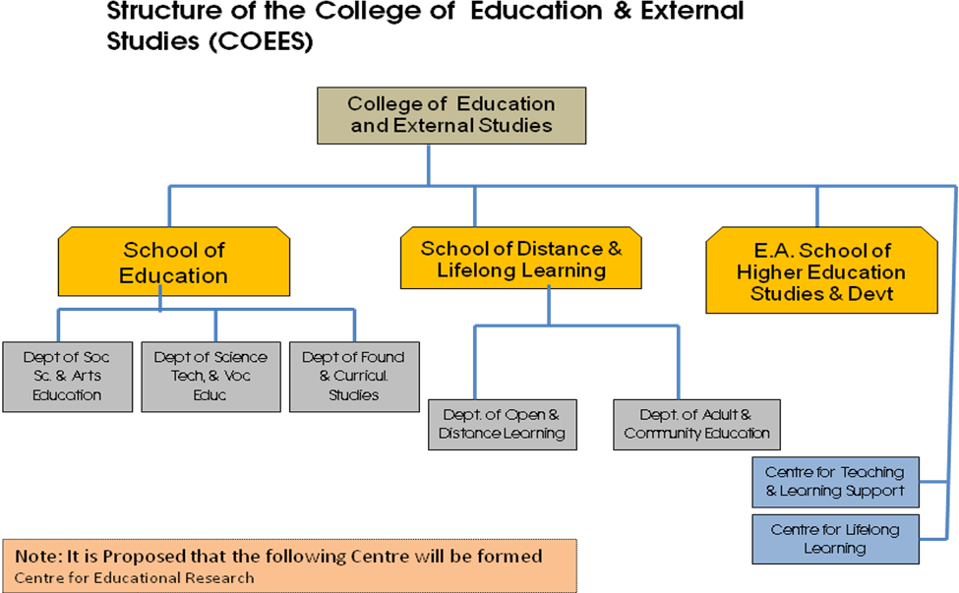

1) The School of Education (SoE) will have the following departments
- Department of Social Sciences & Arts Education
- Dept of Science, Technology & Vocational Education (DSTVE)
- Dept of Foundations & Curriculum Studies (DFCS)

2) The School of Distance and Lifelong Learning (SoDLL) will be re-structured into the following Departments
- The Department of Open & Distance Learning (DODL) and
- The Department of Adult & Community Education (DACE)
Table 2.9.1 In Post Academic staff for COEES
Department | Professor | Assoc. Professor | Senior Lecturer | Lecturer | Asst. Lecturer | Teaching Assistant | Total
Adult and Communication Studies | 0 | 0 | 0 | 2 | 5 | 5 | 12
Community Ed, Extra-Mural Stud | 0 | 0 | 0 | 2 | 3 | 2 | 7
Distance Education | 0 | 0 | 1 | 3 | 4 | 1 | 9
Curriculum, Teaching and Media | 0 | 0 | 2 | 6 | 3 | 3 | 14
Education Foundation and Man | 0 | 0 | 0 | 6 | 4 | 2 | 12
Higher Education | 1 | 0 | 1 | 5 | 0 | 0 | 7
Language Education | 0 | 1 | 1 | 5 | 5 | 2 | 14
Science, Technical Education | 0 | 0 | 5 | 3 | 2 | 5 | 15
Social Sciences, Arts Educ | 0 | 0 | 1 | 8 | 7 | 1 | 17
Total | 1 | 1 | 11 | 40 | 33 | 21 | 107

Table 2.9.2 Required Academic Staff Establishment for COEES
Department | Prof | Assoc. Prof | Senior Lecturer | Lecturer | Asst. Lecturer | Teaching Asst | Total Staff Requirement
Adult and Communication Studies | 2 | 2 | 3 | 6 | 6 | 3 | 21
Community Ed, Extra-Mural Stud | 1 | 1 | 1 | 3 | 3 | 1 | 9
Distance Education | 1 | 1 | 1 | 3 | 3 | 1 | 9
Curriculum, Teaching and Media | 1 | 1 | 2 | 4 | 4 | 2 | 14
Education Foundation and Man | 1 | 1 | 1 | 3 | 3 | 1 | 9
Higher Education | 1 | 1 | 1 | 2 | 2 | 1 | 8
Language Education | 4 | 4 | 7 | 15 | 15 | 7 | 51
Science, Technical Education | 1 | 1 | 2 | 5 | 5 | 2 | 16
Social Sciences, Arts Educ | 7 | 7 | 14 | 28 | 28 | 14 | 99
Total staff required | 17 | 17 | 34 | 68 | 68 | 34 | 238

2.10 The College of Health Sciences (CHAS)
The College of Health Sciences has four Schools namely;
- The School of Medicine
- The School of Public Health
- The School of Biomedical Sciences
- The School of Health Sciences
The College has a total of 20 departments. At the time of establishment, the College of Health Sciences structure was envisaged to provide greater opportunity for faster growth and expansion of constituent components e.g. the new Institute of Public Health.
The new Schools of Biomedical Sciences, that of Medicine and of Health Sciences enjoyed the same degree of autonomy as the new School of Public Health. The CHAS Structure aimed at enabling the expansion of enrolment of students and thus boosting the human resource in the health sector.
The descriptive presentation below defines the Schools and the departments which fall under each academic unit.

- The School of Medicine has the following Departments
- Department of Internal Medicine
- Department of Surgery
- Department Obstetrics &Gynaecology
- Department of Psychiatry
- Department of Family Medicine
- Department of Anaesthesia
- Department of Ear Nose Throat
- Department of Ophthalmology
- Department of Orthopaedics
- Department of Radiology & Radio Therapy
- Medical Research Centre
- Reproductive Health Unit
- Department of Paediatrics & Child Health

- The School of Public Health
- Department of Health Policy &Management
- Department of Epidemic& Biostatistics
- Department of Community Health & Behav Sciences
- Department of Disease Control & Environmental Health.

- The School of Biomedical Science
- Department of Human Anatomy
- Department of Biochemistry
- Department of Microbiology
- Department of Pathology
- Department of Physiology
- Department of Pharmacology & Therapeutics
- Department of Anatomy
- Department of Medical Illustration
The School of Health Sciences has the following Departments
- Department of Pharmacy
- Department of Dentistry
- Department of Nursing Department of Allied Health Sciences

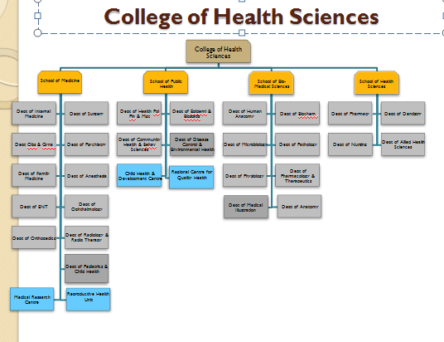

From the foregoing, it becomes evident that CHAS is too multilayered and its components are too dispersed. Therefore to attain efficiency and effectiveness, it will be necessary for CHAS to be restructured and re-aligned to conform to the new Colleges format.
Similarly, the current Faculty of Law and Faculty of Veterinary Medicine which are in transition as Standard Alone Schools will in the meantime be accessing services that are not available at the Centre through the College of Business and Management Sciences and the College of Health Sciences respectively. They too will be considered for re-alignment in the course of College implementation.

3.0 Cost Benefit Analysis
The Current Strategic Plan 2008/9 - 2018/19 was guided by the basic question. “How can Makerere University reposition herself to meet emerging development challenges in Uganda?” Consequently the re-organization of the Units is intended to enable Makerere be able to produce graduates with problem solving skills and reflective ability and relevant to the new situations.

3.1 Qualitative Benefits

3.1.1 Administration
In terms of administration, they have been several bottlenecks in many functions of the University. Decentralized powers and realigning the administrative structure will ease some of these bottlenecks. At the apex, there will be a leaner structure and the span of control will be shorter (Procurement functions, recruitment up to at certain levels, review of programs, Quality Assurance, financial management will now be undertaken at the Colleges). This is in line with the Vision of the University.

3.1.2 Financial
The University has been organized around 110 departments, 21 Academic Units each of these of these has been a cost centre with multiplicity of roles. This is now being reduced to 8 and it is hoped that whereas the financial acquisition was initial very long, this will be reduced at the College level as the staff in it will be able to be familiar with their individual needs. The few that may be financial neutral will require a phased approach.
Secondly, budgeting, micro procurement, auditing and reporting which has been very tedious will now be made easier due to the few Cost Centres.

3.1.3 Professionalism
One of the core values of Makerere University is professionalism. This however has not yet been translated into a meaningful a catchword. At a College level it is envisaged that it will be possible to encourage, ensure, promote and advance sets standards and ethics within the mandates of these Colleges away from the various fragmentation we have been having. .This will be through synergies and relatedness being encouraged in the formation of Colleges. The demonstration of their professional capabilities will now be more distinct within the College especially with the introduction of Communication Officer for each College.

3.1.4 Customer Responsiveness
With the increase in Universities in Uganda and the competition therein, our stakeholders have become an invaluable asset that the Colleges will devise different strategies to retain these stakeholders or look at different ways to increase their relevance both within the Institution and in the Country. Customer responsiveness is giving our stakeholders what they want, when they want it, and at a reasonable rate without comprising the University’s Mission and Vision in the process.
Due to the long bureaucratic path in the present environment in the University, Makerere University has had a lot of criticisms from all quarters in its ability to take action to identify their customers and react to their needs and wants in a way that satisfies them. Through the introduction of Colleges, our responsiveness is expected to be far better and faster to the satisfaction of our various stakeholders.

3.1.5 An Efficient and Effective Makerere University
Peter Drucker, a management guru, defined efficiency as doing the things right and effectiveness as doing the right things. While efficiency focuses on the process or “means”, effectiveness focuses on the end. Efficiency is restricted to the present state whereas effectiveness involves thinking long term. Makerere University needs to be both effective and efficient in order to be successful. The repositioning of Makerere University according to the Strategic Plan is intended to make it a top notch University in the continent. This can be done by working on our current weaknesses and promoting our strengths. This reorganization is the beginning of that journey. This will lead to a more participatory approach by the internal stakeholders in decision making, better satisfaction from the various stakeholders and better accountability of University resources.

3.2 Quantitative Benefits
The conversion into a common financial denominator of the quantitative costs/benefits has been tabulated in the Appendix 3. The transition between the present structures to colleges is financially a neutral process with less than 0.05% increment on top of the current expenditure levels. However, the reduction in cost centres and administrative processes is evidently to bring in a savings in transactional costs are normally considered to be recurrent expenditures.

3.3 Cost/Benefit – Net Effect
The analysis of the financial implications of the implementation of the college structures shows a normal variation of 0.05% in the wage bill. This is based on moving staff members from the centre to the colleges leaving the centre with a lean coordinative role.
There is a cost associated with change management with the new roles that will go along with the movement of staff. This will be mitigated by an inductive process for the Human Resource Directorate in order to induct staff in their new roles and reporting systems.
The benefits, which are largely qualitative far, outweigh the cost of reorienting staff in their new roles as the process will offer space to review methods of work and motivational issues.

4.0 The Road Map to College Formation
The plan for implementation of the colleges is attached in Appendix 4. It is envisaged that the college projects will begin soon as the Council for Higher Education has validated and approved the Colleges’ model. The initial stages will focus on sensitisation to change management and budgeting and planning implementation. Full implementation will begin with the first semester of the academic year 2011/12 subject to the availability of funds. Accordingly, the scenarios of FTSE and workload improvement can be deduced from the tables of Financial Implications of College formation (Appendices 3.1, 3.2, 3.3& 3.4) will be scaled to fit the portfolio that will be dedicated to transforming the university through the proposed reforms.

.

Appendix 1 Teaching Learning & Colleges Sub-committee -Terms of Reference
We the under mentioned members of Teaching, Learning & Colleges are
Title | Name | Representation | Designation
Dr. | Edith Natukunda-Togboa | Senior Lecturer, Languages (French) | Chairperson
Dr. | Christine Dranzoa | Associate Professor, West Nile University | Ex Co- Chair
Dr. | Savino Biryomumaisho | Lecturer Faculty of Veterinary Medicine | Member
Dr. | Vincent A .Ssembatya | Director, Quality Assurance | Member
Mr. | Alfred .M. Namoah | Academic Registrar- Makerere University | Member
Mr. | Goddy Muhumuza Muhanguzi | University Legal Officer | Internal Legal Consultant to URAFRC
Mr. | John K.W. Wabwire | Director, Planning and Development Department, | Internal Consultant
Mr. | Tito Okumu | E-Learning Manager, Makerere University | E-Learning Manager, Makerere University
Mr. | Tony Oluka | Information Technology Specialist, Makerere University | Member
Ms | Florence Nakayiwa | Senior Economist PDD | Co-Opted
Ms. | Francesca Ayaa |  | Secretariat
Prof. | Buyinza Mukadasi | Deputy Director School of Graduate Studies | Member
Prof. | H. Sengendo | Rector IUIU | Member
Prof. | Ikoja Odongo | Director Institute of Psychology | Member
Prof. | Maria Musoke | University Librarian | Member
They were given the following Terms of Reference
- To review the current research function
- To make it more efficient and effective.
- To consider the current administrative structure with a view of making it lean, efficient and effective
- To propose an appropriate college system for the university
- To review the current financial system with a view of improving ITS business processes.
- To make specific recommendations that are appropriate for a research-led university under a college system
- To review the current university programmes.
- To provide a report to the Vice Chancellor on a regular basis.

Appendix 2: University Models
  - Bureaucratic model (“Old school”): As might be anticipated, the bureaucratic model of governance derives its strength from the writings of Max Weber who advocated that decision making and planning are the exclusive preserve of the few individuals in the top wrung of the hierarchy ladder. Such decisions and plans are implemented through a coordinated division of labour, standardization of rules and regulations, and a hierarchical chain of command (Weber, 1948; Baldridge, 1971; Hardy, 1990). However, bureaucracies in academe are thought to function in a different manner from traditional bureaucracies found in the corporate world, the private sector, or for that matter, in ecclesiastical settings, because power is decentralized to units such as departments. Academic staff members constitute a specialized cadre which understands its obligations to the organization, thereby obviating the need for a steep chain of command (Tierney, 2004).

  - The Collegial model: In this model, there is an assumption that a community of scholars operates around the notions of respect and consensus. Proponents of the collegial perspective are convinced that decisions made are honoured in deference to the professional and intellectual competence and authority of the makers, and not through politics, rules and other persuasions (Hamilton, 1997). The collegium is made up of loosely connected individuals embedded in a decentralized edifice. Millet (1962), who is one of the earliest advocates of such a framework summarized cogently the position of the academy when he stated “I do not believe that a structure of a hierarchy is a desirable prescription for the organization of a college….The concept of community presupposes an organization in which functions are differentiated through a dynamic consensus” (p, 5). The collegial model is characteristic of old universities in the UK, e.g. Oxford, Cambridge and a few Scottish universities. In the United States, older universities such as Harvard and Yale which were founded on the Oxbridge model retained such a framework for many decades until a typical American style of university management evolved. The dominant American model is one in which the board of trustees, a self-perpetuating organization, holds the ultimate power in universities and colleges, both public and private (Shattock, 2006).

Students of history, undoubtedly, can trace the origins of the collegial model back to 12th and 13th century when in Paris, the university was conceived to be constituted by the faculty who organized schools, offering professional training. In marked contrast over the same period, Bologna was organized differently in that students were considered to constitute the university. The leaders and owners of the university hired instructors to teach pre-selected curricula and instructors had no rights or tenure and thus could be fired at the whims of management.

  - The Political Model: The political model arose from the circumstances of the 1960s and 1970s during which students in both continental Europe and North America demanded for a greater say in the governance of their respective universities. Collective bargaining, conflicts, give and take comprised the dominant features of the period. The resolution of such conflicting interests and demands took on a political character rather than the traditional processes and consensus building. Baldridge (1971) outlined the tenets of the political governance by showing that universities are complex microcosms of the larger society with conflicts and intrigues. There exists within universities power and pressure groups that influence decision-making. When sufficient momentum is reached, such pressures are translated into policy and during the implementation phase of the policy, feedback is generated that may become the source of new conflicts.

The problem inherent in the political model, it would appear, lies in the fact that it incorporates under its rubric all other models of governance, i.e. the bureaucratic, collegial and related models become encapsulated in the political model (Hardy, 1990).

  - The Cybernetic Model: Robert Birnbaum (1988) is the champion of the cybernetic model which has dominated the theoretical landscape over the last two decades. No better words can describe the theory than to quote from the source. “The cybernetic paradigm integrates existing models by suggesting how bureaucratic, collegial, political, and anarchical subsystems simultaneously in colleges and universities of all kinds to create self-correcting institutions. The cybernetic paradigm posits that organization control systems can be described in terms of sensing mechanisms and negative feedback loops that collectively monitor changes from acceptable levels of functioning and that activate forces that return institutions to their previous stable state. These self-correction (cybernetic) processes function as institutional “thermostats” (1989, p. 239).

The cybernetic model has attracted a number of criticisms, not the least of which is its limited scope in terms of practical application. It is hard to imagine how an institution can set up sensitive sensing mechanisms in its governance structure, some of which involves handling by capricious human beings. It is even harder to imagine how structures involving human beings can be put in place to serve as negative or forward feedbacks. As pointed out earlier in this report, human beings do not behave as rational machines (Salzenick, 1947; Simon, 1958; Sandgren and Stromqvist, 2006). Another criticism against the cybernetic model is that it may work well for an organization that is well grounded and stable. In a dynamic environment where changes are brought about by rapid advances in technology, and where new learning curves emerge, the cybernetic model will not have sufficient speed and power to bring back the entire system into equilibrium (Christensen, 1997; Frank and Cook, 1996).

  - The Corporate or Managerial Model: The managerial model emerged in the past two decades from management science, particularly in connection with the notion of strategic policy making (Dill and Helm, 1988). Corporate governance emphasizes managerialism, i.e., increasing reliance on market as mechanism for decision making, (Buhbinder, 1993; Bertelsen, 2002; Fulton, 2003) and its preoccupation with efficiency and effectiveness as distinct measures of good management. A corporate model of governance in a university setting is easily discernible because managers of institutions are prevailed upon to adopt the tools of new public management such as mission statements, performance indicators, quality assurance or outcome-based evaluation process, and an obsession with continuous improvements (Meek and Hayden, 2005). The outcry for public management, per se, is fuelled by neo-liberalism as a dominant ideology in economic development policy. One of the main characters of corporate governance is the use of an institution’s governing body whose members are largely non-academic, particularly those with credentials from the commercial and financial circles to control the key affairs of the institution.

Historically, the corporate model of university governance (because of its origins in neo-liberal policies) has been associated on a global scale with a number of manifestations including:

    - Cost sharing in higher education
    - A high expectation on the part of government and the public that universities will be accountable for the expenditure of public funds
    - An increased tendency for the government to provide funds that are tied to specific priorities or are intended to support certain socio-economic activities of special interest to government.
    - Increased pressure on universities to adopt an entrepreneurial culture to generate more revenues (Slaughter and Leslie, 1997; Meek, 2000; Sandgren and Stromqvist, 2006).
    - Pre-occupation of the state with eliminating all forms of collective bargaining by labour unions representing university employees.

There is a wide acceptance of the corporate model of governance in higher education institutions globally and the trend is towards more acceptance (Gellert, 1993; Slaughter and Leslie, 1997; Bennett, 2002; Fulton, 2003; Nelson, 2005; Tommaso and Catalano, 2006; Carney, 2006) such that universities like Oxford and Cambridge have been severely criticized by the government and public alike for their reluctance to reform (Oxford, 2005; Shepherd, 2008). Other investigators, on the other hand, are clamouring for a hybrid of the collegial and managerial systems in what has been referred to as shared governance (Quinn and Moore, 1992; Ramo, 1997, 1998; Dearlove, 2002; Shattock, 2002, 2006; Coldrake et al., 2003; Fulton, 2003; Lapworth, 2004; Carney, 2006; Johnson, 2007; McMaster 2007). Tierney (2004) summarized the merit of the hybrid model when he stated:

The challenge is to create processes and structure of governance that enable academic organizations to create and sustain an experimental environment while at the same time holding onto values (Tierney, 2004, p, 114).

  - The Governance Equaliser Model: The governance equaliser model as proposed by Schimank (2005) attempts to integrate all existing models of university governance in European countries. Schimank suggests that there are five mechanisms or modes of university governance regimes and that each mode has the capacity to influence the other mechanisms at any given time. The five mechanisms are: (1) State regulation (SR) in which the state directs universities as regards what needs to be done; essentially this is a prescription mechanism. (2) Guidance by external stakeholders (ES) takes place when advice is given by interested parties outside of academe in order to achieve the institution’s set goals. The external stakeholders may consist of intermediary bodies established by government, parliament, labour unions or industry. (3) Academic self-governance (ASG) derives authority from the traditional democratic collegial decision making and peer review. (4) Managerial or hierarchical self-governance (MSG) consists of formal hierarchical organization of universities centering on the roles and authority of vice chancellors, deputy vice chancellors, deans, directors, etc. and (5) Competition (C) for scarce resources-money, staff, students within the university and between universities.

As pointed out above, the status and position of each of these mechanisms can influence the rest of the other mechanisms, thereby determining the outcome of the decision-making process or event. Just like in an audio equaliser which enables a person to control or adjust the frequency response (tone) of a sound system, it is possible to manipulate the five mechanisms of governance in a way that gives the optimal performance under given circumstances.

A crude example of how the equaliser model works at the University of Dar es Salaam may be cited whenever Government’s support (SR) falls far short of the needs for running the university. Academic self-governance (ASG) and management self-governance (MSG) units may appeal to government, through external stakeholders (ES), e.g. University Council, for a supplementary budget. On the other hand, the same units may decide to increase student tuition fees in order to make up for anticipated deficits in the university expenditures. Management of the university (MSG) may take it upon itself to appeal directly to donors, developers and local industry for financial support or support in kind. Individual academic staff members, as an integral part of the ASG, may apply for research funds available in the public domain in order to support their research agendas, thereby reducing their dependency on only what the university provides. Whenever universities (MSG) work hand in hand with their parent ministry in lobbying members of Parliament for the passage of the universities’ budgets, they are de facto adjusting the sliders on the equaliser. The equaliser model acknowledges the perpetual presence of the different modes or mechanisms as well as recognises the inherent capacity of the system to change the dynamics that allows relative contribution of each mode to the final output. (Source UDSM Restructuring Program Report).

Appendix 3.1 Financial Implications of Administrative Staff

 | Existing |  |  |  | Restructured |  |  |  | Establishment |  |  | M11-Group
a | b | c | d | e | F | g | h | i | j | k | l | M11-Group
Unit/college | Staff No |  | Ushs mil | Staff No |  | Ushs mil | Reallocation | Reassigned | Staff No |  | Ushs mil | M11-Group
 | M1-10 | total |  | M1-10 | Total |  | Ushs | Staff No | M1-10 | Total
Human Resource | 14 | 45 | 476 | 7 | 38 | 301 | (175) | (7) | 7 | 38 | 291 | 31
Academic Registrar | 70 | 106 | 1,797 | 27 | 63 | 795 | (1,003) | (43) | 27 | 63 | 795 | 36
Library | 45 | 159 | 1,422 | 33 | 147 | 1,167 | (255) | (12) | 33 | 147 | 1,167 | 114
Finance | 24 | 84 | 799 | 14 | 74 | 568 | (231) | (10) | 32 | 92 | 1,698 | 60
University Secretary | 13 | 24 | 357 | 13 | 24 | 357 | - | - | 13 | 24 | 357 | 11
Graduate School | 5 | 19 | 177 | 6 | 20 | 210 | 34 | 1 | 16 | 30 | 387 | 14
subtotal centre | 171 | 437 | 5,027 | 100 | 366 | 3,397 | (1,630) | (71) | 128 | 394 | 4,695 | 266
Agricultural and Environmental Sciences | 11 | 309 | 1,157 | 15 | 313 | 1,291 | 134 | 4 | 23 | 321 | 1,437 | 298
Computing and Information Sciences | 1 | 8 | 47 | 14 | 21 | 343 | 296 | 13 | 23 | 30 | 521 | 7
Business and Management Sciences | 7 | 35 | 255 | 15 | 43 | 446 | 191 | 8 | 24 | 52 | 612 | 28
Humanities and Social Sciences | 3 | 51 | 209 | 17 | 65 | 545 | 336 | 14 | 24 | 72 | 663 | 48
Natural Science | 10 | 145 | 701 | 14 | 149 | 824 | 124 | 4 | 22 | 157 | 982 | 135
Engineering, Design Art and Technology | 5 | 92 | 447 | 15 | 102 | 679 | 232 | 10 | 24 | 111 | 845 | 87
Education and External Studies | 2 | 105 | 408 | 15 | 118 | 700 | 292 | 13 | 26 | 129 | 890 | 103
Sub total Colleges | 39 | 745 | 3,223 | 105 | 811 | 4,827 | 1,603 | 66 | 166 | 872 | 5,950 | 706
Grand Total | 210 | 1,182 | 8,251 | 205 | 1,177 | 8,224 | (27) |  | 294 | 1,266 | 10,645 | 972

Assumptions & Notes
NOTES

i) Within existing payroll
- M1-M10 staff at centre = 171 (column (b)) Total cost including support and group = 5.0 billion column (d).
- Colleges have 39 staff M1-M10 total cost including support and group = 3.2billion.

ii) Restructured
- M1-M10 staff at centre reduced to 100 total cost including support = 3.3bn saving 1.6 billion to be reallocated to colleges.
- M1-M10 staff at colleges increased by 71 to 110 total cost including support = 4.8bn extra cost = 1.6bn which balances with the savings from the Centre.

iii) Filling Establishment at the College
- M1-M10 Maintained at restructured levels at Centre- Except for Finance which has several accountants at the M15 levels)- 4.6bn
- M1-M10 Increased to fill Admin structure establishment at College Level 10.6bn - Representing Ushs 2.4bn Above the current Payroll
- M11-Group is expected to be reviewed after a job analysis of the position- it therefore is presented as constant column (m)

Appendix 3.2 Administrative Structure Cost at College fitting within existing Payroll (initial)
 |  | CAES | COCIS | COBAMS | CHUSS | CONAS | CEDAT | COEES | Total | Salary Scale
 | SCHOOLS | 3 | 2 | 3 | 5 | 2 | 3 | 3 | 21
 | DEPT | 8 | 6 | 7 | 14 | 6 | 9 | 5 | 55
 | STUDENTS | 3817 | 5580 | 8007 | 6666 | 2406 | 3249 | 4032 | 33757
 | Staff in Force | 182 | 93 | 95 | 242 | 153 | 159 | 107 | 1031
 | STAFF | 283 | 309 | 401 | 525 | 192 | 319 | 278 | 2307
 | Principal |  |  |  |  |  |  |  | 0 | M2.1
 | Deputy Principal |  |  |  |  |  |  |  | 0 | M2.2
 | Deputy Registrar |  |  |  |  |  |  |  |  | M4
 | Senior Assistant Registrar | 2 | 2 | 2 | 2 | 2 | 2 | 2 | 14 | M5
 | Assistant Registrar | 3 | 2 | 3 | 5 | 2 | 3 | 3 | 21 | M6
 | Admin Assistants | 1 | 1 | 1 | 1 | 1 | 1 | 1 | 7 | M7
 | Admin Secretaries | 2 | 2 | 2 | 2 | 2 | 2 | 2 | 14 | M7
 | Sub Total | 8 | 7 | 8 | 10 | 7 | 8 | 8 | 56
 | Financial Acc Revenue and Expenditure | 1 | 1 | 1 | 1 | 1 | 1 | 1 | 7 | M6
 | Assist Accountant | 1 | 1 | 1 | 1 | 1 | 1 | 1 | 7 | M7
 | Sub Total Bursar | 2 | 2 | 2 | 2 | 2 | 2 | 2 | 14
 | Administration/ Human Resource Officer | 1 | 1 | 1 | 1 | 1 | 1 | 1 | 7 | M6
 | Senior Librarian | 1 | 1 | 1 | 1 | 1 | 1 | 1 | 7 | M5
 | Librarian I | 1 | 1 | 1 | 1 | 1 | 1 | 1 | 7 | M6
 | Librarian II | 2 |  | 2 | 1 | 0 | 1 | 2 | 8 | M7
 | Sub Total Admin | 5 | 3 | 5 | 4 | 3 | 4 | 5 | 29
 | Grand Total | 15 | 12 | 15 | 16 | 12 | 14 | 15 | 99

Notes
- Principal and Deputy Principals are professors within the academic staff establishment
- Deputy Registrar remains at Centre- Exam, Admin, Senate, Gender, Ceremonies, And transcripts
- 2 senior registrars one for post graduate- one under grad at college level
- Each School has a Registrar
- Assist Registrar per college One is specifically in charge of Research & Graduate Studies
- Admin Secretary will be needed two per College Principal and one general pool
- Deputy HR resource left at centre- 1 pension, 1 performance Appraisal, 1 Staff Development, 1 Appointment Coordinating role
- To liaise with Deputy HR on Pensions, appraisal, staff development and Appointments
- One senior Librarian to coordinate Library and Book Bank Activities

Positions For Consideration With Inadequate Human Resource At The Centre Within The Existing Payroll

All positions as prescribed in the MUCs at M4 (Deputy Registrar, Bursar, Human resource)
- Procurement Officer
- System Admin/IT
- Web administrator
- Communications Officer
- Quality Assurance
- Computer Officer
- Lab Attendant
TOTAL COST 1,850,753,957

Appendix 3.3 Financial Implications of Administrative Staff at Colleges
 | CAES | COCIS | COBAMS | CHUSS | CONAS | CEDAT | COEES | Total | Salary Scale
Number of Schools | 3 | 2 | 3 | 5 | 2 | 3 | 3 | 21
Number of Departments | 8 | 6 | 7 | 14 | 6 | 9 | 5 | 55
Number of FTSE | 3817 | 5580 | 8007 | 6666 | 2406 | 3249 | 4032 | 33757
2010/11 Staff on Payroll | 182 | 93 | 95 | 242 | 153 | 159 | 107 | 1031
Staff Establishment based on FTSE and WKLD | 283 | 309 | 401 | 525 | 192 | 319 | 278 | 2307
Principal |  |  |  |  |  |  |  | 0 | M2.1
Senior Assistant Registrar | 2 | 2 | 2 | 2 | 2 | 2 | 2 | 14 | M5
Assistant Registrar | 3 | 2 | 3 | 5 | 2 | 3 | 3 | 21 | M6
Admin Assistant 1 | 1 | 1 | 1 | 1 | 1 | 1 | 1 | 7 | M7
Admin Secretaries | 2 | 2 | 2 | 2 | 2 | 2 | 2 | 14 | M7
Admin Assistants (2) | 3 | 2 | 3 | 5 | 2 | 3 | 3 | 21 | M10
Sub Total | 11 | 9 | 11 | 15 | 9 | 11 | 11 | 77
BURSAR | 1 | 1 | 1 | 1 | 1 | 1 | 1 | 7 | M5
Financial Acc (Rev) | 1 | 1 | 1 | 1 | 1 | 1 | 1 | 7 | M7
Financial Acc (Exp) | 1 | 1 | 1 | 1 | 1 | 1 | 1 | 7 | M7
Grants, Assets Resource Mob | 1 | 1 | 1 | 1 | 1 | 1 | 1 | 7 | M7
Assistant Accountant |  | 1 | 1 | 1 |  | 1 | 1 | 5 | M7
Sub Total Bursar | 4 | 5 | 5 | 5 | 4 | 5 | 5 | 33
ADMIN OFFICE
Administration/ Human Resource Manager | 1 | 1 | 1 | 1 | 1 | 1 | 1 | 7 | M5
Human Resource Officer | 1 | 1 | 1 | 1 | 1 | 1 | 1 | 7 | M6
Procurement Officer | 1 | 1 | 1 | 1 | 1 | 1 | 1 | 7 | M6
System Admin/IT | 1 | 1 | 1 | 1 | 1 | 1 | 1 | 7 | M6
Web administrator | 1 | 1 | 1 | 1 | 1 | 1 | 1 | 7 | M7
Communications Officer | 1 | 1 | 1 | 1 | 1 | 1 | 1 | 7 | M6
Quality Assurance Officer | 1 | 1 | 1 | 1 | 1 | 1 | 1 | 7 | M6
Senior Librarian | 1 | 1 | 1 | 1 | 1 | 1 | 1 | 7 | M5
Librarian I | 1 | 1 | 1 | 1 | 1 | 1 | 1 | 7 | M6
Librarian II | 2 | 2 | 2 | 2 | 2 | 2 | 2 | 14 | M7
Sub Total Admin | 11 | 11 | 11 | 11 | 11 | 11 | 11 | 77
Lab space | 2976 |  |  |  | 3470 | 1940 | 159 | 8545
Lab No/rooms | 30 |  |  |  | 31 | 13 | 2 | 76
Technicians
Chief Technician | 8 |  |  |  | 6 | 9 | 1 | 24 | M6
Principal Technician | 10 |  |  |  | 6 | 9 |  | 25 | M7
Senior Technician | 10 |  |  |  | 15 | 30 |  | 55 | M10
Technicians | 30 |  |  |  | 25 | 30 | 2 | 87 | M11
Technical assistant | 10 |  |  |  | 30 | 10 | 10 | 60 | M12
Lab Attendants | 30 |  |  |  | 20 | 13 | 2 | 65 | Group
Curator |  |  |  |  | 3 | 2 |  | 5 | M4
Sub Total Technicians | 98 |  |  |  | 105 | 103 | 15 | 321
Computing Officer | 4 | 10 | 2 | 4 | 4 | 4 | 3 | 32 | M7
Sub Total Computer Labs | 12 | 31 | 6 | 13 | 11 | 13 | 9 | 95
Grand Total | 136 | 56 | 33 | 44 | 140 | 143 | 51 | 603

NOTES
- 2 Senior Assistant Registrar based on students numbers; oversight can be undertaken by Deputy Registrar where numbers are few.
- One Registrar per 2000 students.
- Assistant Registrar based on students numbers; one is specifically in charge of Research & Graduate Studies.
- Admin Secretary one for the Principal and One for Deputy and Deans per College
- One Admin Assistant per school.
- Administration /Human Resource Manager per College to head Administrative Services.
- HR at the Centre, 1is MIS, 1 is general admin, 2 Coordinate College functions
- One Admin Officer to Support Admin/Human Manager, in all the functions, HR, PR and General admin.
- One Procurement Officer to Handle micro procurement as stipulated by MUCS
- One Senior Librarian, 1 Librarian I and 2 Librarian II to handle both libraries and the Book Bank
- One Chief Technician Per Department
- Principal Technicians based on number of discipline specific Laboratories
- One Lab attendant per Laboratory
- two intermediate technicians per department
- One computer Technician based on number of computers serviced per quarter
- 1 attendant per 100 computers

Appendix 3.4 Financial Implications of Academic Staff

 |  | Staff in Post |  |  |  |  |  |  | Total REQ Staff | Financial Implication
 | Faculty | P | AP | SL | L | AL | TA | June 2010 staff | Total REQ Staff | Current 2010/11 salary levels | 50% Estab | 100% Estab
Council Established Ratio |  | 1 | 1 | 2 | 4 | 4 | 2 |  | 14
Agricultural  And  Environmental  Sciences | Agric Economics & Agribusiness | 0 | 3 | 3 | 7 | 3 | 3 | 19 | 30 | 524,784,602 | 524,784,602 | 822,990,337
Agricultural  And  Environmental  Sciences | Agricultural Engineering | 0 | 0 | 2 | 2 | 8 | 4 | 16 | 17 | 396,651,718 | 396,651,718 | 476,416,653
Agricultural  And  Environmental  Sciences | Agricultural Extension/Educ | 0 | 0 | 2 | 6 | 3 | 0 | 11 | 20 | 291,843,098 | 291,843,098 | 542,645,050
Agricultural  And  Environmental  Sciences | Animal Science | 1 | 1 | 3 | 2 | 3 | 2 | 12 | 15 | 340,449,466 | 340,449,466 | 424,916,614
Agricultural  And  Environmental  Sciences | Crop Science | 3 | 1 | 7 | 4 | 3 | 0 | 18 | 31 | 557,144,632 | 557,144,632 | 862,253,226
Agricultural  And  Environmental  Sciences | Food Science and Technology | 2 | 2 | 3 | 4 | 3 | 0 | 14 | 15 | 429,781,277 | 429,781,277 | 404,304,565
Agricultural  And  Environmental  Sciences | Soil Science | 1 | 2 | 4 | 4 | 2 | 1 | 14 | 16 | 415,099,417 | 415,099,417 | 451,073,138
Agricultural  And  Environmental  Sciences | Geography | 1 | 2 | 0 | 7 | 12 | 3 | 25 | 103 | 660,240,392 | 1,413,853,573 | 2,827,707,147
Agricultural  And  Environmental  Sciences | Community Forestry and Extension | 0 | 1 | 2 | 0 | 4 | 3 | 10 | 10 | 262,100,015 | 262,100,015 | 275,859,924
Agricultural  And  Environmental  Sciences | Forest Biology, Ecosystem Man | 1 | 2 | 3 | 4 | 2 | 1 | 13 | 13 | 384,183,453 | 384,183,453 | 358,617,901
Agricultural  And  Environmental  Sciences | Forest Management | 0 | 1 | 0 | 2 | 7 | 1 | 11 | 12 | 285,060,776 | 285,060,776 | 344,677,586
Agricultural  And  Environmental  Sciences | Forest Products Engineering | 1 | 0 | 0 | 1 | 3 | 4 | 9 | 12 | 225,769,180 | 225,769,180 | 318,816,747
Agricultural  And  Environmental  Sciences | Environment | 1 | 2 | 3 | 1 | 4 |  | 11 | 23 | 335,601,289 | 335,601,289 | 622,001,298
 | Sub total in post | 11 | 17 | 32 | 44 | 57 | 22 | 183 |  | 5,108,709,315 | 5,862,322,497 | 8,732,280,185
 | Sub total Required | 23 | 23 | 45 | 90 | 90 | 45 |  | 317
Computing  and  Information  Technology | Information Science | 2 | 0 | 1 | 1 | 3 | 1 | 8 | 22 | 235,570,540 | 235,570,540 | 598,324,021
Computing  and  Information  Technology | Library Science | 0 | 0 | 1 | 2 | 0 | 2 | 5 | 11 | 124,408,964 | 124,408,964 | 304,106,892
Computing  and  Information  Technology | Records, Archives Management | 0 | 1 | 0 | 0 | 2 | 5 | 8 | 13 | 192,145,789 | 192,145,789 | 347,398,447
Computing  and  Information  Technology | Dept Of Computer Science |  | 0 | 1 | 0 | 10 | 4 | 15 | 121 | 363,900,090 | 1,666,564,246 | 3,333,128,493
Computing  and  Information  Technology | Dept Of Information Systems |  | 1 | 0 | 1 | 12 | 7 | 21 | 27 | 509,225,137 | 369,116,773 | 738,233,545
Computing  and  Information  Technology | Dept Of Information Technology |  | 0 | 3 | 1 | 11 | 5 | 20 | 84 | 497,423,426 | 1,163,556,024 | 2,327,112,049
Computing  and  Information  Technology | Dept Of Network |  | 1 | 0 | 3 | 9 | 3 | 16 | 41 | 402,580,854 | 564,106,923 | 1,128,213,846
 | Sub total in post | 2 | 3 | 6 | 8 | 47 | 27 | 93 |  | 2,325,254,801 | 4,315,469,260 | 8,776,517,294
 | Sub total Required | 23 | 23 | 45 | 91 | 91 | 45 |  | 318
Business  Economics  and | Dept Of Finance And Accounting | 0 |  | 0 | 1 | 13 | 0 | 14 | 100 | 350,146,555 | 1,383,094,594 | 2,766,189,187
Business  Economics  and | Dept Of Marketing And Mgt. | 0 |  | 1 | 0 | 7 | 0 | 8 | 114 | 205,530,325 | 1,577,620,883 | 3,155,241,767
Business  Economics  and | Development Economics | 0 |  | 0 | 4 | 5 | 1 | 10 | 73 | 249,059,267 | 1,009,381,798 | 2,018,763,596
Management | Economic Policy and Planning | 1 |  | 2 | 4 | 3 | 1 | 11 | 42 | 302,538,051 | 576,609,859 | 1,153,219,719
Management | Economic Theory and Analysis | 0 |  | 0 | 3 | 5 | 1 | 9 | 86 | 223,196,526 | 1,180,993,673 | 2,361,987,346
Management | Planning, Applied Statistics | 0 |  | 2 | 5 | 4 | 1 | 12 | 25 | 311,809,026 | 343,199,751 | 686,399,501
Management | Population Studies | 1 |  | 4 | 2 | 7 | 5 | 19 | 35 | 495,959,170 | 482,835,565 | 965,671,131
Management | Statistical Methods | 0 |  | 0 | 5 | 5 | 2 | 12 | 37 | 295,805,767 | 516,980,521 | 1,033,961,042
 | Sub total in post | 2 | 0 | 9 | 24 | 49 | 11 | 95 | 513 | 2,434,044,688 | 7,070,716,644 | 14,141,433,289
 | Sub total Required | 37 | 37 | 73 | 146 | 146 | 73 | 0 | 513
Education  and  External Studies | Adult and Communication Studies |  |  | 0 | 2 | 5 | 5 | 12 | 21 | 280,868,824 | 292,492,654 | 584,985,309
Education  and  External Studies | Community Ed, Extra-Mural Stud |  |  | 0 | 2 | 3 | 2 | 7 | 9 | 168,327,727 | 168,327,727 | 244,837,273
Education  and  External Studies | Distance Education |  |  | 1 | 3 | 4 | 1 | 9 | 9 | 229,167,581 | 229,167,581 | 248,273,931
Education  and  External Studies | Curriculum, Teaching and Media | 0 | 0 | 2 | 6 | 3 | 3 | 14 | 14 | 354,494,377 | 354,494,377 | 386,203,893
Education  and  External Studies | Education Foundation and Man | 0 | 0 | 0 | 6 | 4 | 2 | 12 | 9 | 296,723,599 | 296,723,599 | 256,318,521
Education  and  External Studies | Higher Education | 1 | 0 | 1 | 5 | 0 | 0 | 7 | 8 | 201,766,342 | 201,766,342 | 229,777,611
Education  and  External Studies | Language Education | 0 | 1 | 1 | 5 | 5 | 2 | 14 | 51 | 364,558,904 | 708,596,384 | 1,417,192,767
 | Science, Technical Education | 0 | 0 | 5 | 3 | 2 | 5 | 15 | 16 | 386,476,656 | 386,476,656 | 451,167,941
 | Social Sciences, Arts Educ | 0 | 0 | 1 | 8 | 7 | 1 | 17 | 99 | 433,316,011 | 1,368,168,482 | 2,736,336,964
 | Sub total in post | 1 | 1 | 11 | 40 | 33 | 21 | 107 |  | 2,715,700,022 | 4,006,213,803 | 6,555,094,210
 | Sub total Required | 17 | 17 | 34 | 68 | 68 | 34 | 0 | 238
Natural Science | Biochemistry | 0 | 2 | 1 | 7 | 6 | 5 | 21 | 21 | 541,717,747 | 541,717,747 | 579,305,840
Natural Science | Botany | 2 | 3 | 2 | 3 | 3 | 1 | 14 | 42 | 431,723,506 | 431,723,506 | 1,148,875,883
Natural Science | Chemistry | 2 | 0 | 3 | 8 | 4 | 7 | 24 | 44 | 628,689,119 | 628,689,119 | 1,218,816,440
Natural Science | Dept OF SPORTS SCIENCE | 0 | 0 | 0 | 0 | 2 | 9 | 11 | 12 | 237,843,654 | 237,843,654 | 340,780,080
Natural Science | Geology | 0 | 0 | 5 | 3 | 5 | 1 | 14 | 20 | 377,776,344 | 377,776,344 | 550,403,195
Natural Science | Mathematics | 2 | 1 | 3 | 7 | 6 | 3 | 22 | 55 | 607,018,331 | 607,018,331 | 1,525,668,996
Natural Science | Engineering Math | 0 | 0 | 0 | 0 | 2 | 4 | 6 | 47 | 133,424,856 | 652,308,263 | 1,304,616,526
Natural Science | Physics | 3 | 1 | 1 | 4 | 5 | 7 | 21 | 23 | 567,724,985 | 567,724,985 | 634,477,824
Natural Science | Zoology | 1 | 3 | 3 | 6 | 4 | 3 | 20 | 24 | 565,403,445 | 565,403,445 | 662,063,817
 | Sub total in post | 10 | 10 | 18 | 38 | 37 | 40 | 153 |  | 4,091,321,987 | 4,610,205,394 | 7,965,008,601
 | Sub total Required | 21 | 21 | 41 | 82 | 82 | 41 | 0 | 289
Humanities  and  Social Sciences | Political Science, Public Administration | 0 | 4 | 8 | 6 | 1 | 0 | 19 | 33 | 578,797,757 | 458,822,766 | 917,645,532
Humanities  and  Social Sciences | Social Work, Social Administration | 0 | 0 | 3 | 10 | 6 | 1 | 20 | 34 | 521,928,511 | 521,928,511 | 936,032,734
Humanities  and  Social Sciences | Sociology | 2 | 1 | 5 | 6 | 5 | 2 | 21 | 45 | 597,158,849 | 624,268,872 | 1,248,537,744
Humanities  and  Social Sciences | Women and Gender Studies | 1 | 1 | 5 | 4 | 6 | 2 | 19 | 27 | 528,841,601 | 528,841,601 | 736,297,602
Humanities  and  Social Sciences | Educational Psychology | 0 | 0 | 1 | 2 | 2 | 2 | 7 | 7 | 174,298,782 | 174,298,782 | 193,101,947
Humanities  and  Social Sciences | Mental Health, Community Psy | 0 | 0 | 2 | 1 | 4 | 4 | 11 | 42 | 271,009,342 | 577,132,225 | 1,154,264,451
Humanities  and  Social Sciences | Organizational, Social Psy | 1 | 1 | 0 | 3 | 3 | 1 | 9 | 27 | 252,680,557 | 372,038,470 | 744,076,940
Humanities  and  Social Sciences | Outreach Department | 0 | 0 | 0 | 0 | 0 | 1 | 1 | 1 | 20,883,760 | 20,883,760 | 27,585,992
Humanities  and  Social Sciences | History | 0 | 1 | 0 | 12 | 1 | 0 | 14 | 53 | 373,134,972 | 724,980,268 | 1,449,960,535
Humanities  and  Social Sciences | Languages | 2 | 1 | 3 | 10 | 23 | 6 | 45 | 131 | 1,171,321,282 | 1,812,657,410 | 3,625,314,820
Humanities  and  Social Sciences | Literature | 0 | 2 | 5 | 3 | 4 | 2 | 16 | 16 | 449,389,542 | 449,389,542 | 441,375,878
 | Mass Communication | 0 | 1 | 2 | 1 | 5 | 1 | 10 | 24 | 271,140,145 | 325,166,054 | 650,332,107
 | Music, Dance and Drama | 1 | 2 | 3 | 3 | 3 | 13 | 25 | 40 | 633,870,736 | 633,870,736 | 1,096,106,330
 | Philosophy | 0 | 4 | 1 | 3 | 1 | 1 | 10 | 10 | 305,681,549 | 305,681,549 | 283,547,324
 | Religious Studies | 0 | 0 | 2 | 11 | 2 | 0 | 15 | 23 | 396,211,894 | 396,211,894 | 647,992,659
 | Sub total in post | 7 | 18 | 40 | 75 | 66 | 36 | 242 |  | 6,546,349,277 | 7,926,172,440 | 14,152,172,596
 | Sub total Required | 37 | 37 | 73 | 147 | 147 | 73 | 0 | 513
Engineering  Design  and  Technology | Architecture | 0 | 1 | 1 | 6 | 7 | 2 | 17 | 47 | 440,311,463 | 645,920,947 | 1,291,841,894
Engineering  Design  and  Technology | Civil Engineering | 2 | 0 | 4 | 3 | 10 | 4 | 23 | 54 | 617,309,552 | 738,267,507 | 1,476,535,015
Engineering  Design  and  Technology | Construction Economics & Mgt. | 0 | 1 | 0 | 0 | 3 | 12 | 16 | 34 | 363,277,015 | 473,330,449 | 946,660,898
Engineering  Design  and  Technology | Electrical Engineering | 0 | 1 | 4 | 3 | 7 | 14 | 29 | 58 | 706,076,246 | 799,980,891 | 1,599,961,782
Engineering  Design  and  Technology | Mechanical Engineering | 0 | 2 | 4 | 3 | 3 | 6 | 18 | 43 | 477,063,708 | 599,074,832 | 1,198,149,663
Engineering  Design  and  Technology | Surveying | 0 | 0 | 1 | 6 | 3 | 5 | 15 | 37 | 365,345,933 | 509,615,166 | 1,019,230,333
Engineering  Design  and  Technology | Industrial Arts and Design | 0 | 1 | 2 | 4 | 6 | 2 | 15 | 27 | 394,557,036 | 394,557,036 | 748,922,883
Engineering  Design  and  Technology | Painting and Art History | 1 | 0 | 3 | 6 | 2 | 1 | 13 | 13 | 360,234,587 | 360,234,587 | 358,617,901
 | Sculpture | 0 | 1 | 2 | 4 | 5 | 1 | 13 | 13 | 348,728,368 | 348,728,368 | 358,617,901
 | Sub total in post | 3 | 7 | 21 | 35 | 46 | 47 | 159 |  | 4,072,903,909 | 4,869,709,783 | 8,998,538,270
 | Sub total Required | 23 | 23 | 47 | 93 | 93 | 47 | 0 | 326
 | Grand Total impost | 36 | 56 | 137 | 264 | 335 | 204 | 1,032 | 2,513 | 27,294,283,998
 | Grand Total Required | 179 | 179 | 359 | 718 | 718 | 359 |  | 2513 |  | 38,660,809,821 | 69,321,044,442

Appendix 4: Implementation Plan
Date | Phase | Activity | Remarks | Deliverable
November 2010 | Reorganisation of Academic Units | Units converge to discuss and harmonise merger proposals |  | Proposals by prospective Colleges
December 2010 | Reorganisation of Academic Units | University approval process | Focus on the overall organisational structure. Human resource considers Academic and Senior Administrative functions | Approved structure by University Policy Organs
December 2010 | Reorganisation of Academic Units | - Senate
December 2010 | Reorganisation of Academic Units | - Council
January 2011 | Reorganisation of Academic Units | Review and updates based on Council recommendations and comments |  | Revised Proposals
January 2011 | Reorganisation of Academic Units | Establishment of Implementation and change management committee for oversight
February 2011 | Reorganisation of Academic Units | - Submission to National Council for Higher Education (NCHE)  - Beginning of approval process by the NCHE | With reference to Section 3 of the MUCS on formation of constituent colleges |  | Acknowledgement and proof of commencement of approval process by NCHE
January- February 2011 | Reorganisation of Academic Units | Review of the College of Health Science Structure | Restructure and rationalise the departments, academic and administrative functions |  | Revised CHS structure in line with the new college structures
January- April 2011 | Reorganisation of Support Functions | Job analysis of support functions | Restructure and reorganise scale M11-Group based on functions in all Colleges |  | Revised structure and job descriptions
January- April 2011 | Reorganisation of Support Functions | Review of administrative and support functions and reporting relation ships |  |  | Revised structure and job descriptions
February- June 2011 | Verification and Gazetting | NCHE verification visits | Schedules synchronised with the NCHE |  | Constituent Colleges Approved
February- June 2011 | Verification and Gazetting | Feedback loop to Colleges |  |  | Constituent Colleges Approved
February- June 2011 | Verification and Gazetting | Interim review of integration of the established colleges- Restructuring of College of health Sciences (CHAS) | Based recommendations and comments from the NCHE visits |  | Constituent Colleges Approved
August 2011 | Implementation Phase | Implementation of the College system | beginning of new academic year August
March 2012 | Review | Review of progress on implementation |  |  | Review Report
Aug-Dec 2012 | Review | Update structure according to review report |  |  | Updated College Structures
Dec 2012 | Review | Review status of School of Law and School of Veterinary Medicine |  |  | Update status in light of review recommendations

See in Smart, J.C (2004), Higher Education Handbook of Theory and Research Vol 19, Kluwer Academic Publishers, Netherlands.
The School of Psychology will continue to service Social Sciences, Education, College of Health, East African School of Librarian and Information Science, Science and Arts.,
Drucker, P (2003), The Effective Executive: The Definitive Guide to Getting the Right Things Done (Harper business Essentials) available from Amazon.com

