VEHICLE DESIGN PROJECT (2006-2010)

The Second World War was primarily seen as a battle for military might and world domination but to the scientific world this was a major landmark as far as innovative research is concerned. Events such as the race to the moon are a clear indication of this rigorous research movement. The giant leaps in technology in the last 50 years clearly demonstrate the extent and impact of this research.
Inspired by the key challenges/ opportunities presented in the 21st century , a group of motivated ,energetic researchers led by Anna Jaffe based at Massachusetts Institute of Technology (MIT) founded a visionary group with a mission to catalyze an Energy space Race to identify the key characteristics of events like the race to the moon and then transpose this energy , passion , focus and urgency to a multitude of global challenges ( opportunities) facing humanity and the planet in this day and age . Identifying the global mantra of Energy and Environment , they decided to fast track this mission by developing energy efficient and environmentally friendly automobiles through a pioneer project, the vehicle design summit(VDS).This cause was inspired by the extent to which automobiles have become part of the human race.
To achieve this end, VDS begun assembling a global consortium of the world’s top thinkers, dreamers, revolutionaries and change agents to develop a collaborative framework necessary to harness the world’s genius imagination and inspiration. A global team of students, researchers and industrialists from the world’s top Universities, research fora and automotive industries was gradually formed spearheaded by MIT.

Key Events
June-August 2006 (Prototyping of 4 alternative fuels automobiles at MIT)
To give the VDS initiative an initial focal point, an eight week long design and implementation workshop was organized at MIT between June and August of 2006 targeted at prototyping alternative fuels locomotives. A collection of 55 students from 13 countries collected to build 4 initial prototypes including; an Assisted Human powered Vehicle (AHPV) which uses human power, an electric motor and batteries to move its driver up to 80 miles an hour. Pulse of the city automobile which is an all electric compact stylish fast-charge car with a body made of Carbon composite material and a space frame made of chromyl steel. Bio-fuels vehicle using organic Bio-fuels for propulsion and lastly a Fuel cell prototype. Figure1: shows the four prototypes assembled outside MIT in Boston.

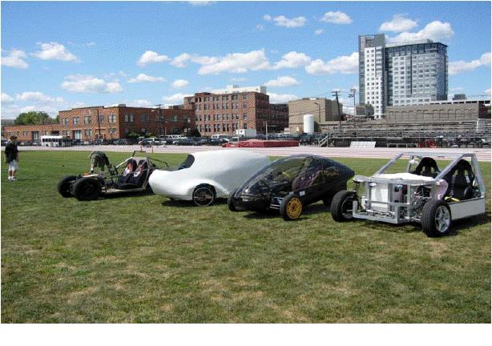
Figure 1: APHV, Biofules , Pulse and Fuel cell Prototypes assembled at MIT.

2006-2008–Vision 200
At the end of the design expo at MIT, VDS focused on leapfrogging sustainable transport technologies and systems tangible for the developing world. It benchmarked its activities towards the goal of designing, producing and bringing to market Vision 200, a Hyper efficient 6 Passenger Vehicle earmarked for India (developing world) with a 95 % reduction in embodied energy materials and toxicity cradle-to-grave. This goal would be achieved by a global consortium of student led research.
A team of over 30 pre-eminent research Universities from around the globe advised by the world’s leading industrialists like General Motors (GM) was then formed to design and build the different systems of the vision 200. The consortium consisted of twelve (12) Universities from Europe, fifteen (15) from North and South America, eight (8) from Asia and one (1) from Africa. Some of the prominent representatives included ; MIT-Boston (Architectural Team and also the lead team),University of California ( Architectural team), University of Leuven Belgium ( Frame , Body and Propulsion), TUDelf University (Interior and Exterior Design ), Delhi College of Engineering ( Braking system ) and Makerere University Kampala ( Electrical System and Data networking)
A design and evaluation continuum then followed the formation of the global Vision 200 team .A Conceptual development and exploration workshop was conducted between November 5th and 9th 2007 in Delhi India for the different Teams. This event also acted as a platform for a one-to-one interaction between the different team members. 3 weeks later, 15 teams met in Leuven, Belgium to present their findings and Technical progress. At this workshop, the Ugandan Team was represented by its team leader, Steven Jeremy Ntambi.
In February 2008, 25 VDS team members convened in Milan Italy to begin work on systems integration and map ecological impact that VDS and vision 200 would have on the world. The Ugandan Team was represented by Team leader Ntambi, Florence Nakitto, Rashid Mijumbi and Aggrey Kabunga. At this workshop a decision was reached to make Torino, The design capital of VDS.
In the summer of 2008, between June and August, the VDS teams met in the design capital Torino to build the vision 200. The prototype was fabricated with assistance from Politecnic di Torino. The representatives from the Uganda team included; Steven Ntambi, Aggrey Kabunga, Paul Rwemalla, Douglas Bibita, Dativa Tizikara and Emmanuel Ssebagala .A 6 passenger, hybrid, 100 mpg, and world prototype was thus built. This was showcased at the dream exposition in Torino, an event celebrating automotive history and future opportunities. Figure 2 shows vision 200 architectural drawings and the actual prototype without the body exhibited in Torino.
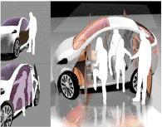 | 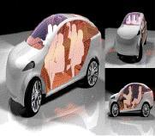 | 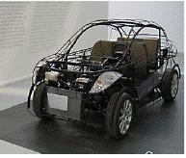
Figure 2: Vision 200 3D models and the protoype assembled in Torino , Italy

2008- To date –Centre for Research in Transportation Technologies (Vehicle Design Project)
Beyond the vision 200, VDS aimed at inspiring young people everywhere around the world with big ideas who lack the resources to act independently to seek the expertise and resources they need to forge solutions to a wide range of diffuse challenges facing our planet today.
The University of Leuven in Belgium set up an independent research project into green transport Technologies as a result of lessons learnt from the vision 200. Along the same lines the Ugandan Team Inspired by its mentors Prof. S.S Sandy Stevens Tickodri-Togboa and Paul Isaac Musasizi conceived the idea of setting up a Centre for Research in Transport Technologies (CRTT). The aim behind this was to put to effective use the skills obtained from the involvement of students in the Vision 200 dream design event and to capture the genius, time and energies of students with the aim of coming up with workable solutions to Uganda’s transport challenges (opportunities).
At the forefront was the Vehicle Design Project which was established in late 2008, to design and build energy efficient automobiles custom made for the Ugandan Market. The mission of this Endeavour was to develop cost effective and environmentally friendly automobiles for Africa.
As proof of concept, Vehicle design project set out to design a 2 seater electric Vehicle code named KIIRA EV after H.E. the president of Uganda Suggested a native name from its previous name MAKEV, as a University campus transport solution. It is currently based at the faculty of Technology and is organized into three major Teams, The Electrical systems, Mechanical systems and the Communication Network Teams .Its Research is supported by the Ugandan Government through the presidential Pledge to Boost technological Education. It is composed of 4 staff members 4 graduate research assistants and 6 Undergraduate Researchers. Figure 3 shows the 3D design of the KIIRA EV.

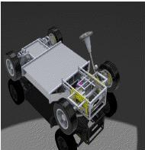 | 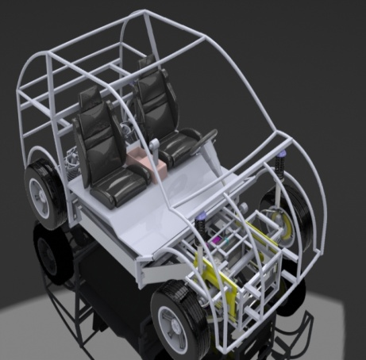 | 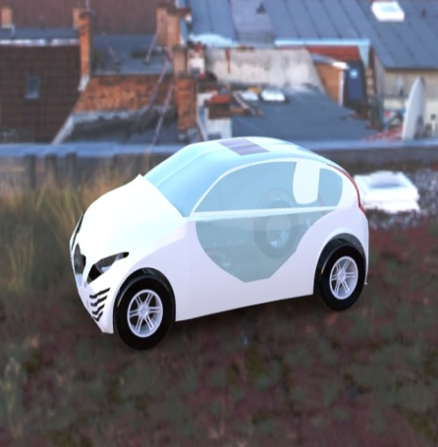
Figure 3: KIIRA EV designs

