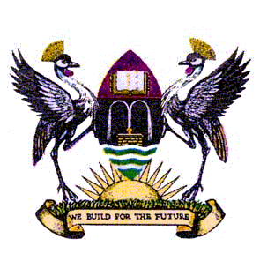
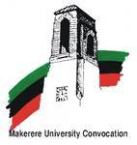
Programme for the GLOCO PARTNERSHIPS
BETWEEN UNIVERSITIES AND COMMUNITIES
ON KNOWLEDGE CREATION AND TRANSFER
SYMPOSIUM
Friday 5th November 2010 VENUE: CONFERENCE HALL
DEPARTMENT OF FOOD SCIENC E AND
TECHNOLOGY
MPAMBO AFRICAN MULTIVERSITY IN COLLABORATION WITH MAKERERE UNIVERSITY
Participants Assemble | 13.00-13.30
Universities in Renegotiating their Relationships with Community | 13.30-14.00 | Budd Hall, Professor of Public Administration, University of Victoria, BC Canada
NGOs/Civil Society Repositioning Themselves to serve Community Better: The local and Global Dimensions | 14.00-14.30 | Lynn Thomson Executive - Canada
African Institutions of Higher Learning and the 21st Century demands of knowledge Society and the Challenge of Re-discovering indigenous knowledge | 14:30-15:00 | Wangoola Paulo, Founder and Nabyama, Mpambo Afrikan Multiversity
An Afrikan Mother Tongue Community View of Institutions of Higher Learning in Uganda. A Treatise in the Luganda Language. | 15:00-15:30 | Kabona Mugaalula Wamala, Head of The School of African Spirituality and Philosophy, Mpambo Afrikan Multiversity
Open Discussions | 15.30- 16.20 | Dr. George L. Openjuru
Closing Remarks | 16.20- 16.45 | The Director of the Institute of Adult and Continuing Education, Makerere University
Departure | 16.45-17:00 | The Host
- Refreshments will be provided!

